**AMBER: FACULTY EVALUATION SYSTEM**

A Capstone Project Presented to the Faculty of

College of Computer, Information and Communication Technology Department

Cebu Technological University - Main Campus

In Partial Fulfillment

Of the Requirements for the Degree

Bachelor of Science in Information Technology

By

Andrea B. Agbay

Marviquint B. Bahio

Bobby Mark S. Berden

Anny Christ L. Villarin

Bell S. Campanilla Ph. D

Adviser

January 2023

**APPROVAL SHEET**

The Capstone 2 project entitled **AMBER: Faculty Evaluation System** prepared and submitted by Andrea B. Agbay, Marviquint B. Bahio, Bobby Mark S. Berden and Anny Christ L. Villarin has been examined and is recommended for approval and acceptance.

Recommended:

|  |
| --- |
| **Bell S. Campanilla, Ph. D.**  Adviser |

**APPROVED** by the Committee on ORAL DEFENSE with a verdict of **ACCEPTED WITH REVISIONS** on **Tuesday, January 03, 2023.**

**Suztte B. Bacus, MIT**

Chairman

|  |  |  |
| --- | --- | --- |
| **Joseph P. Barawidan, MTE**  Member |  | **Janeth S. Ugang, MST-CS**  Member |

ACCEPTED and APPROVED in partial fulfilment of the requirements in Bachelor of Science in Information Technology

|  |
| --- |
| **Gerry Ritz R. Densing, Ph. D.**  Associate Dean, CCICT  **Jose Maria S. Garcia II, Ph. D.**  Dean, CCICT |

**ABSTRACT**

AMBER: Faculty Evaluation System is a web application intended for an institution faculty evaluation. Information Technology (IT) has evolved over the years in various parts of the world. From the invention of the first computer to the present day, mobile technology influenced our lives. Individuals' daily lives have been affected by information technology, especially those who rely on it to make their jobs and other tasks easier, faster, and more efficient. Technology has become so advanced, and there is never a dull moment or nothing to look forward to. It has paved the way for greater opportunities and greater potential for people to live in a better world, and there is no doubt that information technology will provide a possible and extremely hopeful future for everyone in every way. Faculty evaluation is defined as a systematic procedure for reviewing the performance of a teacher in a classroom and analyzing the review to provide constructive feedback for the teacher’s professional growth. A faculty evaluation plays an important role in a university, where its role is to know the performance of the faculty member or a dean, a peer, and a self-evaluation. It is important to know the performance of a certain faculty member, to know if there is a part of them to improve. A faculty member can improve himself/herself after viewing the result of each evaluation done. The problem when using manual evaluation forms is the record keeping of the evaluation, the fact that this alone requires human intervention which can lead to security issues. That’s why the researchers are here to bridge the gap of that problem by using this system that they will implement. Just like other universities which have their own faculty evaluation system, the researchers also want to make the said type of system for the university to use. This will take time to make but the researcher will make sure of the fact that this system will help the university to become a smart university in the future.

***Keywords****: AMBER, Faculty Evaluation, Instructors, Students, Web Application, Universities*

**ACKNOWLEDGEMENT**

The Capstoners team would like to express its sincere gratitude to everyone who supported and contributed to the success of this study.

We want to start by giving thanks to the Lord Almighty God for providing us courage, strength and determination to work on this project. Without his guidance towards the good direction, we would have not completed this work.

We also want to express our sincere gratitude to everyone who has helped us with our endeavor, especially our parents, who have helped us both financially and emotionally while also having complete faith in us.

We would also like to express our gratitude to the mentors, classmates, and close friends who provided advice and suggestions for improving this study.

Thank you to our esteemed dean, Dr. Jose Maria Garcia II, for allowing us to collaborate on this productive project.

Thank you to Dr. Bell Campanilla, our dependable and inspiring advisor, for all of the help and unwavering support you have given us along the path. His knowledge and skills have been helpful to us from beginning to end of this project study. We couldn't have finished our study without his presence and teachings. We are so grateful to him as well as his knowledge and skills.

To the four of us, the researchers — Andrea B. Agbay, Marviquint B. Bahio, Bobby Mark S. Berden and Anny Christ L. Villarin — for cooperating to create and finish this study.

* Capstoners

**DEDICATION**

This study is dedicated to our devoted and loving parents for their unwavering support, wisdom, and patience throughout the process. Additionally, the individuals, coworkers, and friends that supported us in this project in various small ways. Thanks to the professors who shared their wisdom and experiences with us. To our dependable and inspiring advisor, who has always offered his encouragement and direction. And especially to our Creator, the All-Powerful God, who gave us the courage and trust to carry out this research.

**TABLE OF CONTENTS**

|  |  |
| --- | --- |
| TITLE PAGE  APPROVAL SHEET  ABSTRACT  ACKNOWLEDGMENT  DEDICATION  TABLE OF CONTENTS  LIST OF TABLES  LIST OF FIGURES  **CHAPTER I**  Rationale of the Study  Objectives of the Study  Scope and Limitation of the Study  Significance of the Study  Flow of the Study  Definition of Terms  **CHAPTER II**  REVIEW OF RELATED LITERATURE AND STUDIES  Related Literature  Related Studies  **CHAPTER III**  RESEARCH METHODOLOGY  Software Engineering Methodology  Planning Phase  Business Model Canvas  Program Workflow  Gantt Chart  Functional Decomposition Diagram  Analysis Phase  Use-Case Diagram  Storyboard  Database Design  Entity-Relationship Diagram  Data Dictionary  Network Design  Network Model  Network Topology  Development Phase  Technology Stack Diagram  Software Specification  Hardware Specification  Program Specification  List of Modules  Testing Phase  Unit Testing  Integration Testing  Implementation/Deployment Phase  Software Specification  Hardware Specification  User-Guide  Roadmap  CONCLUSION  RECOMMENDATIONS  REFERENCES  APPENDICES  Appendix A: Oath of Confirmation  Appendix B: Capstone Project Team Composition Form  Appendix C: Capstone Working Title Form  Appendix D: Consultation Log  Appendix E: Source Code  CURRICULUM VITAE | i  ii  iii  iv  v  vi  viii  ix  1  1  3  4  5  6  7  8  8  8  10  13  13  13  14  14  15  18  20  21  21  23  47  47  48  58  58  59  60  60  60  62  63  63  68  69  80  83  83  84  85  129  130  130  131  133  133  135  136  137  139  150 |

**LIST OF TABLES**

|  |  |
| --- | --- |
| Table 1: Comparative Matrix  Table 2: Admin  Table 3: Constructor  Table 4: Course  Table 5: Department  Table 6: Evaluation  Table 7: Files  Table 8: Indicator  Table 9: Instructor  Table 10: Notification  Table 11: Schedule  Table 12: School List  Table 13: School  Table 14: Section  Table 15: Semester  Table 16: Skill Test  Table 17: Student  Table 18: Subject  Table 19: Subscription  Table 20: Super Admin  Table 21: Super Admin Notification  Table 22: Users Notification  Table 23: Technology Stack Diagram  Table 24: Software Specification in System Development  Table 25: Web Browsers  Table 26: Hardware Specification in System Development  Table 27: List of Modules  Table 28: Unit Testing  Table 29: Integration Testing  Table 30: Software Specification in System Development  Table 31: Web Browsers  Table 32: Hardware Specification in System Development | 12  48  48  49  49  50  50  50  51  51  52  52  53  53  53  54  54  55  56  56  57  57  60  61  61  62  63  68  80  83  84  84 |

**LIST OF FIGURES**

|  |  |
| --- | --- |
| Figure 1: Flow of the Study  Figure 2: Missionare Della Fede’s Online Teacher Evaluation System  Figure 3: Faculty Evaluation System  Figure 4: ABC School Faculty Classroom Observation  Figure 5: Waterfall Development Model  Figure 6: Business Model Canvas  Figure 7: Admin Program Workflow  Figure 8: Dean Program Workflow  Figure 9: Instructor Program Workflow  Figure 10: Student Program Workflow  Figure 11: Gantt Chart: Capstone 1  Figure 12: Capstone 2 Gantt Chart  Figure 13: Functional Decomposition Diagram  Figure 14: Admin’s Use Case Diagram  Figure 15: Dean’s Use Case Diagram  Figure 16: Instructor’s Use Case Diagram  Figure 17: Student’s Use Case Diagram  Figure 18: Home page  Figure 19: Admin Create Account  Figure 20: Admin Login  Figure 21: Admin Landing Page  Figure 22: Admin Notification  Figure 23: Admin Profile  Figure 24: Bulk Upload of Users Record  Figure 25: Bulk Upload of Categories and Questions  Figure 26: Add School Admin  Figure 27: Manage Faculty Member  Figure 28: Manage Student  Figure 29: Manage Term  Figure 30: Manage Department  Figure 31: Manage Course  Figure 32: Manage Section  Figure 33: Manage Subject  Figure 34: Manage Schedule  Figure 35: Manage Evaluation Schedule  Figure 36: Generate Link  Figure 37: Manage Categories  Figure 38: Manage Question  Figure 39: Rankings  Figure 40: Student to Instructor Evaluation Report  Figure 41: Peer Evaluation  Figure 42: Self-Evaluation Report  Figure 43: Overall Evaluation Report  Figure 44: Overall Report by Category  Figure 45: Overall Report by Question  Figure 46: Reports by Department  Figure 47: Student Login  Figure 48: Student Landing Page  Figure 49: Student Profile  Figure 50: Student to Instructor Evaluation  Figure 51: Dean’s Profile  Figure 52: Student Management  Figure 53: Faculty Member Management  Figure 54: Section Management  Figure 55: Course Management  Figure 56: Subject Management  Figure 57: Evaluation Ranking  Figure 58: Student Evaluation Report  Figure 59: Peer Evaluation Result  Figure 60: Instructor Login Page  Figure 61: Instructor Landing Page  Figure 62: Peer Evaluation  Figure 63: Self-Evaluation  Figure 64: Evaluation Result  Figure 65: Entity Relationship Diagram  Figure 66: Network Topology  Figure 67: Home Page  Figure 68: Create Account  Figure 69: Input Verification Code  Figure 70: Successfully Signed up  Figure 71: Admin Login  Figure 72: Pop up message for subscription  Figure 73: Admin Landing Page  Figure 74: Upload Users  Figure 75: Upload Category and Questions  Figure 76: Admin Management  Figure 77: Manage Faculty  Figure 78: Manage Student  Figure 79: Term Management  Figure 80: Department Management  Figure 81: Course Management  Figure 82: Section Management  Figure 83: Subject Management  Figure 84: Schedule Management  Figure 85: Evaluation Schedule  Figure 86: Generate Evaluation Link  Figure 87: Category Management  Figure 88: Question Management  Figure 89: Rankings  Figure 90: Admin Request Skill Test  Figure 91: Student Evaluation Report  Figure 92: No Result  Figure 93: Peer Evaluation Result  Figure 94: Peer Evaluation Result to be printed  Figure 95: Self Evaluation Result  Figure 96: Overall Report by Category  Figure 97: Overall report by Question  Figure 98: Department Reports  Figure 99: Admin Profile  Figure 100: Edit Information  Figure 101: Edit Password  Figure 102: Edit Contact Information  Figure 103: Edit Username  Figure 104: School Information  Figure 105: Edit School Information  Figure 106: Subscription Page  Figure 107: Reason for Cancellation  Figure 108: Subscription Plan  Figure 109: Confirmation Logout  Figure 110: Mini Pack Subscription Plan  Figure 111: Medium Pack Subscription Plan  Figure 112: Large Pack Subscription Plan  Figure 113: Subscription Plan Details  Figure 114: Email Received  Figure 115: Faculty Login Page  Figure 116: Student Login  Figure 117: Student Verification  Figure 118: Successfully Verified  Figure 119: Student Landing Page  Figure 120: Pop up Message for New User  Figure 121: No Evaluation Available  Figure 122: Descriptive Rating  Figure 123: Evaluation Form  Figure 124: Selecting instructor  Figure 125: Already Evaluated Instructor  Figure 126: Error When Submitting  Figure 127: Successfully Evaluated  Figure 128: Student’s Profile  Figure 129: Student’s Notification  Figure 130: Confirmation to Logout  Figure 131: Faculty Login  Figure 132: Verify Account  Figure 133: Faculty Landing Page  Figure 134: Descriptive Rating  Figure 135: Evaluation Form  Figure 136: Instructor Already Evaluated  Figure 137: Self Evaluation  Figure 138: Evaluation Result  Figure 139: Faculty’s Notification  Figure 140: Faculty’s Profile  Figure 141: Contact Admin  Figure 142: Change Password  Figure 143: Dean’s Profile  Figure 144: Student Management  Figure 145: Faculty Member Management  Figure 146: Section Management  Figure 147: Course Management  Figure 148: Subject Management  Figure 149: Evaluation Ranking  Figure 150: Skill Test Notification from Admin  Figure 151: Select Instructor for Skill Test  Figure 152: Student Evaluation Report  Figure 153: Peer Evaluation Report  Figure 154: Roadmap | 6  10  11  11  13  14  15  16  16  17  18  19  20  21  21  22  22  23  23  24  24  25  25  26  26  27  27  28  28  29  29  30  30  31  31  32  32  33  33  34  34  35  35  36  36  37  37  38  38  39  39  40  40  41  41  42  42  43  43  44  44  45  45  46  47  59  85  86  86  87  87  88  88  89  89  90  90  91  91  92  92  93  93  94  94  95  95  96  96  97  97  98  98  99  99  100  100  101  101  102  102  103  103  104  104  105  105  106  106  107  107  108  108  109  109  110  110  111  111  112  112  113  113  114  114  115  115  116  116  117  117  118  118  119  119  120  120  121  121  122  122  123  123  124  124  125  125  126  126  127  127  128  128  129 |

**CHAPTER I**

**INTRODUCTION**

**Rationale of the Study**

Information Technology (IT) has evolved over the years in various parts of the world. From the invention of the first computer to the present day, mobile technology influenced our lives. Individuals' daily lives have been affected by information technology, especially those who rely on it to make their jobs and other tasks easier, faster, and more efficient. Technology has become so advanced, and there is never a dull moment or nothing to look forward to. It has paved the way for greater opportunities and greater potential for people to live in a better world, and there is no doubt that information technology will provide a possible and extremely hopeful future for everyone in every way.

Software applications is a type of computer program that performs a specific personal, educational, and business function. Each application is designed to assist end-users in accomplishing a variety of tasks, which may be related to productivity, creativity, or communication

The advantages of software applications are the following, first is the fact that it fulfills the client's exact criteria is their single and greatest advantage. Client recognizes that he/she must use one explicit programming to complete his/her errand because it is planned explicitly for one reason. Next is, Possibility of infections attacking hand crafted projects may be little, as long as any business that accompanies it can limit access and ought to give your strategy to secure their locale too.

The disadvantages of software applications is first, developing application programming for specific reasons can be prohibitively expensive for engineers. This can have an impact on their financial plan and income stream, especially if an excessive amount of time is spent on a product that is not generally worthy. Application programming that is utilized regularly by numerous individuals of us, at that point shared on the web, conveys a truly genuine danger of contamination by a bug or other vindictive projects. And lastly, creating them is a process that takes a lot of time because it necessitates consistent communication between the developer and the supporter. This postpones the entire creation process, which could be detrimental in some instances

Faculty evaluation is defined as a systematic procedure for reviewing the performance of a teacher in a classroom and analyzing the review to provide constructive feedback for the teacher’s professional growth. A faculty evaluation plays an important role in a university, where its role is to know the performance of the faculty member or a dean, a peer, and a self-evaluation. It is important to know the performance of a certain faculty member, to know if there is a part of them to improve. A faculty member can improve himself/herself after viewing the result of each evaluation done.

This system will also provide recommendations according to the results of the evaluation. And the results of the evaluation will be done by applying data analytics specifically using the decision tree and classification algorithm. Analytics is the systematic computational analysis of data or statistics. It is used for the discovery, interpretation, and communication of meaningful patterns in data. It also entails applying data patterns toward effective decision-making. It can be valuable in areas rich with recorded information; analytics relies on the simultaneous application of statistics, computer programming, and operations research to quantify performance.

Cebu Technological University (CTU) is a public, non-sectarian, coeducational state funded higher education institution located in Cebu, Philippines. The university has 40,000 students on 23 campuses located throughout the province of Cebu. Its main campus is situated in Cebu City, the capital of the province of Cebu. Cebu Technological University, formerly known as Cebu State College of Science and Technology (CSCST), became a state university on November 10, 2009 by virtue of Republic Act No. 9744.

Since the beginning of the University, the manual evaluation is done using semi computerize, which is done by computer production application (i.e. MS Word, Excel and Google forms) manual evaluation sheets in evaluating the performance of the faculty members, administrators through the past years. The said university has no other type of evaluation system ever since, it is a problem for a university if it doesn’t have a faculty evaluation system because it can affect the quality of education that the university provides.

The problem when using manual evaluation forms is the record keeping of the evaluation, the fact that this alone requires human intervention which can lead to security issues. That’s why the researchers are here to bridge the gap of that problem by using this system that they will implement. Just like other universities which have their own faculty evaluation system, the researchers also want to make the said type of system for the university to use. This will take time to make but the researcher will make sure of the fact that this system will help the university to become a smart university in the future.

**Objectives of the Study**

This study presents AMBER, a web-based application that will help educational institution administrators in addressing the faculty evaluation challenges.

Specifically, this study aims to develop a web application for the:

1. Administrators to manage:
   1. profile,
   2. users,
   3. reports,
   4. results using data analytics,
   5. evaluation,
   6. receive notifications,
   7. academic detail management (university wide),
   8. send skills test requests,
   9. recommendations, and
   10. rankings based from the results of evaluation
2. Dean to manage:
   1. profile,
   2. conducting of skills test,
   3. receiving of notifications,
   4. faculty evaluation, and
   5. academic detail management (department wide)
3. Instructor to manage:
   1. profile,
   2. self-evaluation,
   3. receiving of notifications, and
   4. evaluation of peer
4. Students to manage:
   1. profile
   2. the evaluation faculty member, and
   3. receiving of notifications
5. Super admin to manage:
   1. profile,
   2. users,
   3. the adding of users,
   4. reports,
   5. receive notifications,
   6. subscriptions,
   7. viewing of rankings based from the evaluation, and
   8. academic detail management (system wide)

**Scope and Limitations**

This study will focus on developing a faculty evaluation for a university. The proposed system will help the university administrators keep track of the performance of the faculty members, and manage the evaluation reports. The study will take place at Cebu Technological University – Main Campus. The University is located at M.J. Cuenco Avenue corner R. Palma Street, Cebu City, Philippines.

The Limitations of Faculty Evaluation Performance System are the following:

* The faculty can view his/her evaluation result,
* The students can’t view the result of the evaluation,
* Only the university ID number can be used
* The students must only evaluate his/her instructors
* One school campus per subscription.
* If using free mode in subscription, users are given one month to use and access the web application with only few functionalities.
* Faculty members and students can only login when they receive an email that contains a link and login account details to access the web app.
* The skill test depends on the educational institution’s policy if they are implementing it or not.
* Everything that is under the dean’s management can only be updated or edit and can’t delete.

**Significance of the study**

This study presents the AMBER, a faculty evaluation form to help the:

**University**. This will help in providing quality education to the students.

**Administrators**. The findings of this study will help in aiding the problem of having security issues of the system.

**Professors**. This will help in identifying the part of them to improve to become better.

**Students**. Will be provided with quality education by the help of the members of the faculty or by the whole institution.

**Other researchers**. The findings of the study will be used as a reference and a guide for others who want to perform a similar study.

**Programmers**. This might serve as the basis for developing and designing a more innovative faculty evaluation system. The study's findings will help them choose where they should focus their efforts in order to enhance the system.

**Flow of the Study**

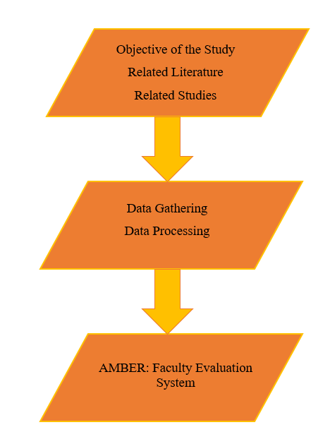

Figure 1: **Flow of the Study**

Figure 1 illustrates the result of the research and the process of screening and selecting studies for inclusion to review. This is the main flow of the study which will be done by the researchers.

**Definition of Terms**

**Information Technology.** This research wants to show relativity on the study and on the things widely used and closely connected to our daily lives, to the community and other industries.

**Faculty Evaluation.** is the process in which the performance of oneself and to a faculty member is being or to be evaluated in an evaluation form.

**Faculty Member**. one of the main users of the system, these are the instructors, and dean.

**Cebu Technological University**. is the chosen university of the researchers and their target focus in making the system.

**Researchers**. the people behind the study who do the work of researching and collecting data and making ideas come to reality.

**Smart University**. is something the researchers want the university or institution to become. To contribute in ways of having more use of technical innovations that will help meet the needs in accomplishing a greater learning institution.

**Faculty Evaluation System**. a web-based application software that processes evaluation on faculty members and keeps its record confidentially. It is intended to help the faculty to know and monitor their performance and improve the effectiveness of their teaching methods.

**Students**. one of the users of the system, they are one of the evaluators who are given an opportunity to help their teachers to be better at what they do so the students would be able to attain a good quality education they deserve. Helping their teachers by providing a concrete answer or information done in the given evaluation form.

**Evaluation form**. is a medium made and used for evaluation.

**Data Analytics**. is the systematic computational analysis of data or statistics. It is used in the system to provide and display all of the results with regards to the evaluation.

**Evaluation**. It is the assessment and making of a judgment based on amount, number or value.

**CHAPTER II**

**REVIEW OF RELATED LITERATURE AND STUDIES**

**Review of Related Literature**

Faculty evaluation is defined as a systematic procedure for reviewing the performance of a teacher in a classroom and analyzing the review to provide constructive feedback for the teacher’s professional growth. According to Almiranez (2018). It is one of the important parts of any educational institution that assesses the efficiency and effectiveness of teaching methodology and strategy used by faculty to meet the objectives of the institution, to produce highly and globally competitive graduates. The main objective of the online faculty evaluation system is to enhance or improve teaching performance for promotion purposes.

Universities using a faculty evaluation system can be considered as a smart university especially if the evaluation system is done online. Jaramillo (2017) states that, in recent years there have been considerable changes in the university system, so in a globalized context the organization and funds are being directed to efforts to transform the traditional university into “universities of entrepreneurship”. Given the nature of academic activities and the organizational structure in universities, evaluation systems are quite complex, mostly oriented towards assessments based on achievements and objectives, but for the control institutions it is very important that they be according to standards. Which often brings conflicts between academic and administrative members, while some argue that it is possible to accurately measure the different key aspects, others argue that the use of tools to measure affect the autonomous and free development of the university.

Patimo (2020) added that evaluating faculty effectiveness is important in every institution of higher education. Assessing teaching performance enables one to gauge the quality of instruction represented by the institution and facilitate better learning among students. Assessing the effectiveness with which various functions of the faculty members are performed is essential to a variety of important administration recommendations and decisions. The evaluation system also provides feedback which influences the faculty member’s self-image and professional satisfaction. The faculty performance management system establishes a climate which communicates the institution’s commitment to professional improvement and confidence that every faculty member will make a valuable contribution to the achievement of shared goals. The processes in the performance evaluation of instructors, professors, and professionals of the SUCs are highly critical since it is used to decide on matters such as hiring, rehiring, and promotion. Hence, there should be careful calibration and continuous study of the instruments used to assess the teachers.

The proposed an automatic system to analyze the textual feedback of faculty members teaching in any institute. The suggested approach captures all of the essential features from the feedback and then uses machine learning algorithms to determine the sentiment score for each aspect for each faculty. The proposed system is more adaptable and varied than the current teacher feedback evaluation system, in which students rate professors on specified criteria determined by experienced and senior academics and administrators. The Faculty Evaluation System (FES) identifies teachers' strengths and deficiencies in all areas that are significant to students. Higher authorities at the institute may also use this information to build appropriate teams of faculty members for various academic and administrative tasks at the institute (Singh, 2020).

Taguiam (2016) stated that, using manual process of evaluation routinely repeats the job especially that evaluation is conducted twice in a year. It is a waste of time and that the consumed bond paper and toner in a year continually increases. Unlike electronic systems, it is simple to supervise. The reports are based on real time. Another advantage is that it is paperless.

Salas (2015) states that, in terms of the composition of the evaluators and who chooses them, the transcribed answers showed that the evaluation team is usually composed of the dean, department chairs, faculty members or peers, and students. This ensures the validity and reliability of the evaluation. The number of evaluators varies depending on the size of the faculty force or the size of classes they handle. Likewise, the department chair, college dean, and peers in the department evaluate each faculty. The number of evaluators again depends on the population of the faculty.

According to Kumar (2018) Traditionally teachers’ feedback evaluation system is a questionnaire-based system where a pre-designed questionnaire form is given to each student. The form may have 10 or more questions and students assign a grade to each question for every teacher according to the predefined measuring scale. On the basis of responses of all students, it is determined how much a teacher is able to contribute in his/her course. The main problem of the questionnaire-based system is that higher authorities identify the key points of a teacher and form questions, set on the basis of their personal experiences without taking into account students’ view. Due to this, the traditional questionnaire-based system becomes very restricted as students can give their views for only those questions which are mentioned in the questionnaire.

**Review of Related Studies**

This study presents a web-based application named. AMBER: Faculty Evaluation System. Web-based faculty evaluation systems are the one’s making it easier for an institution to have an application that can help in providing quality education by producing smart and amazing faculty members. There are a lot of faculty evaluation systems out there, especially in the private institutions. But the researchers innovated the known system to become more efficient and effective in providing the said aspects of quality education. Starting with the first system;

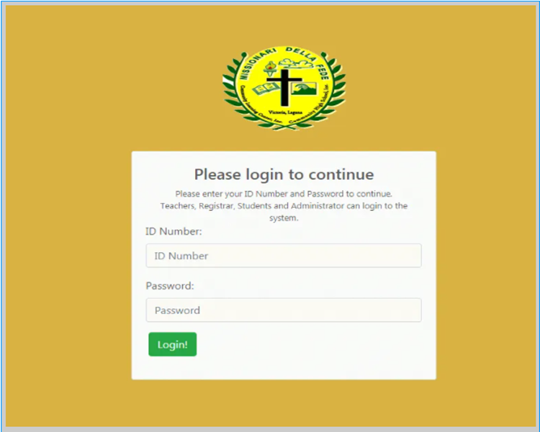

Figure 2: **Missionare Della Fede’s Online Teacher Evaluation System**

Figure 2 comes from the study of Missionare Della Fede is a private education institution that offers nursery-kinder preparatory, complete elementary course with computer literacy and complete secondary course with computer literacy. One of the competitors of the AMBER would be the Missionare Della Fede’s Online Teacher Evaluation System. It is web-based tools that will be built in accordance with the school's standards and requirements. This system will automate the evaluation process from start to finish.

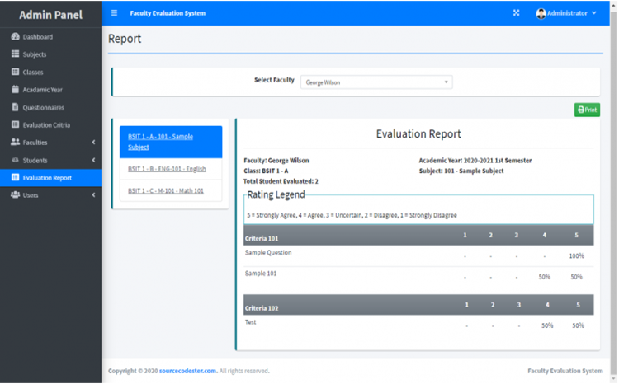

Figure 3: **Faculty Evaluation System**

Figure 3 is The Faculty Evaluation System assists the school in managing the outcomes of their faculty evaluations. The system has three user types: administrators, faculty, and students. The system evaluation report will be based on the system default academic year, which the administrator can alter on the academic page. In this system, the evaluation questionnaire is dynamic, which means that the administrator can design the questions and adjust the order of the questions based on the evaluation criteria.

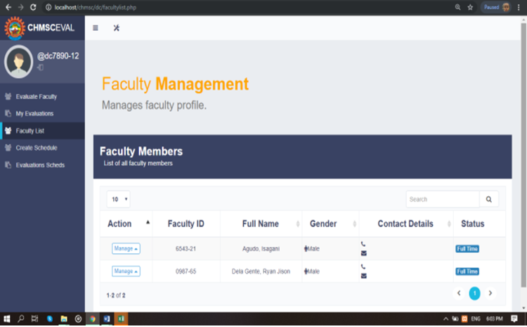

Figure 4: **ABC School Faculty Classroom Observation**

Figure 4 is also one of the names that would be included in the list of competitors of AMBER is ABC School Faculty Classroom Observation. A system that will turn the manual procedure of ABC School Fortune Town Faculty Classroom Performance Evaluation, notably in the Bachelor of Science in Information System Department, into a more systematic and automated data gathering and storage using technology.

**Comparative Matrix**

**Table 1**

**Comparative Matrix**

|  |  |  |  |  |
| --- | --- | --- | --- | --- |
| **FEATURES** | **Online Teacher Evaluation System** | **Faculty Evaluation System** | **ABC School Facculty Classroom Observation** | **AMBER** |
| Create Account |  |  |  |  |
| User Profile Management |  |  |  |  |
| Student to Faculty Evaluation |  |  |  |  |
| Peer to Peer Evaluation | X | X | X |  |
| Recommendation | X | X | X |  |
| List of Faculty Members | X | X | X |  |
| Self-Evaluation | X | X | X |  |
| Ranking | X | X | X |  |
| Skills Test | X | X | X |  |
| Web Support |  |  |  |  |
| Total | 40% | 40% | 40% | 100% |

**Chapter III**

**RESEARCH METHODOLOGY**

**Software Engineering Methodology**

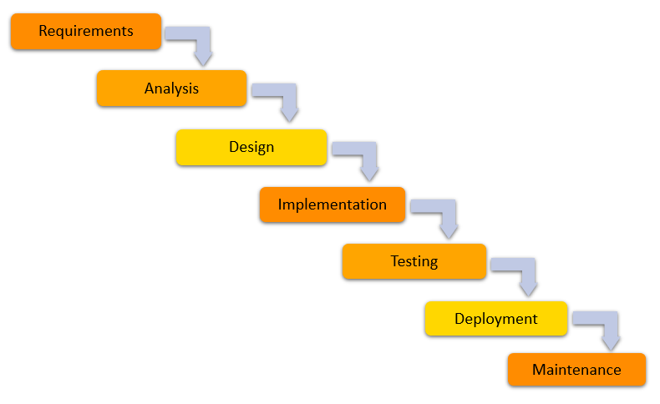

Figure 5: **Waterfall Development Model**

Figure 5 represents the Waterfall Development Model. A linear-sequential life cycle model is another name for it. It is really easy to comprehend and use. Each phase must be finished before the next can begin in this model, and the phases do not overlap. The Waterfall model is the most basic SDLC approach for software development. The Waterfall approach to systems analysis and design was the first established modern approach to building a system. This method was originally defined by Winston W. Royce in 1970. This model depicts the software development process as a sequential flow of events. This indicates that any step of the development process can start only after the previous one has finished. The phases in this waterfall model do not overlap.

In this model there are seven (7) phases; namely: System requirements, system analysis, system design, system implementation, testing phase, deployment phase, and maintenance. System requirements in this phase, the system requirement comes from the inputs of the users, all of the problems that they encountered in manual faculty evaluation. Like the following; the needed reports, the record keeping of the evaluation results, etc. System analysis - in the analysis phase, problems that are gathered from the first phase will be analyzed to produce possible solutions and help the users bridge the gap of the problems that they had encountered. Design phase - the proponents to design the appropriate user interface, database, and add all of the necessary features that the system will provide. Implementation phase - in this phase, the proponents will implement all of the necessary functions of the system, also in this phase, all of the features that the system possesses will be implemented. Here are some of the features that the system has; peer-to-peer evaluation, self-evaluation, etc. Testing phase - in this phase, the proponents will find some users to test the system before deployment, the said users will be students and faculty members or a dean and a chairman of a faculty. Deployment phase - after the testing of the system in the testing phase, if the system is good to go, then the proponents will be deploying the system so that the target market or target users can use the said system. Maintenance - after the deployment of the system, if there are errors or bugs encountered, then the proponents will do maintenance works to solve and fix the issues of the system until it becomes good and, in this phase, will never be ending.

**Planning Phase**

**Business Model Canvas**

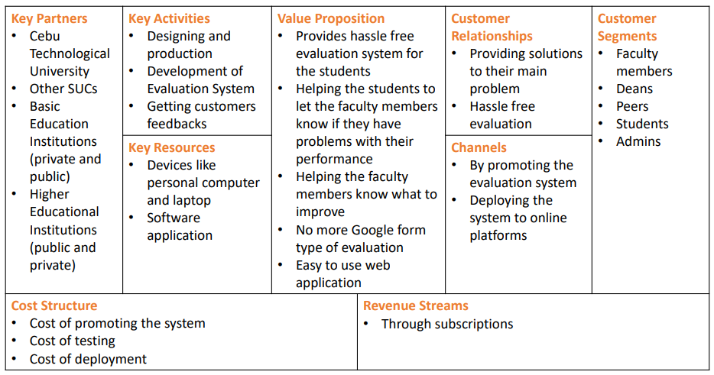

Figure 6: **Business Model Canvas**

Figure 6 illustrates the business model canvas of the system. The said components that are shown in the canvas are the main activities that the system will produce. Starting from the key partners which are the following Cebu Technological University, other SUC’s, Basic and higher educational institutions either private or public. Key activities are designing and production, development of evaluation system, and getting customer’s feedbacks. Key resources are laptops and personal computers and software applications. The value proposition provides the values that the system offers to the users, like the following; providing hassle free evaluation, helping faculty members what to improve and no more using of third-party web applications when evaluating. Customer relationships are connected to the value proposition. Channels promote the system and upload it to online platforms. Customer segments are instructors, administrators, deans, and students. Cost structure are costs of promoting the system, cost of testing, and cost of deployment. Lastly, revenue streams are through subscriptions to the system.

**Program Workflow**

**Admin**

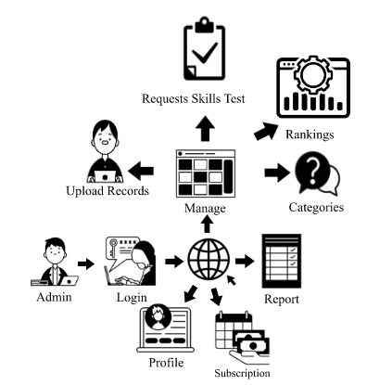

Figure 7: **Admin Program Workflow**

Figure 7 Illustrates the depiction of an admin’s possible interactions with the system where the admin can modify its profile, subscription, reports, and manage records such as user’s, either an instructor or a student, constructors, rankings, and Approval of skills Test Questions.

**Dean**

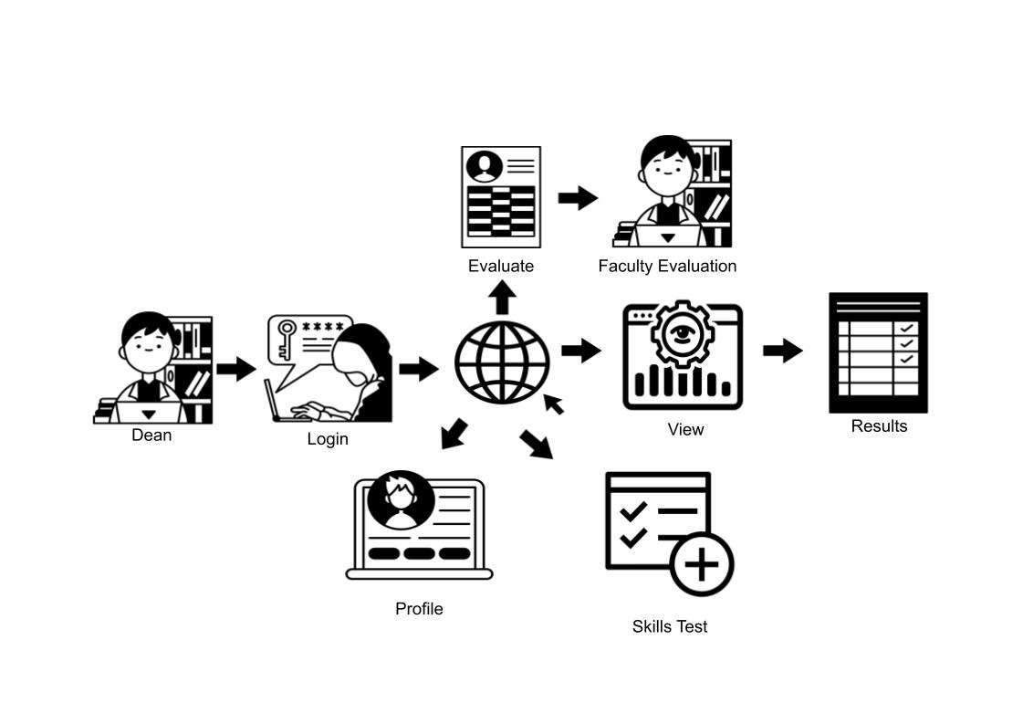

Figure 8: **Dean Program Workflow**

Figure 8 illustrates the depiction of a dean's possible interactions with the system where the dean can modify its profile, skills Test, view results, and Evaluation.

**Instructor**

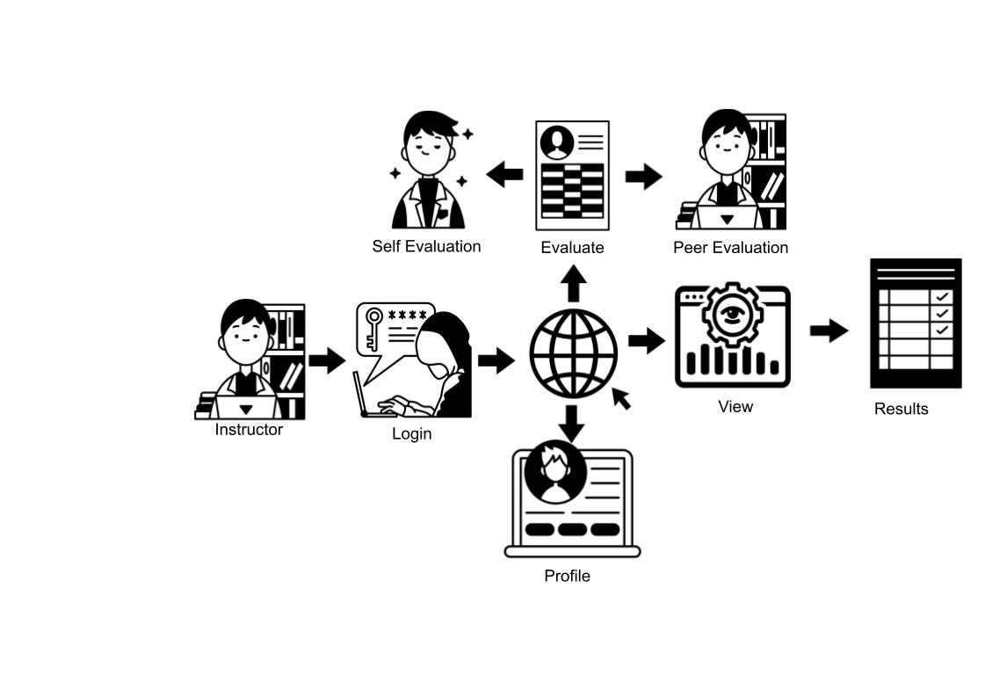

Figure 9: **Instructor Program Workflow**

Figure 9 illustrates the depiction of an Instructor’s possible interactions with the system where the Instructor can modify its profile, view results, and Evaluation.

**Student**

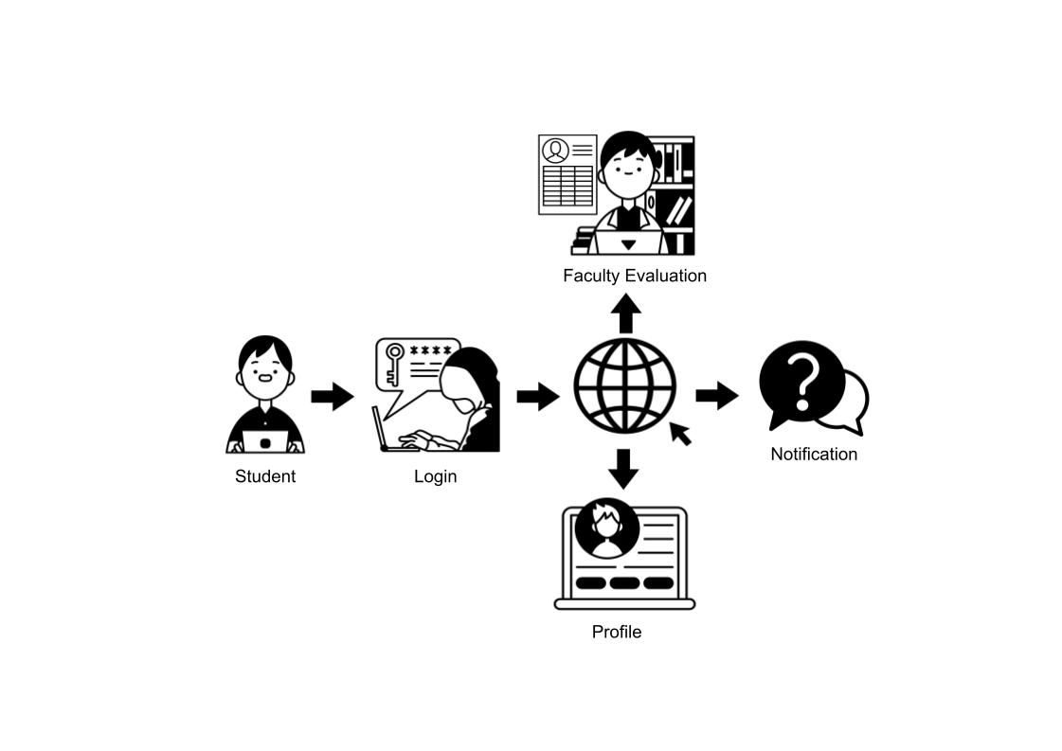

Figure 10: **Student Program Workflow**

Figure 10 Illustrates the depiction of a student’s possible interactions with the system where the student can modify its profile, view notification, and Evaluation.

**Gantt Chart**

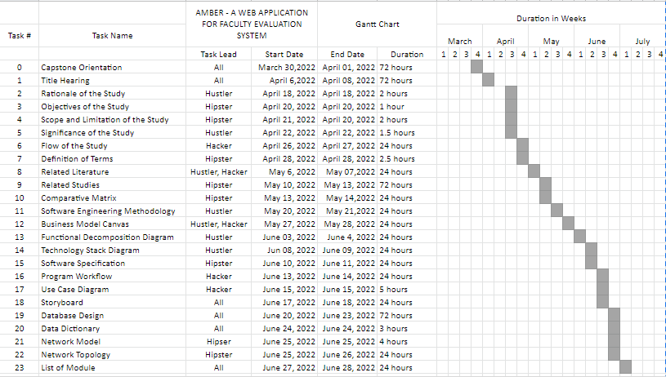

Figure 11: **Gantt Chart: Capstone 1**

Figure 11 is the capstone 1 Gantt chart that provides a schedule that was used in to plan in capstone 1.

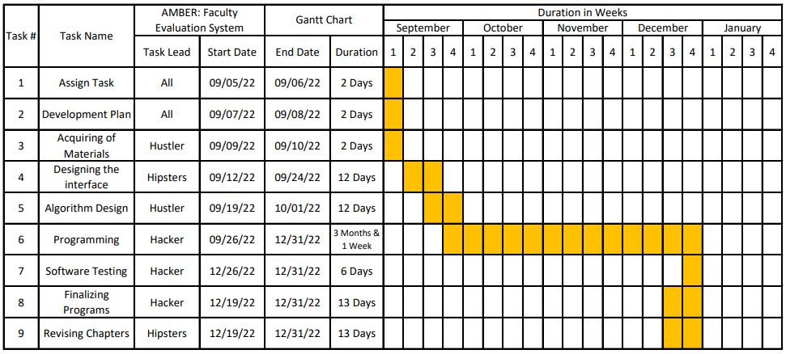

Figure 12: **Capstone 2 Gantt Chart**

Figure 12 is the capstone 2 Gantt chart that helps us coordinate and track tasks in our project.

**Functional Decomposition Diagram**

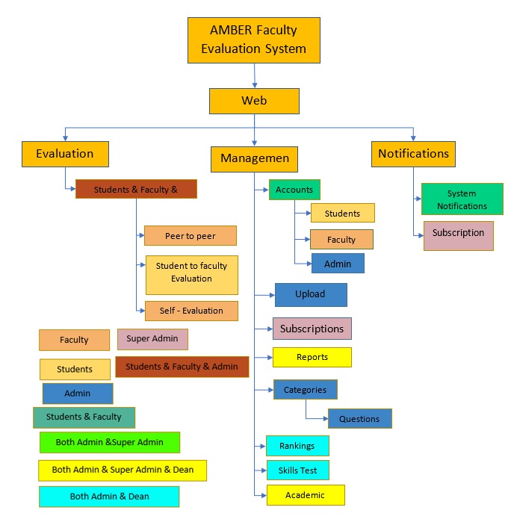

Figure 13: **Functional Decomposition Diagram**

Figure 13 illustrates the functional decomposition diagram of the system, here you can see the processes and the modules of the system. It is divided into three parts, the evaluation, management and notifications. Under the evaluation, you can see the main process of the system when it comes to evaluating, specifically, the student to instructor evaluation, self-evaluation, and the peer evaluation. Under Management, you can see how the users specifically the super admin, admin, and dean do their own management of the system, like the user account management, the reports, rankings and skills test. And for the notifications, it is manageable by all users including the administrator.

**Analysis Phase**

**Use case diagram**

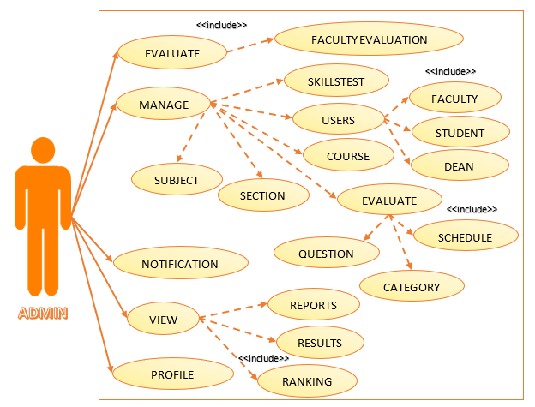

Figure 14: **Admin’s Use Case Diagram**

Figure 14 Illustrates the depiction of an admin’s possible interactions with the system where the admin can modify its profile, subscription, reports, ranking, and manage records add or update users.

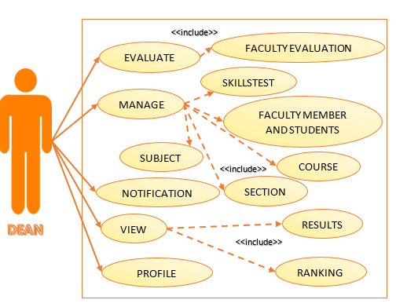

Figure 15: **Dean’s Use Case Diagram**

Figure 15 Illustrates the depiction of a dean's possible interactions with the system where the dean can modify its profile, skills Test questionnaire, view results, notification and Evaluation.

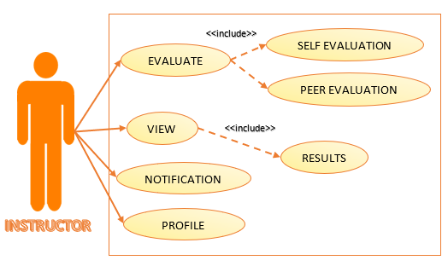

Figure 16: **Instructor’s Use Case Diagram**

Figure 16 Illustrates the depiction of an Instructor’s possible interactions with the system where the Instructor can modify its profile, view report and ranking, notification and Evaluation.

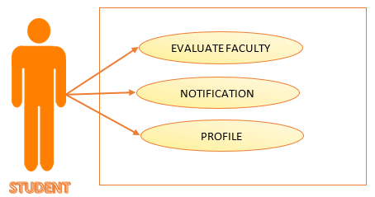

Figure 17: **Student’s Use Case Diagram**

Figure 17 Illustrates the depiction of a student’s possible interactions with the system where the student can modify its profile, view notification, and Evaluation.

**Storyboard**

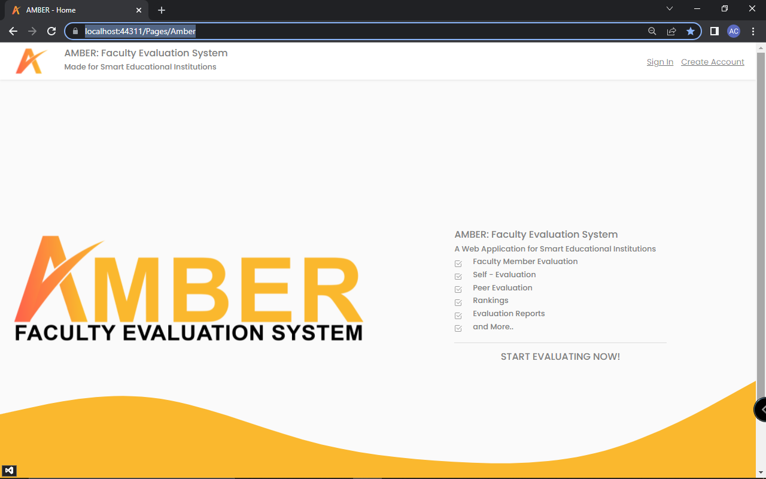

Figure 18: **Home page**

Figure 18 is the home page; this is where the landing page if the user is going to search for the website.

**Admin**

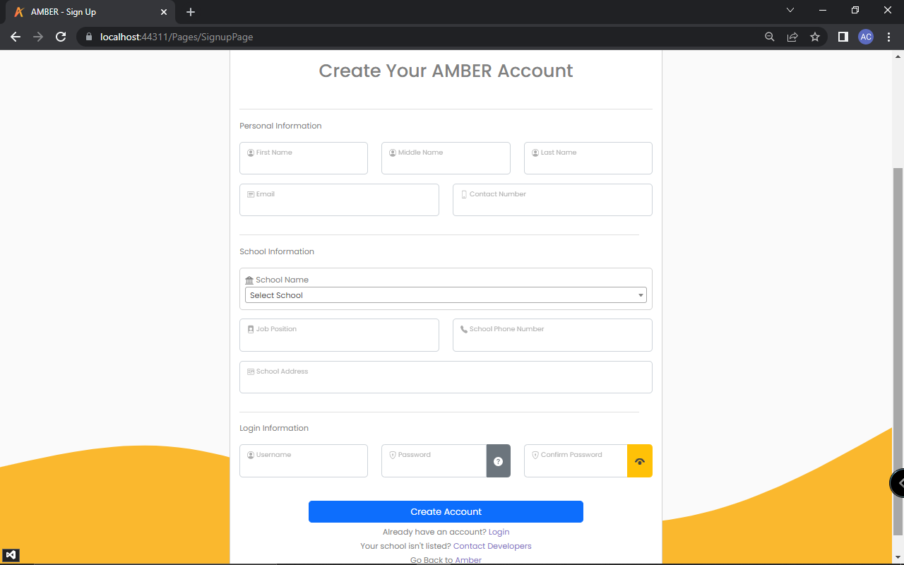

Figure 19: **Admin Create Account**

In figure 19 is the admin's create account, this is where they have to sign up

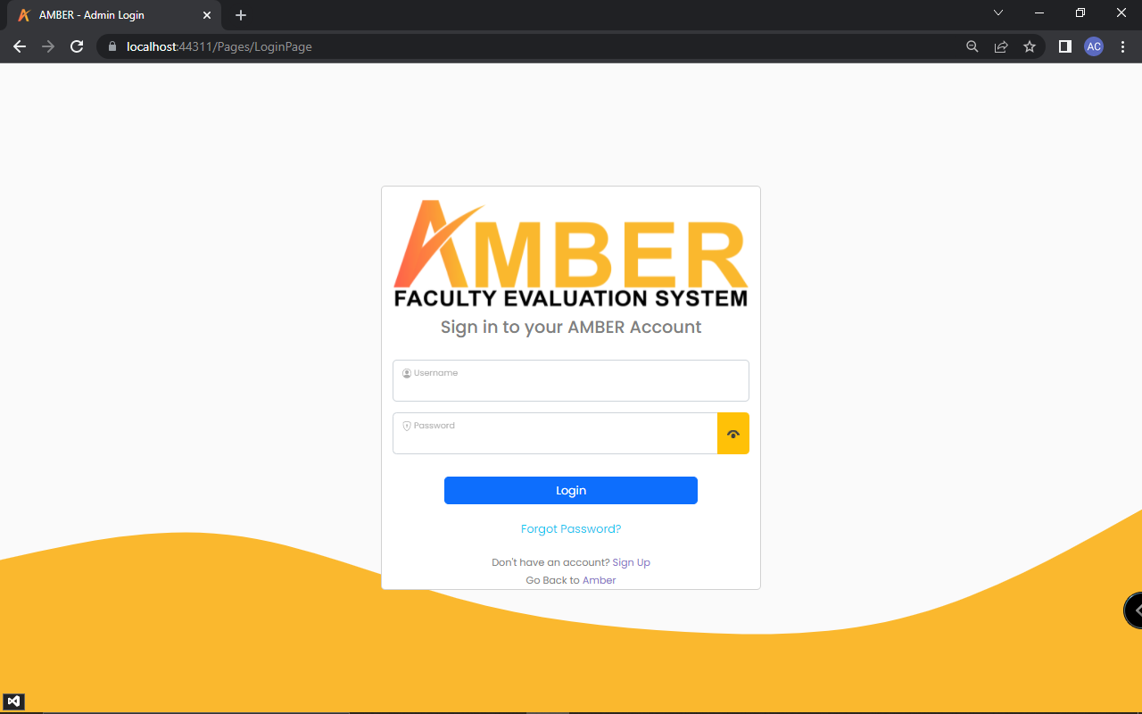

Figure 20: **Admin Login**

In figure 20 is the admin's login page, this is where they have to login to their account to access the system.

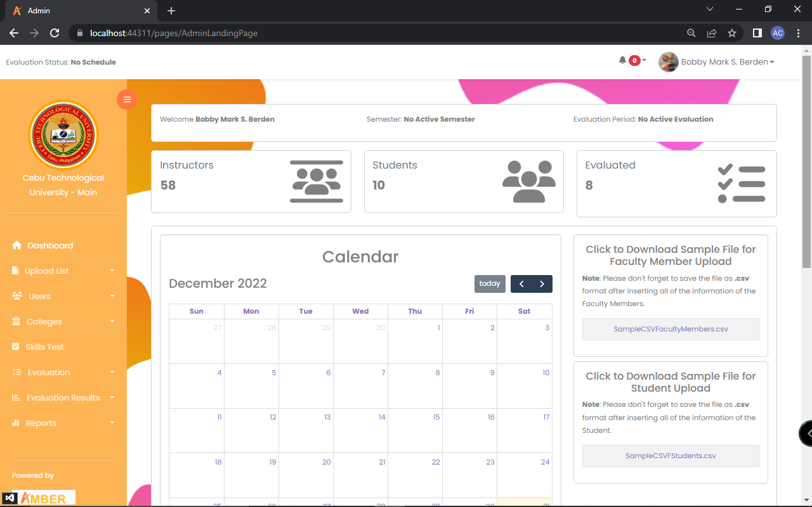

Figure 21: **Admin Landing Page**

Figure 21 is the admin’s landing page. Here, the admin can see how many users have registered in the system and can also add a semester.

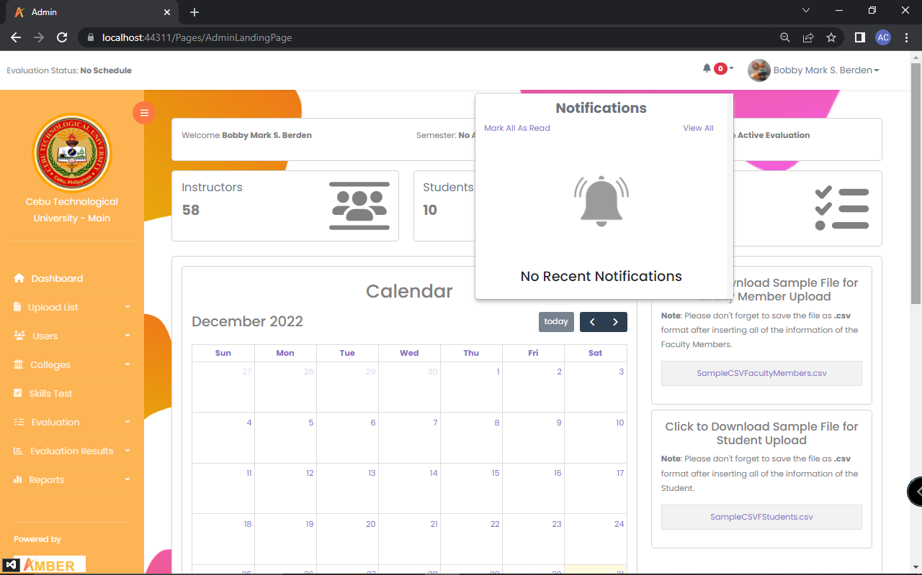

Figure 22: **Admin Notification**

Figure 22 is the admin’s notification. Here, the admin can see its notification.

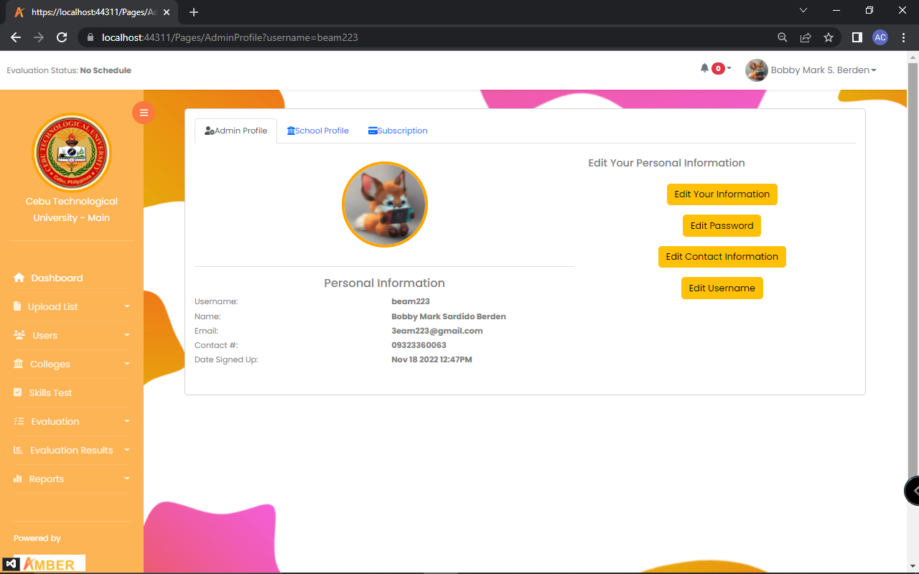

Figure 23: **Admin Profile**

Figure 23 is the admin’s profile. This is where the admin can edit its personal information, upload the school’s logo and edit its subscription plan.

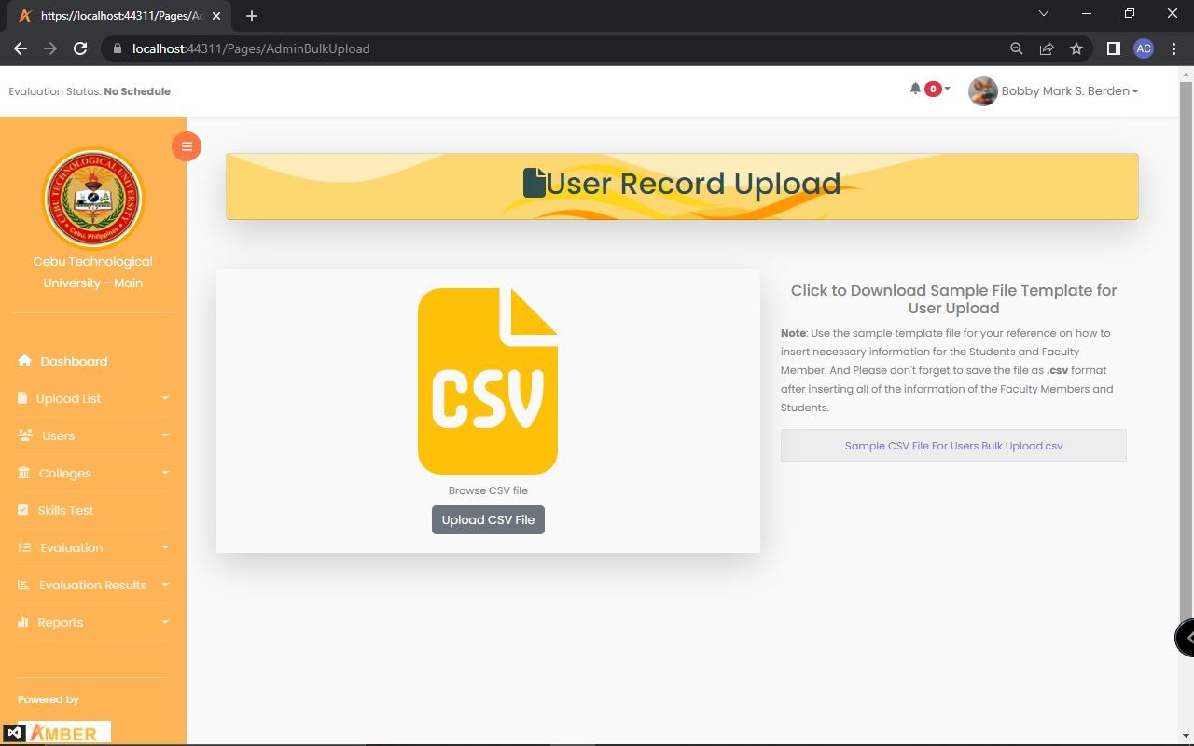

Figure 24: **Bulk Upload of Users Record**

Figure 24 is the uploading a file that contains the user’s information. The file should be in csv.

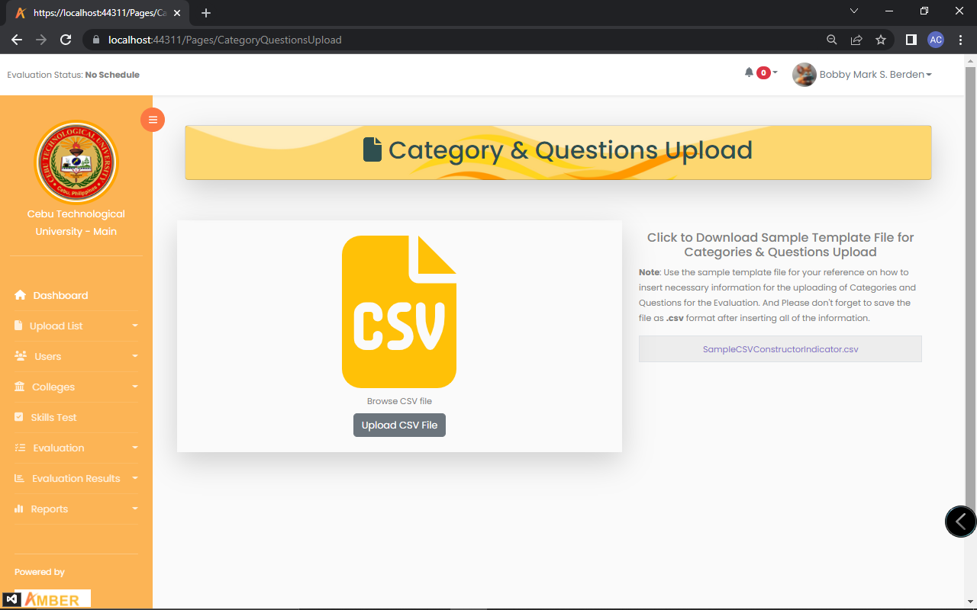

Figure 25: **Bulk Upload of Categories and Questions**

Figure 25 is the uploading of csv file. The file that contains the categories and Questions.

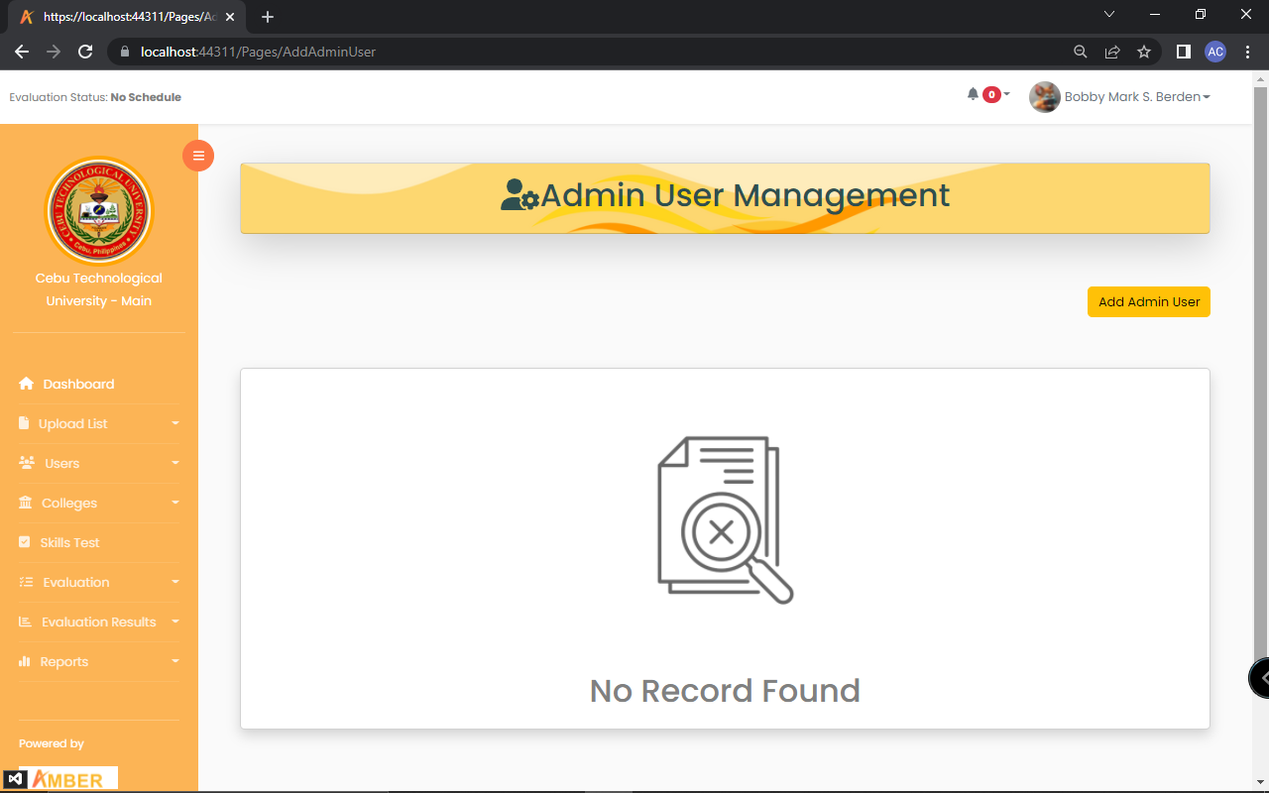

Figure 26: **Add School Admin**

Figure 26 is where to manage the school admin. In here you can add, edit and delete an admin.

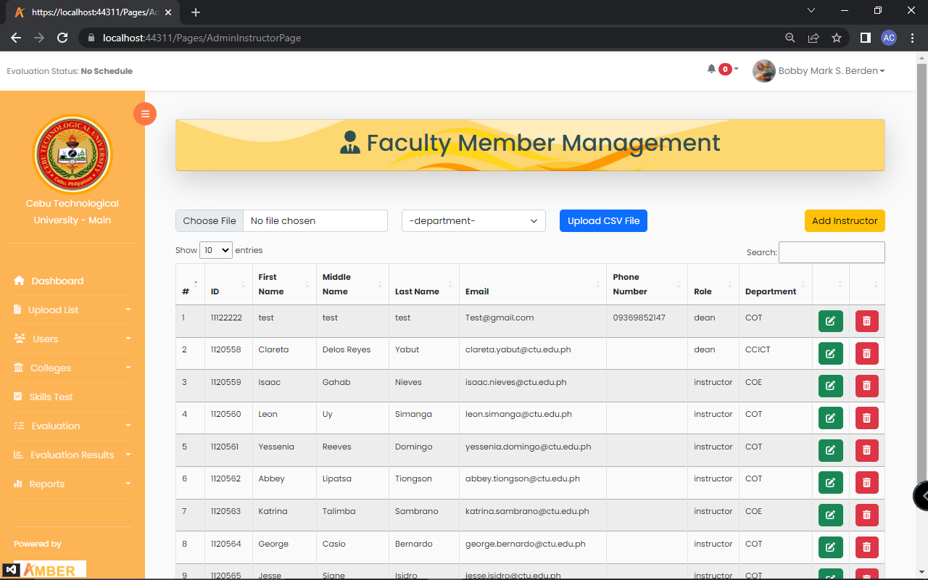

Figure 27: **Manage Faculty Member**

In figure 27 is the manage faculty. This is where the admin can upload csv file containing the faculty’s details. The admin can also add, edit, delete a faculty.

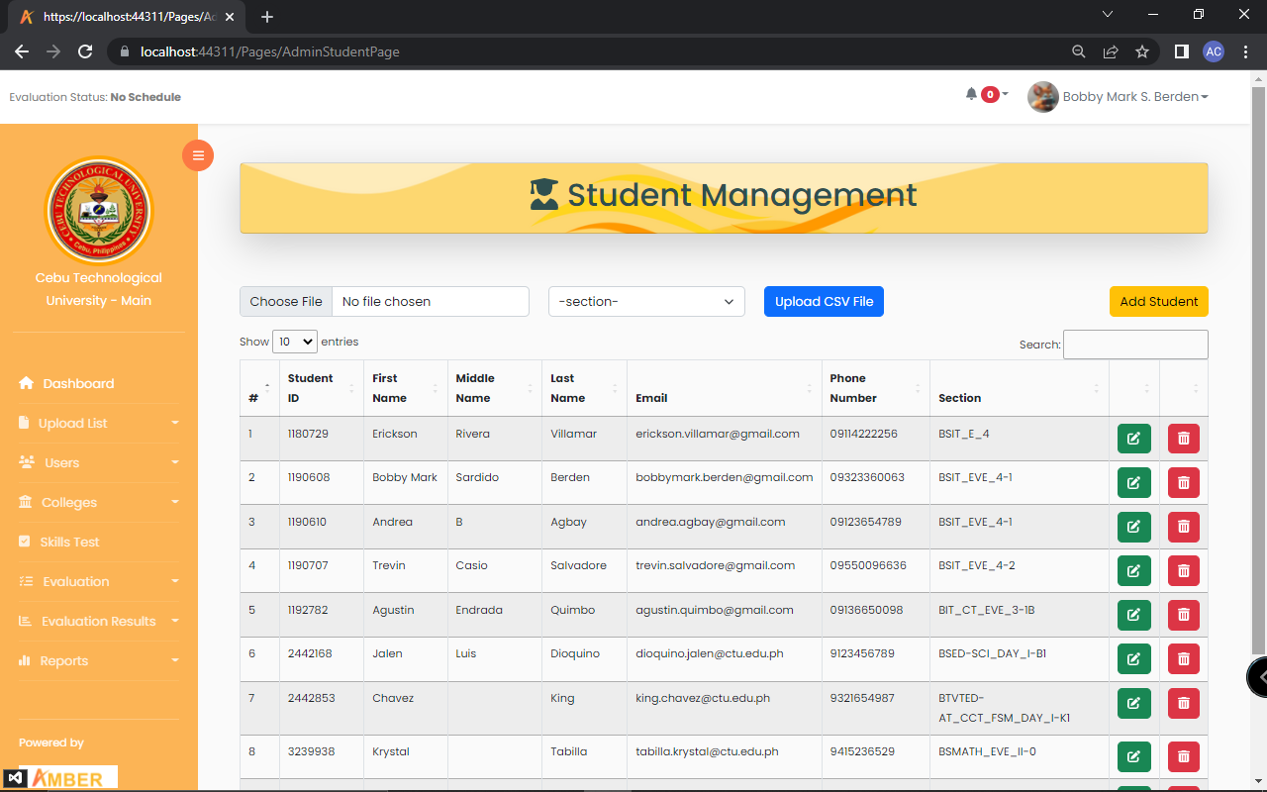

Figure 28: **Manage Student**

In figure 28 is the manage students. This is where the admin can upload csv file containing the student’s details. The admin can also add, edit, delete a student.

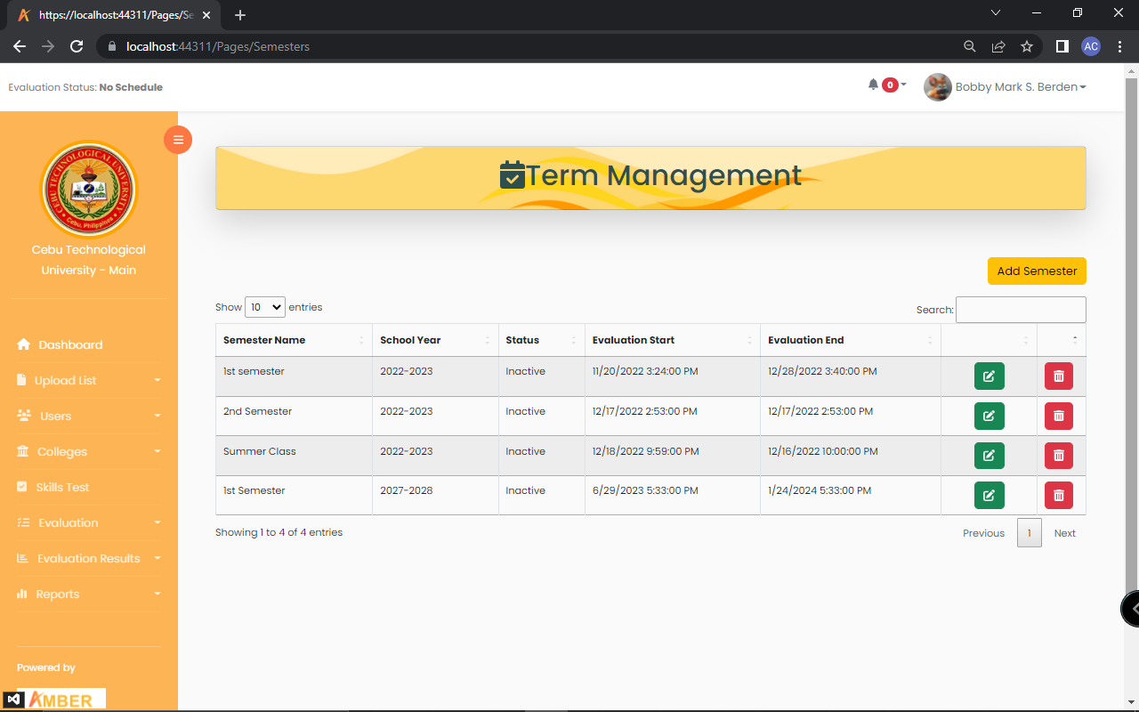

Figure 29: **Manage Term**

In figure 29 is the manage term. This is where the admin can add, edit, delete and search a term.

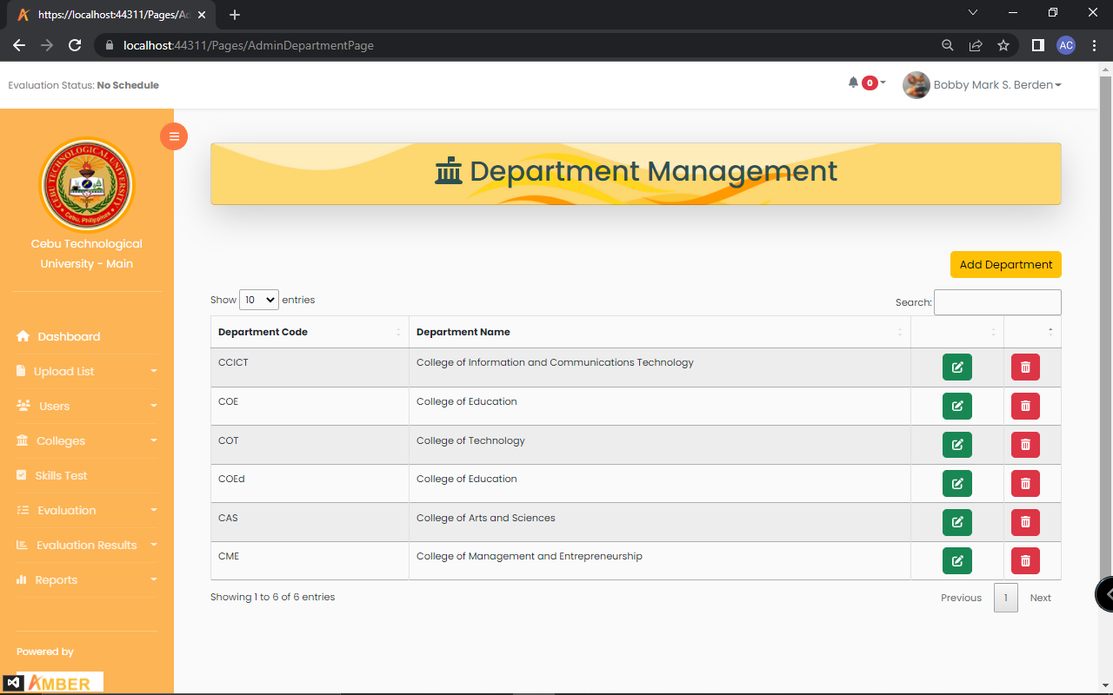

Figure 30: **Manage Department**

In figure 30 is the manage department. This is where the admin can add, edit, delete and search a department.

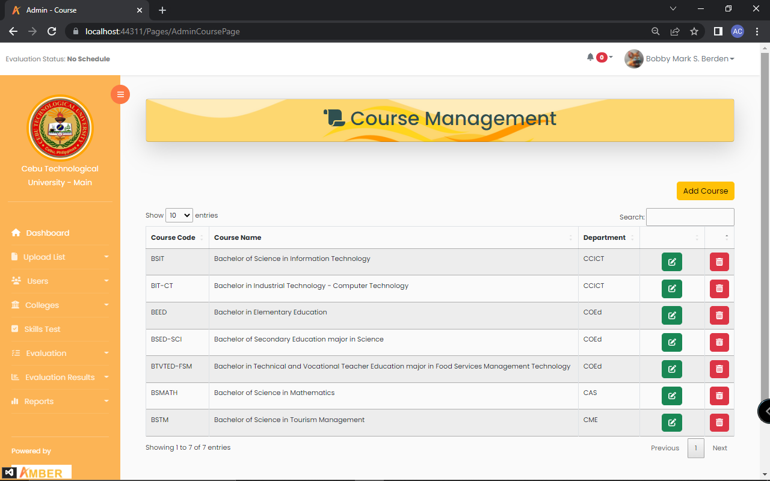

Figure 31: **Manage Course**

In figure 31 is the manage course. This is where the admin can add, edit, delete and search a course.

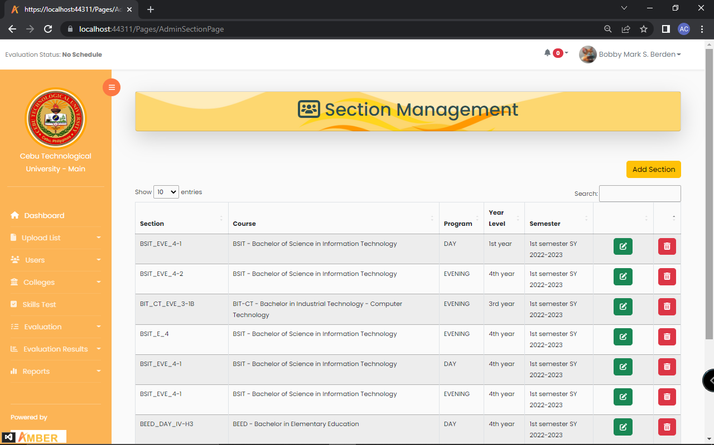

Figure 32: **Manage Section**

In figure 32 is the manage section. This is where the admin can add, edit, delete and search a section.

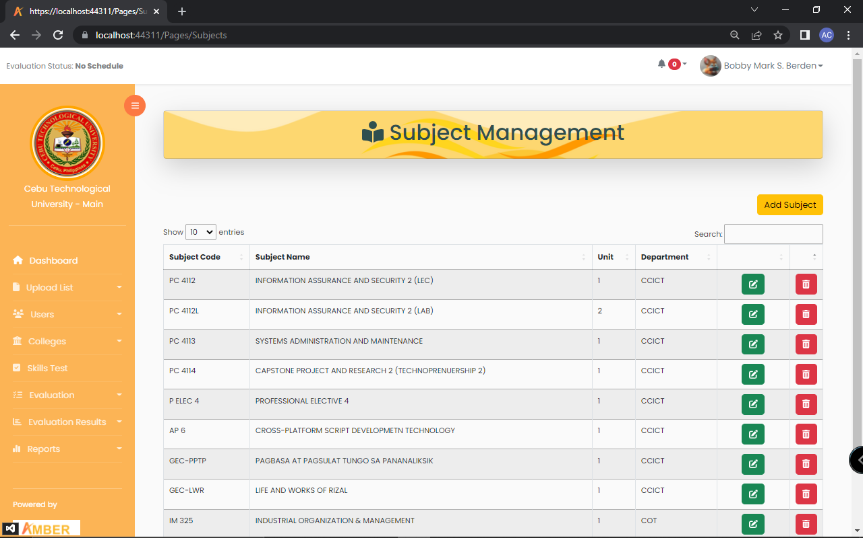

Figure 33: **Manage Subject**

In figure 33 is the manage subjects. This is where the admin can add, edit, delete and search a subject.

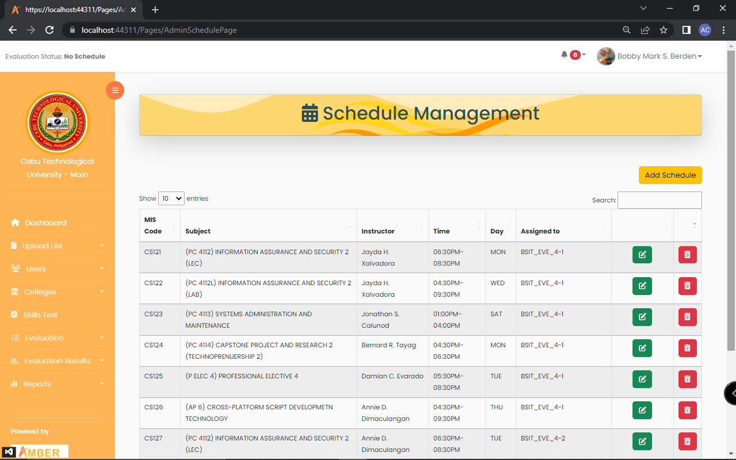

Figure 34: **Manage Schedule**

In figure 34 is the manage schedule. This is where the admin can add, edit, delete and search a schedule.



Figure 35: **Manage Evaluation Schedule**

In figure 35 is the evaluation schedule. This is where the admin can activate the evaluation form and setting the starting date and ending date of the evaluation.

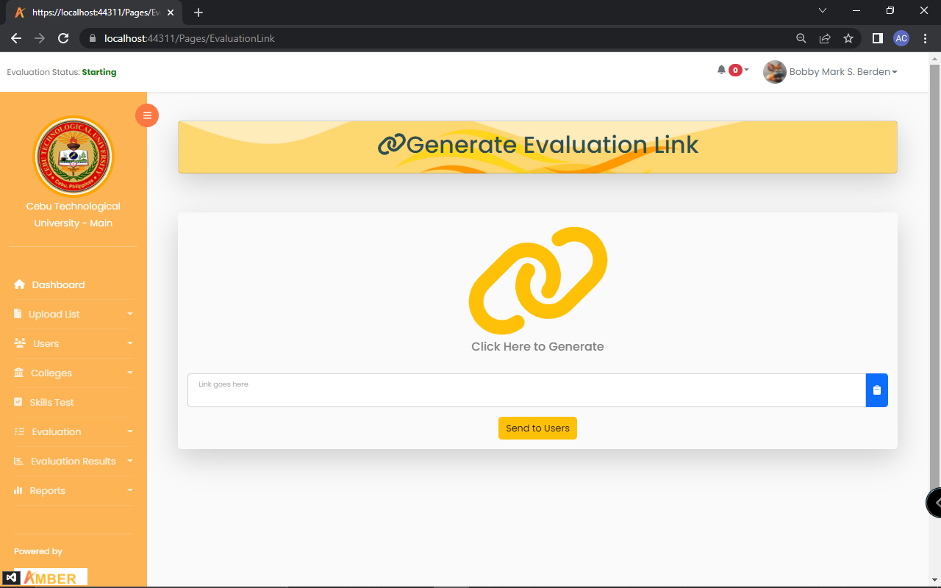

Figure 36: **Generate Link**

In figure 36 is the generate evaluation link. This is where the admin can send the link to users by clicking the link icon button.

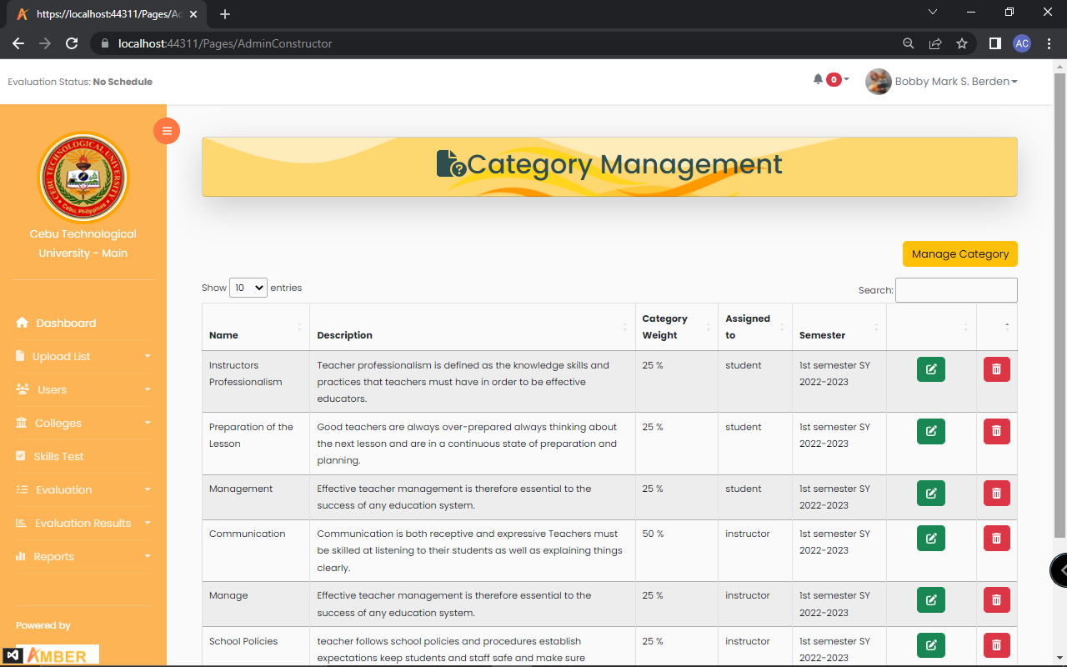

Figure 37: **Manage Categories**

In figure 37 is the manage category. This is where the admin can add, edit, delete and search a category for evaluation form.

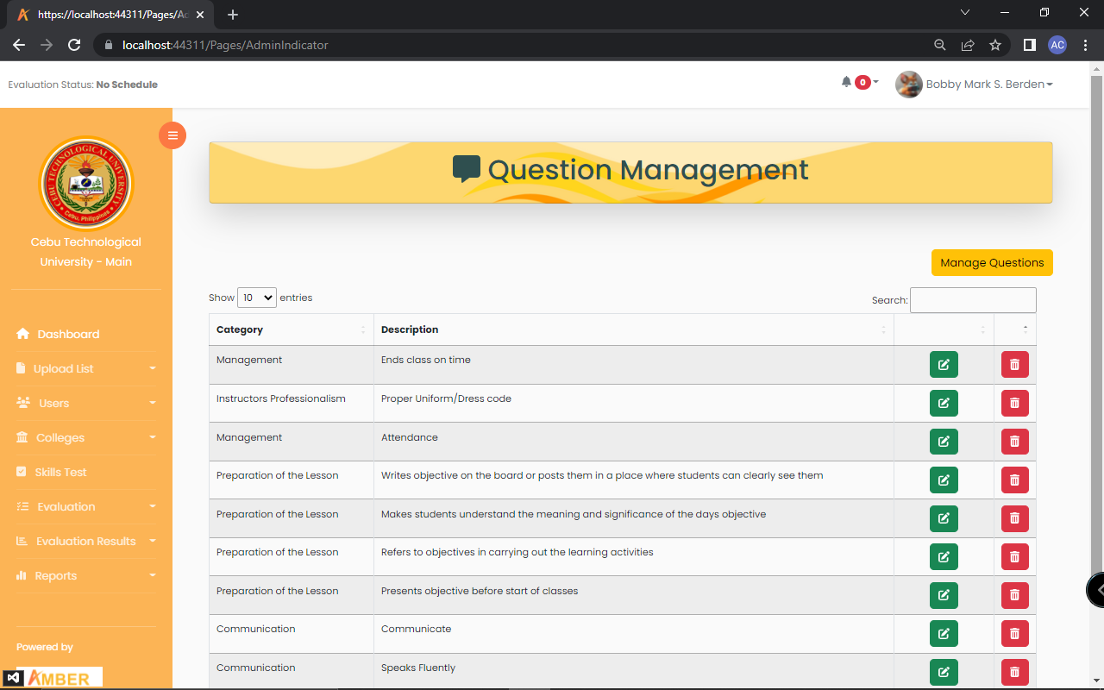

Figure 38: **Manage Question**

In figure 38 is the manage questions. This is where the admin can add, edit, delete and search a question for evaluation form.

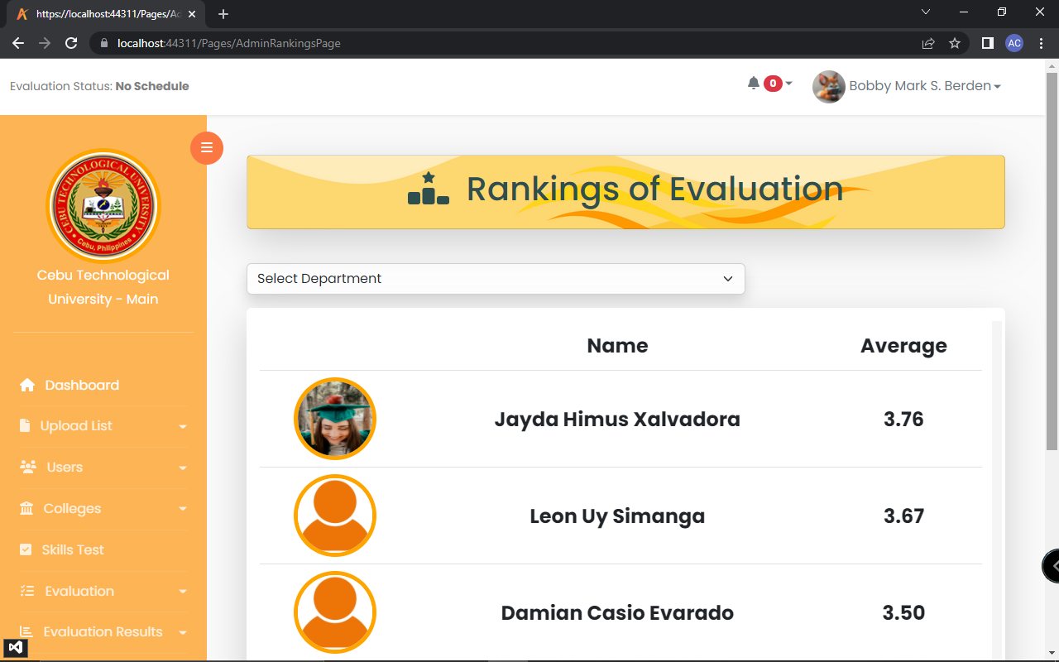

Figure 39: **Rankings**

In figure 39 is the rankings. This is where the admin can view the ranks of the instructors.

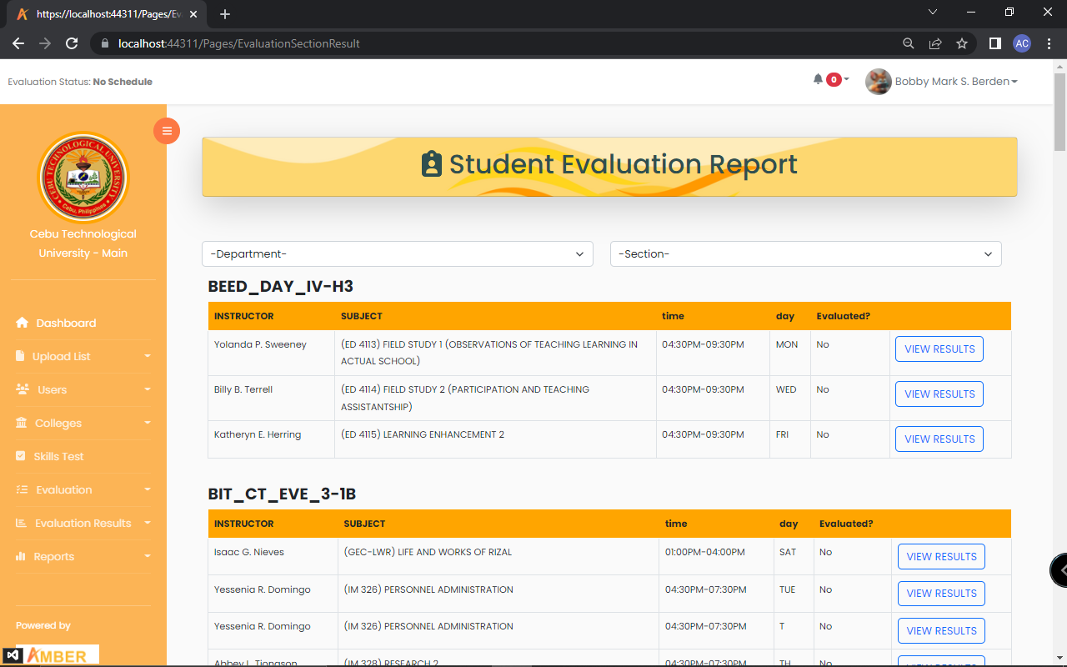

Figure 40: **Student to Instructor Evaluation Report**

In figure 40 is the evaluation result. This is where the admin can view list of results of the evaluation form

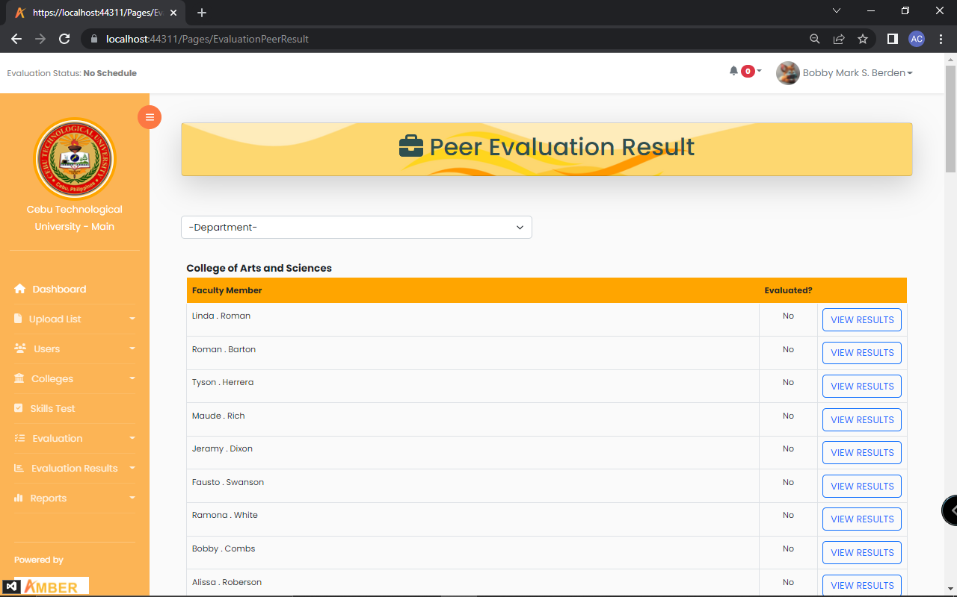

Figure 41: **Peer Evaluation**

In figure 41 is the peer evaluation result. This is where the admin can view list of results of the evaluation form.

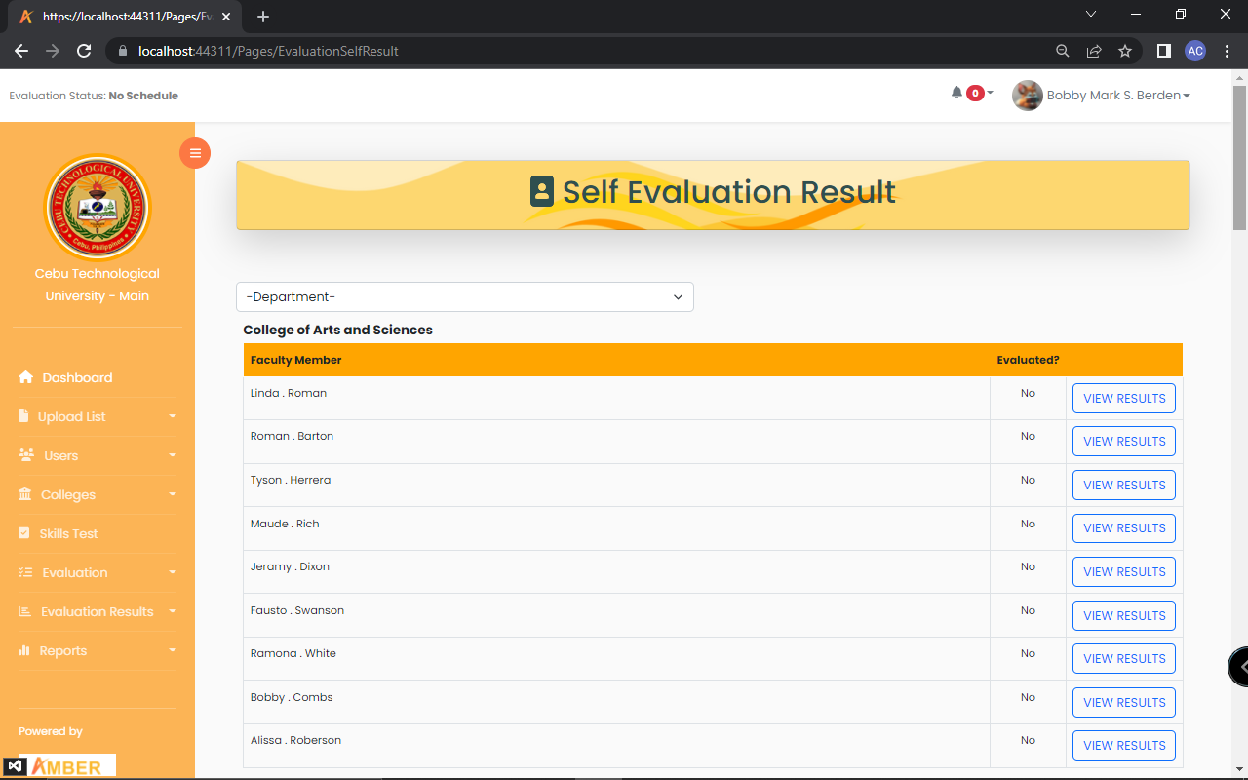

Figure 42: **Self-Evaluation Report**

In figure 42 is the self-evaluation result. This is where the admin can view list of results of the self-evaluation form.

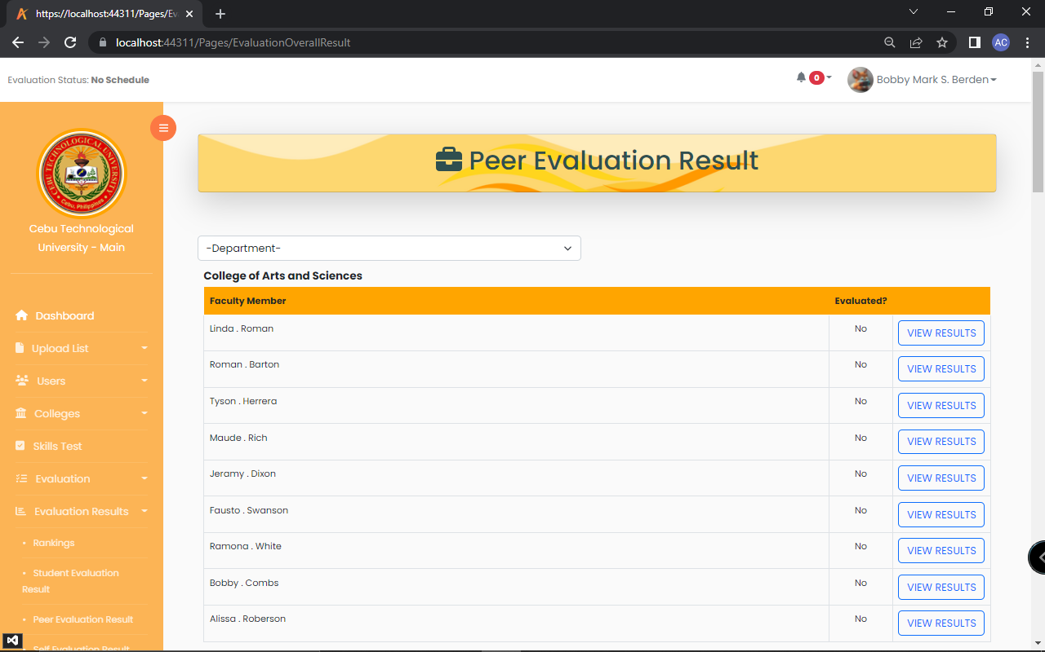

Figure 43: **Overall Evaluation Report**

In figure 43 is the overall evaluation result. This is where the admin can view list of results of the overall evaluation.

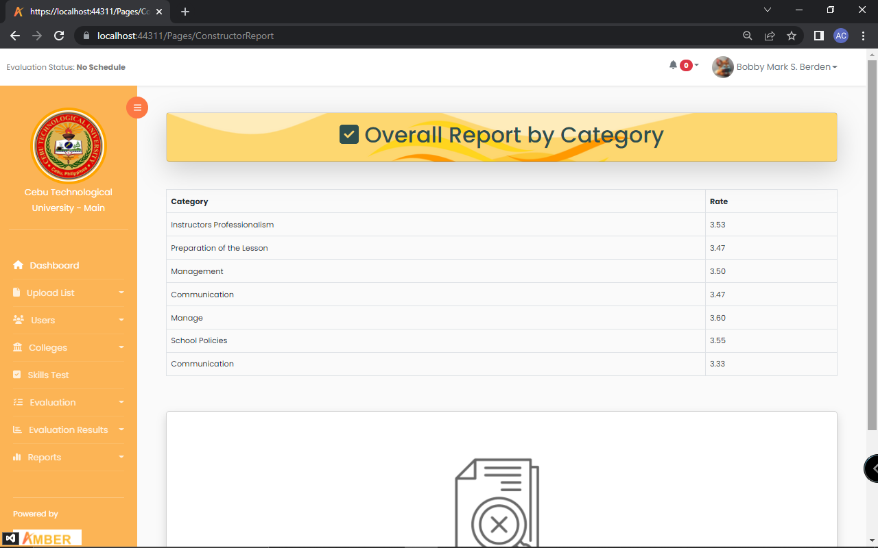

Figure 44: **Overall Report by Category**

In figure 44 is the overall report by category. This is where the admin can view the overall report by category.

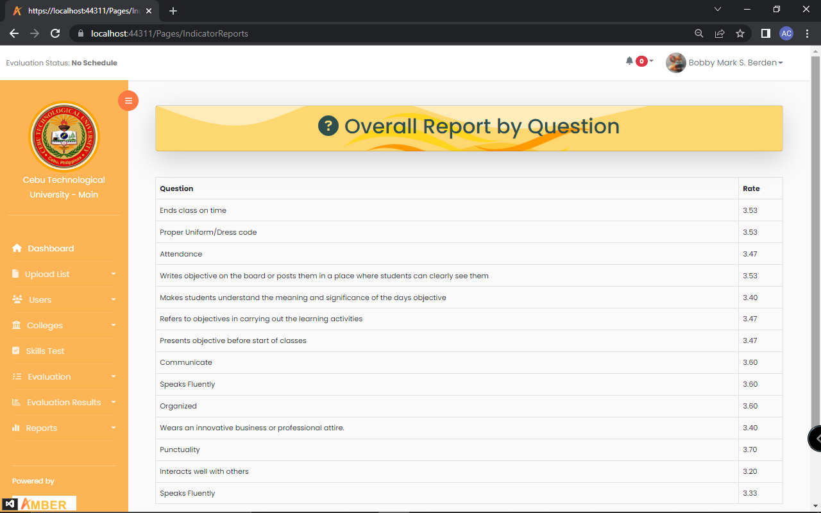

Figure 45: **Overall Report by Question**

In figure 45 is the overall report by question. This is where the admin can view the overall report by question

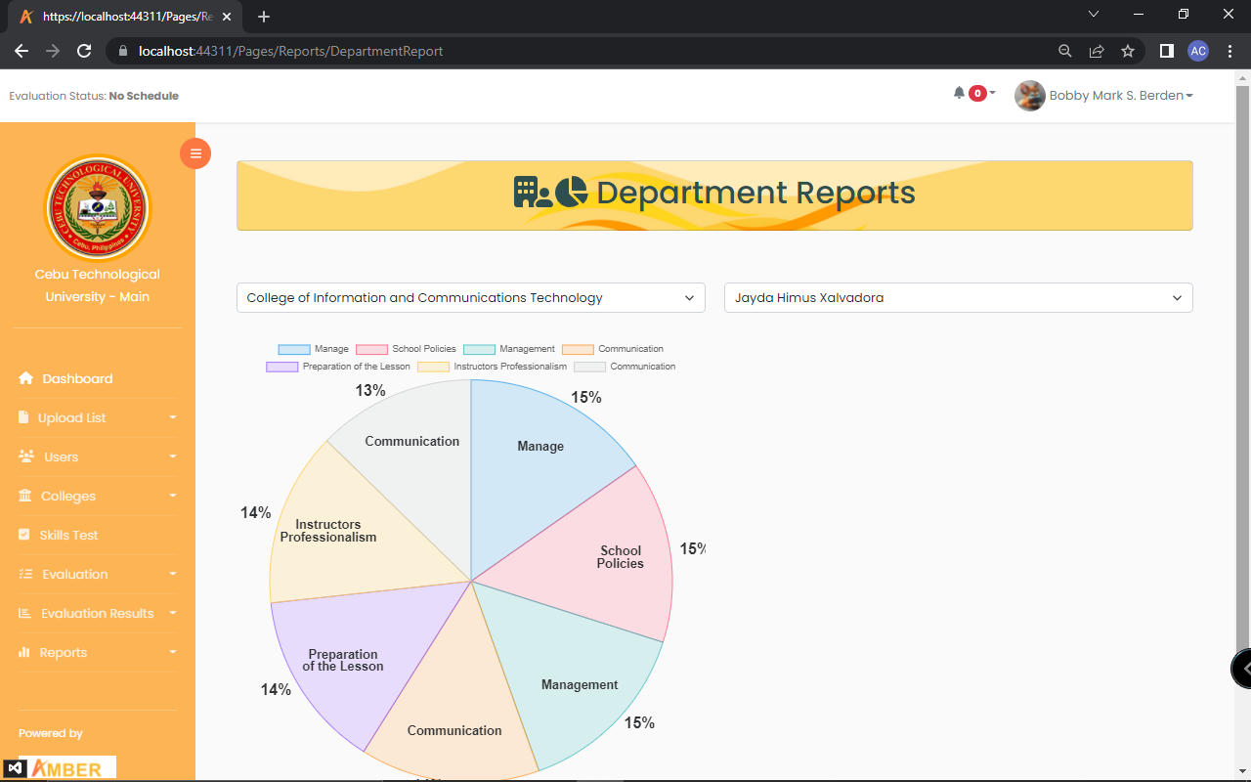

Figure 46: **Reports by Department**

In figure 46 is the reports by department. In here the admin can view the department’s report in pie chart form.

**Student**

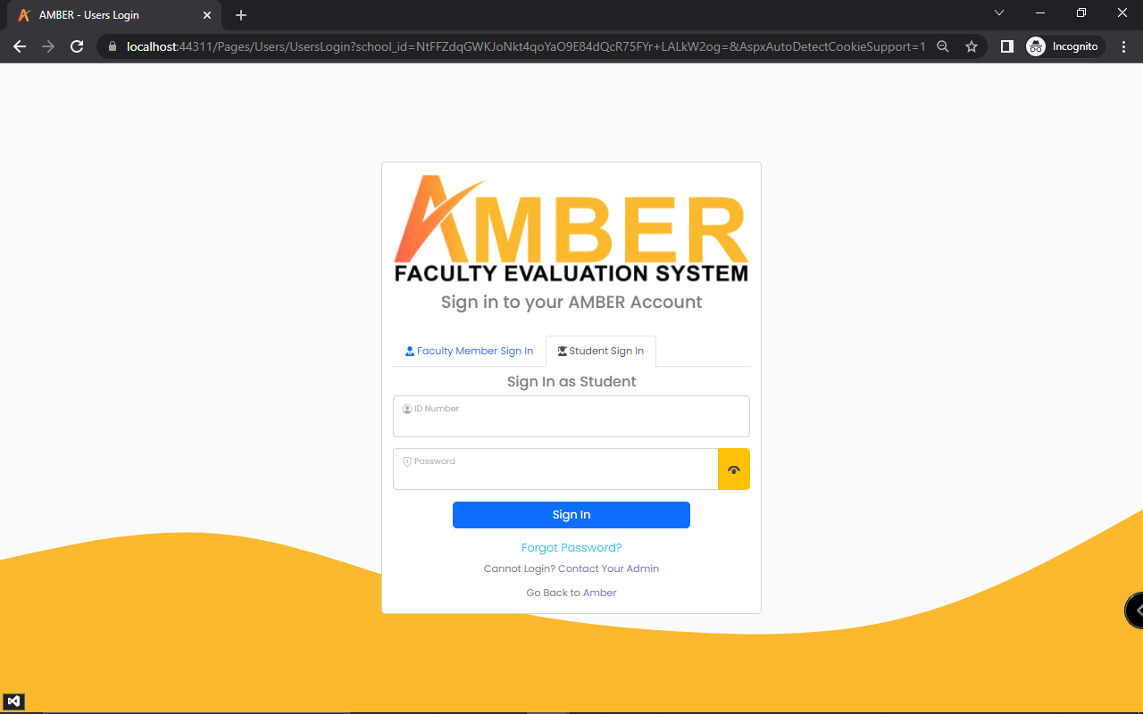

Figure 47: **Student Login**

In figure 47 is the student’s login. This is where the student input their login details to access the system.

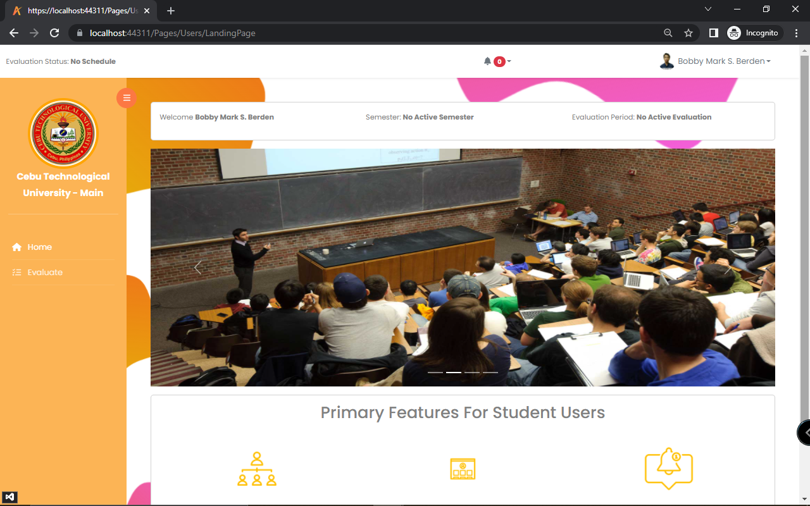

Figure 48: **Student Landing Page**

In figure 48 is the students landing page. This is where they will be directed after they login.

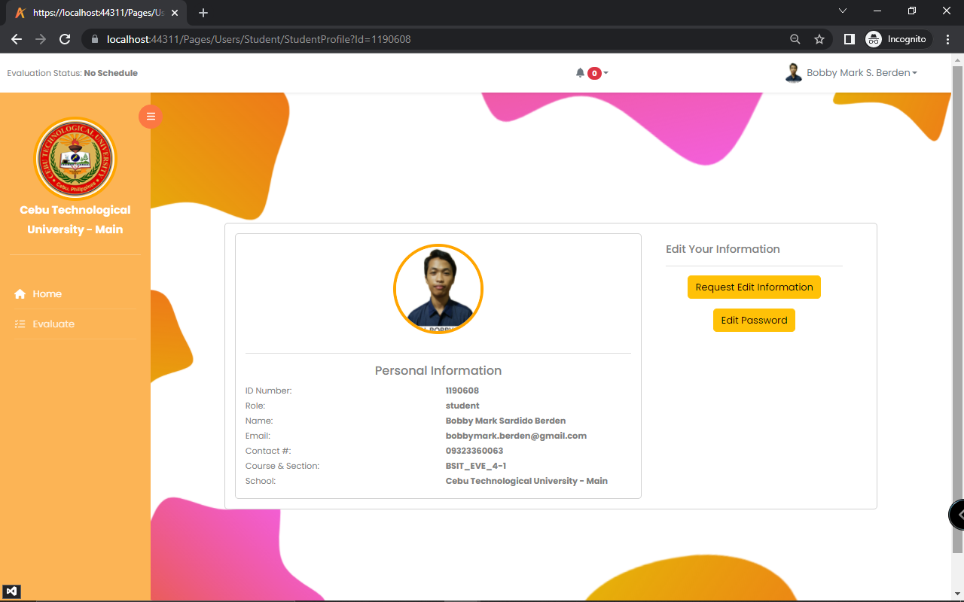

Figure 49: **Student Profile**

In figure 49 is the student’s profile. This is where the student can view its information and can request edit on it.

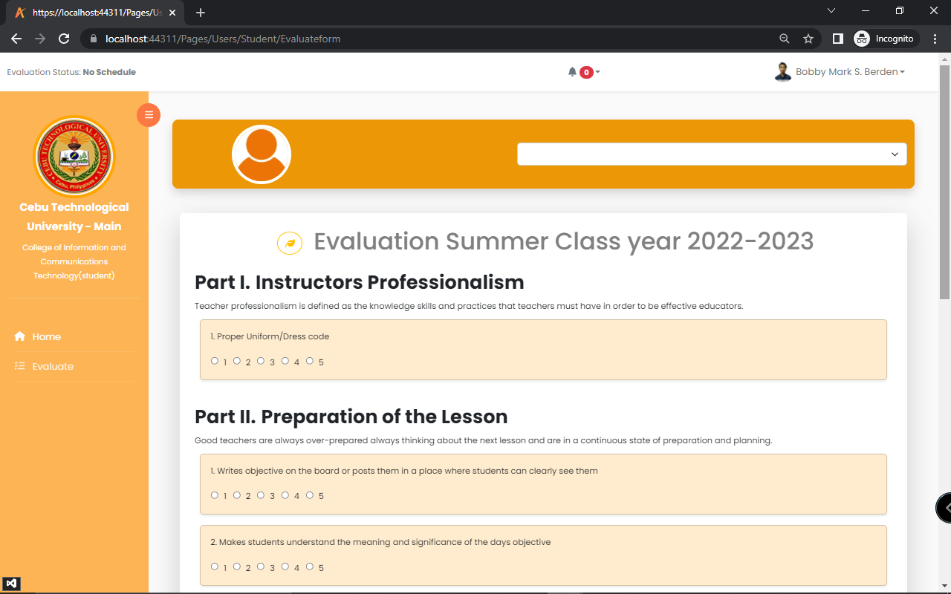

Figure 50: **Student to Instructor Evaluation**

In figure 50 is student to instructor evaluation. This is where the student evaluates their instructor.

**Dean**

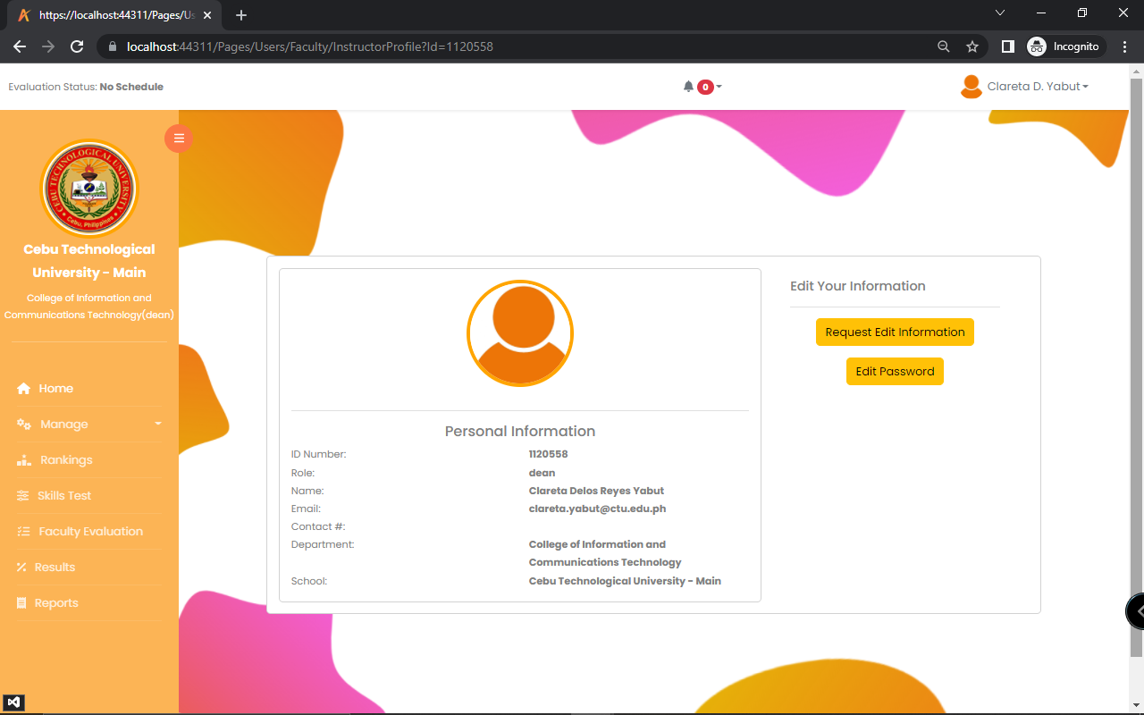

Figure 51: **Dean’s Profile**

In figure 51 is dean’s profile. This is where the dean can view its information and request edit on it.

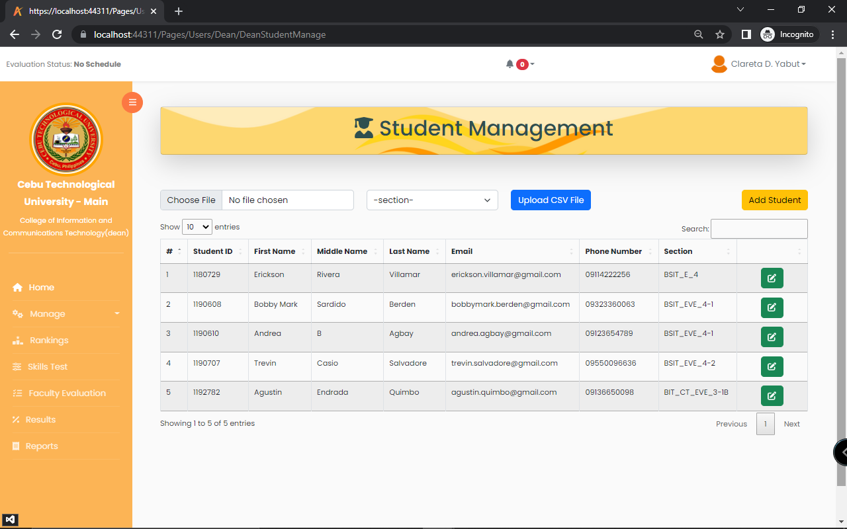

Figure 52: **Student Management**

In figure 52 is the student management. This is where the dean can add, edit and delete a student information.

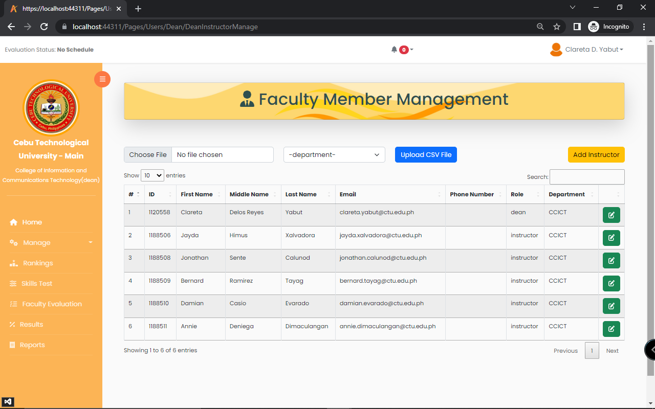

Figure 53: **Faculty Member Management**

In figure 53 is the faculty member management. This is where the dean can add, edit and delete a faculty member.

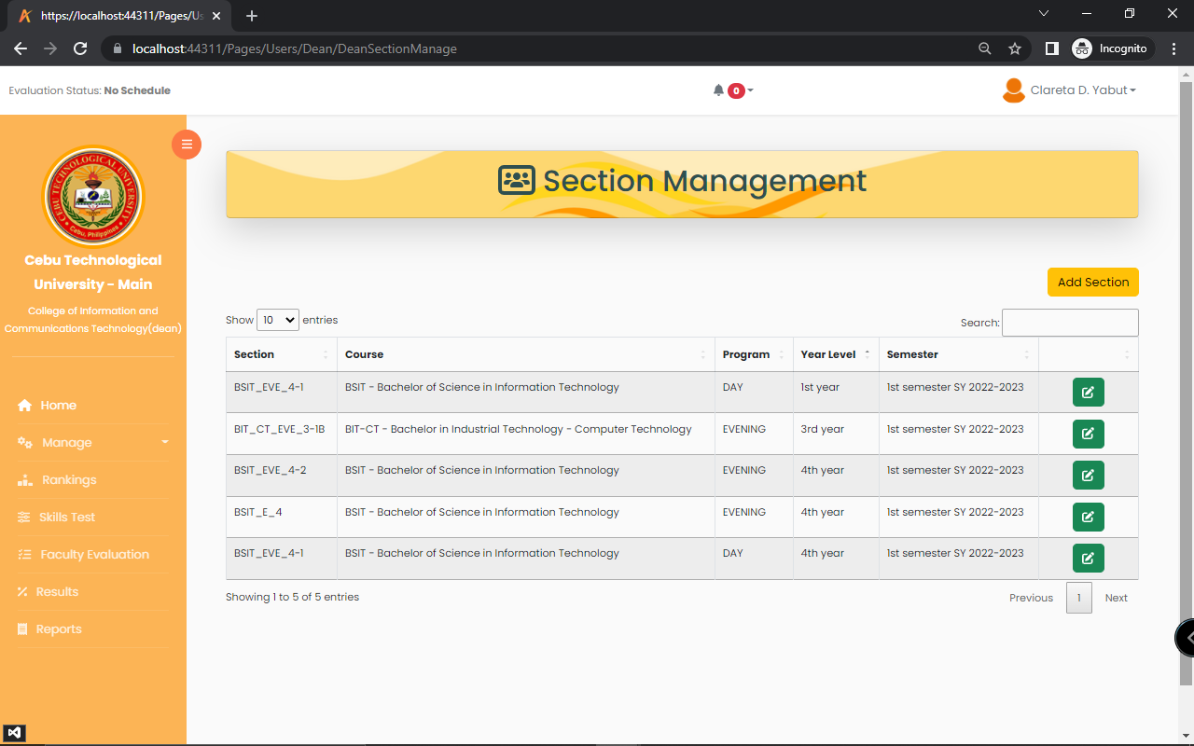

Figure 54: **Section Management**

In figure 54 is the section management. This is where the dean can add, edit, and delete a section.

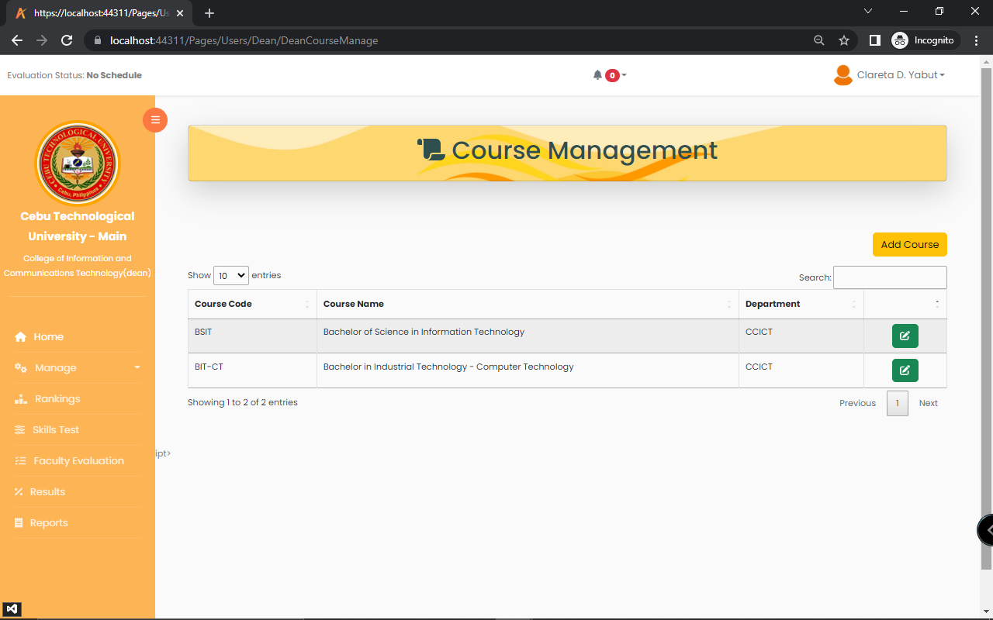

Figure 55: **Course Management**

In figure 55 is the course management. This is where the dean can manage the course.

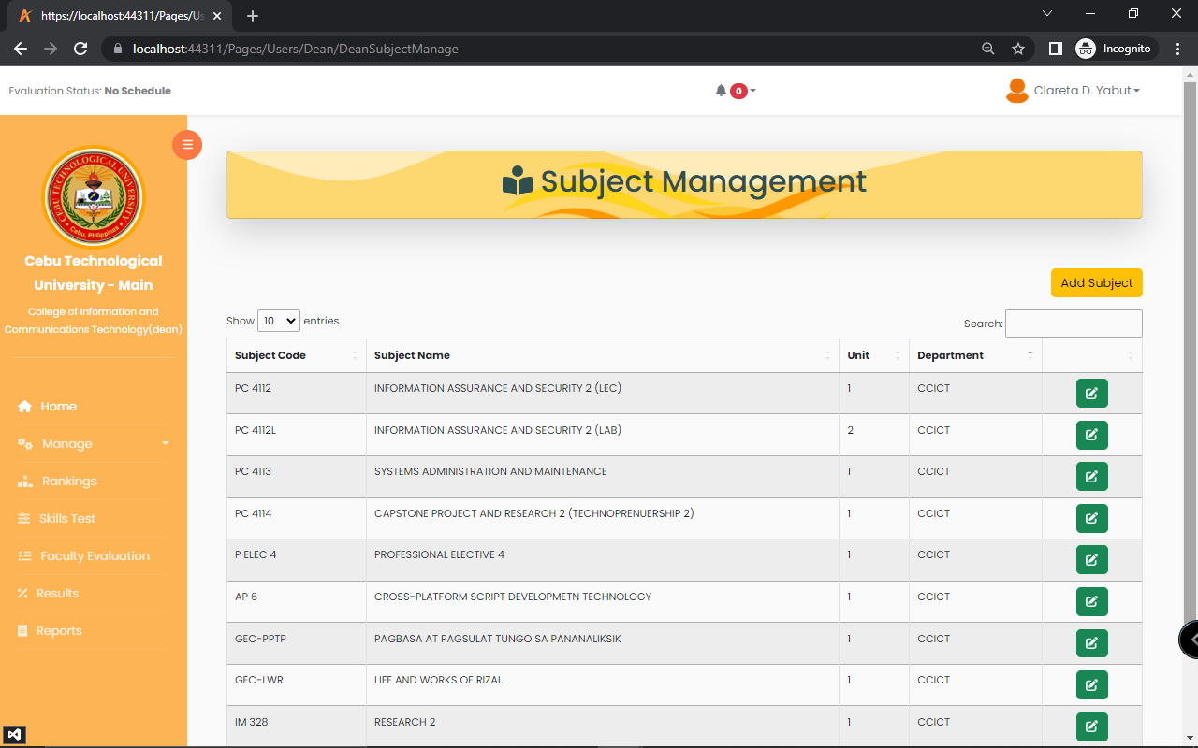

Figure 56: **Subject Management**

In figure 56 is the subject management. This is where the dean manages the subject.

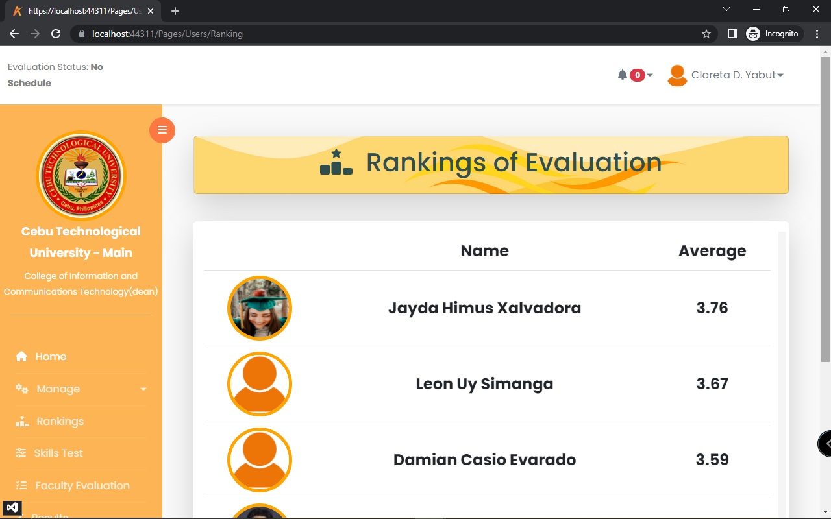

Figure 57: **Evaluation Ranking**

In figure 57 is the ranking. This is where the dean can view the ranks of the instructor.

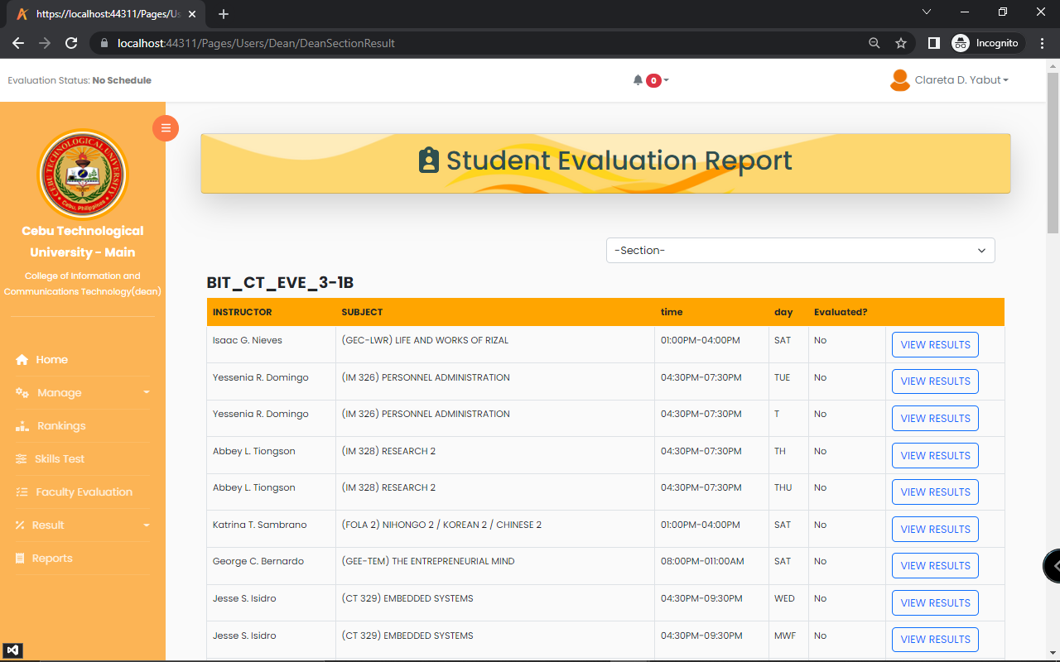

Figure 58: **Student Evaluation Report**

In figure 58 is the student evaluation report. This is where the dean can view, if the instructor of that subject has been evaluated.

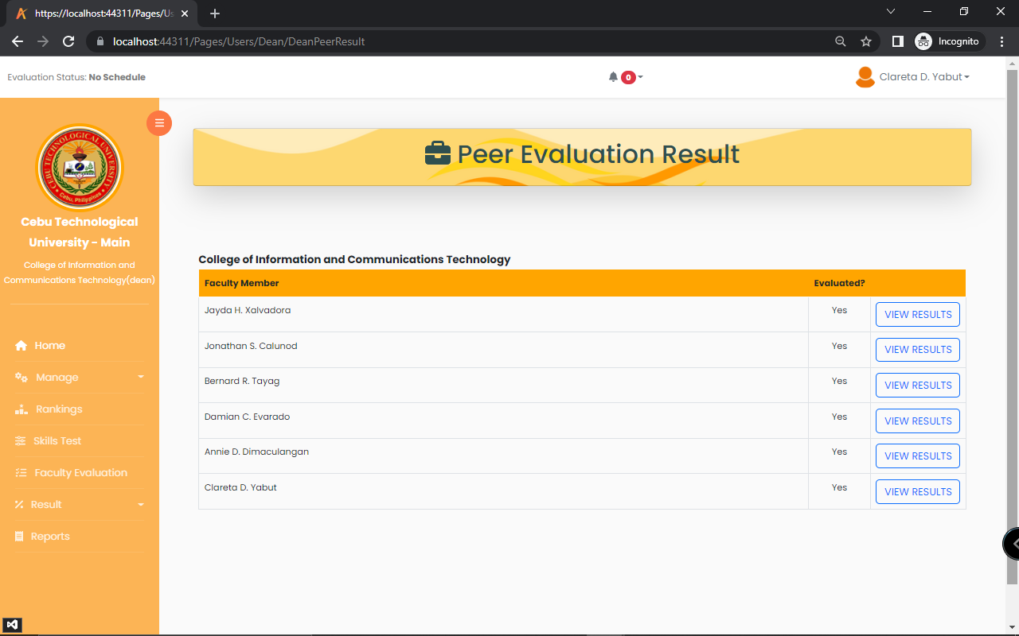

Figure 59: **Peer Evaluation Result**

In figure 59 is the peer evaluation result. This is where the admin can view the evaluation result of the instructor.

**Instructor**

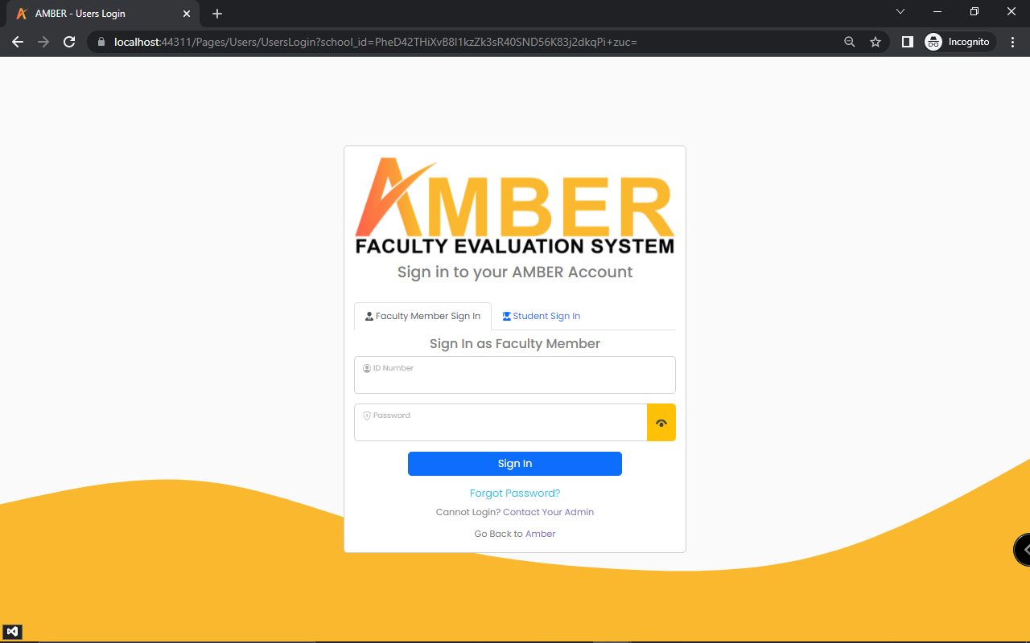

Figure 60: **Instructor Login Page**

In figure 60 is the faculty member’s login page. This is where the instructor’s login their account details to access the system.

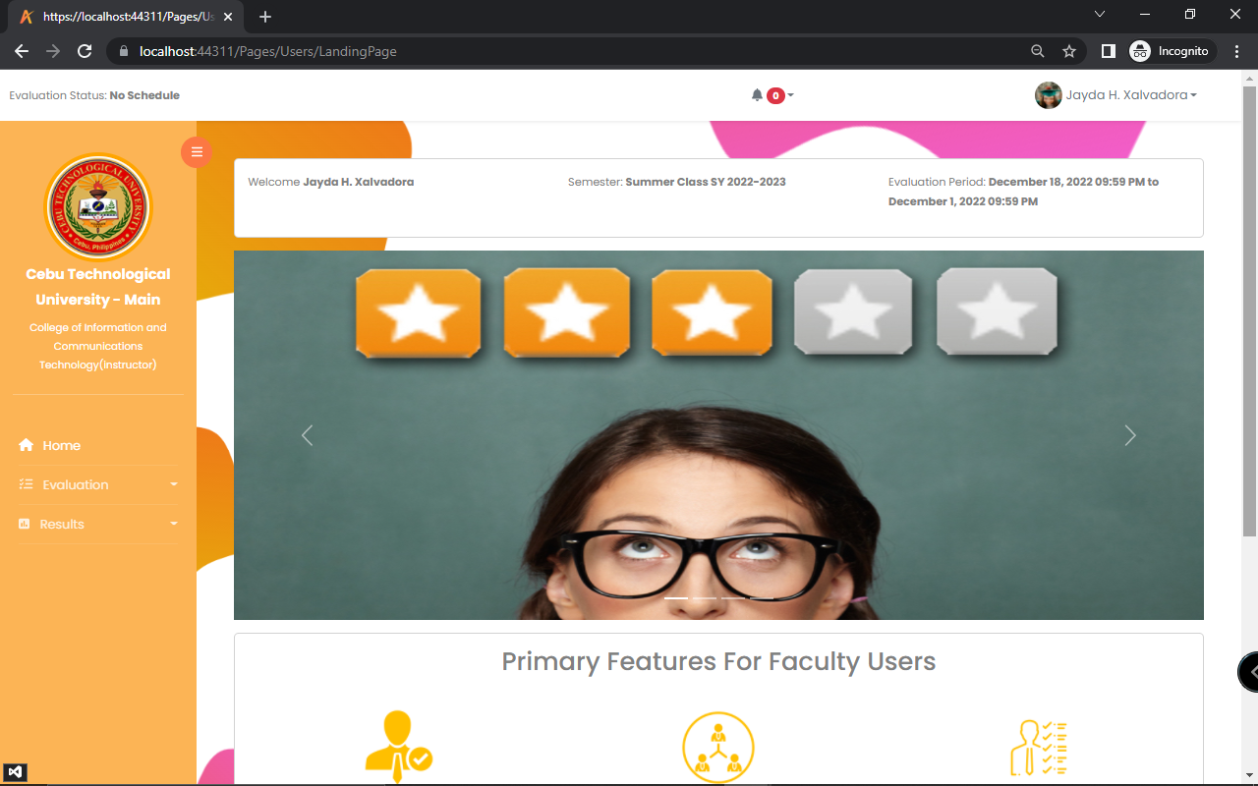

Figure 61: **Instructor Landing Page**

In figure 61 is the instructor landing page. This is where the instructors will be directed after logging in.

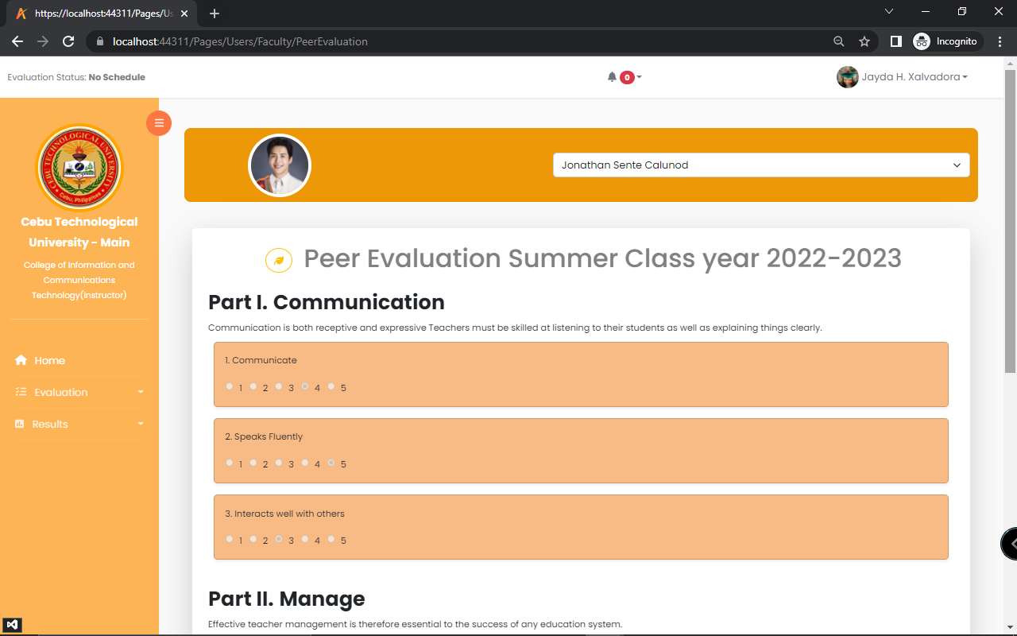

Figure 62: **Peer Evaluation**

In figure 62 is the peer evaluation. This is where the faculty members evaluate its peer.

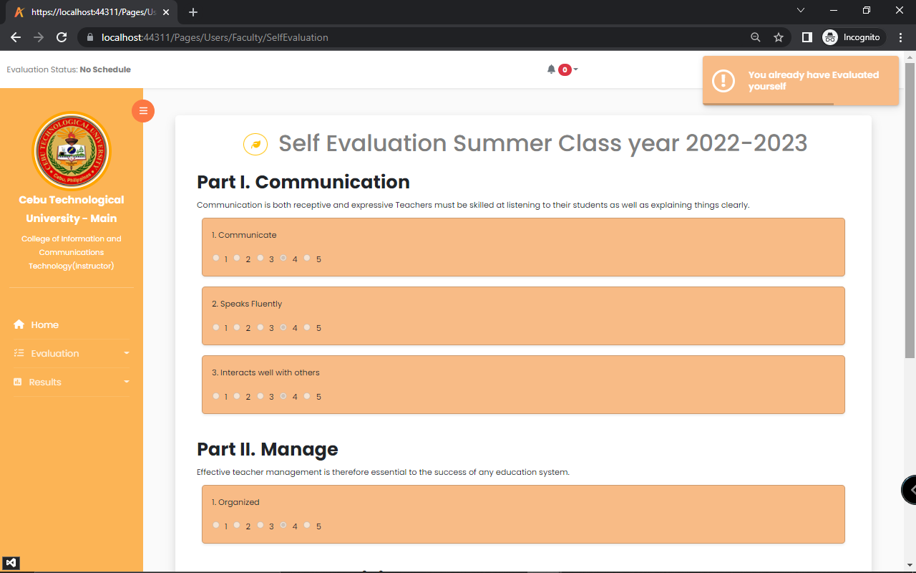

Figure 63: **Self-Evaluation**

In figure 63 is the self-evaluation. This is where the instructor evaluates itself.

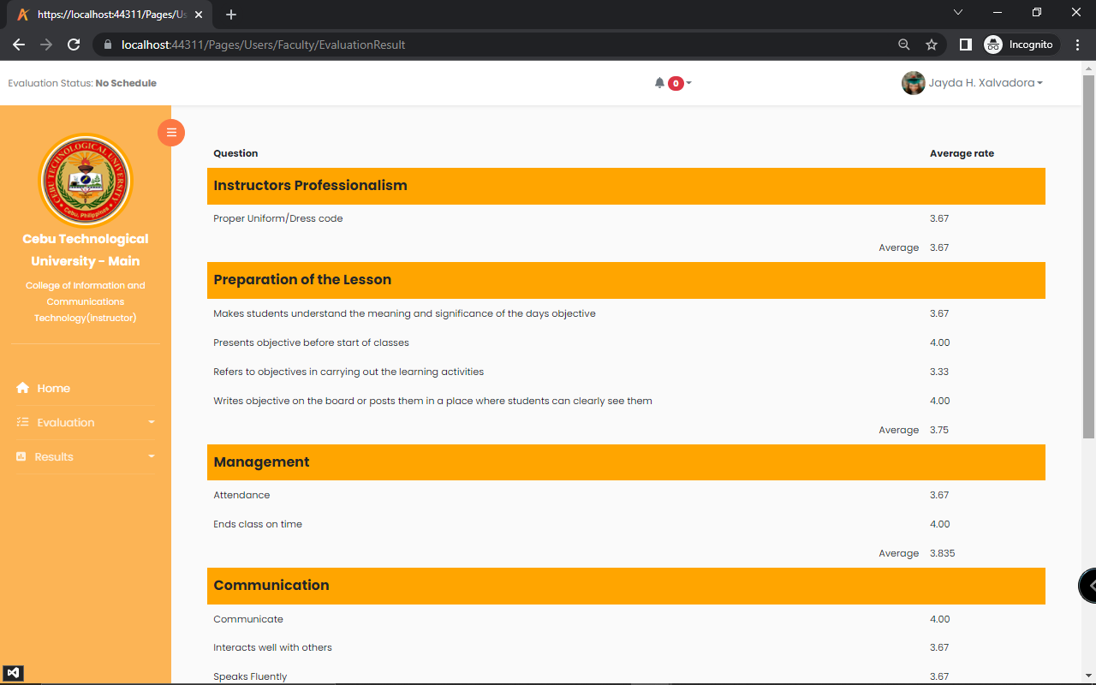

Figure 64: **Evaluation Result**

In figure 64 is the evaluation result. This is where the instructor views its result from the evaluation.

**Database Design**

**Entity Relationship Diagram**

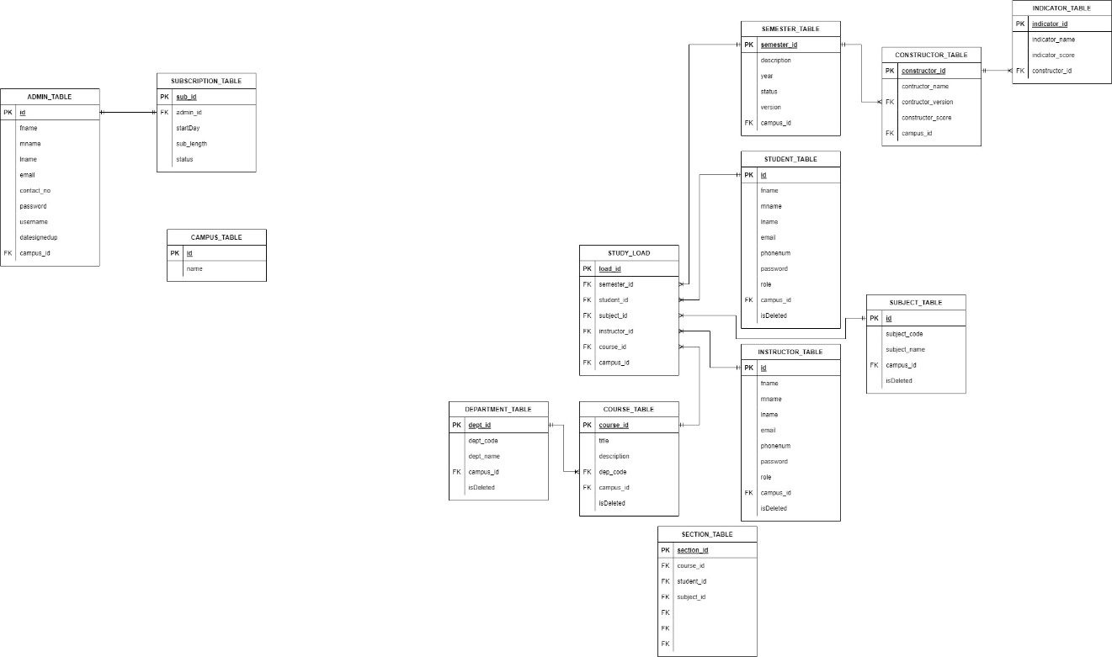

Figure 65: **Entity Relationship Diagram**

In figure 65 represents the Database design of the system. This is the Entity Relationship Diagram that is composed of the tables that are necessarily related to each other. The ERD is composed of the following tables; evaluation table, evaluator table, faculty table, student table, instructor table, course, subject, study load, semester table, constructor, indicator table, choice and skills test table. These tables are the building blocks of the database design of the system.

**Data Dictionary**

**Table 2**

**Admin**

|  |  |  |  |  |
| --- | --- | --- | --- | --- |
| **Field** | **Data Type** | **Length** | **Allow Nulls** | **Description** |
| Id | nvarchar | 50 | False | An auto increment Id, the primary key of the table |
| Fname | nvarchar | 50 | False | First name of the admin |
| Mname | nvarchar | 50 | False | Middle name of the admin |
| Lname | nvarchar | 50 | False | Last name of the admin |
| Email | nvarchar | 50 | False | Email of the admin |
| contact_no | nvarchar | 50 | False | Contact number of the admin |
| school_id | int | 8 | False | An auto generated school id where the admin works |
| Position | nvarchar | MAX | False | Job position of the admin |
| Role | nvarchar | 50 | False | Role of the user which is admin |
| Password | nvarchar | 50 | False | Password of the admin |
| Username | nvarchar | 50 | False | Username of the admin |
| Datesignedup | nvarchar | 50 | False | Date when the admin signed up |
| verify_code | int | 8 | True | Verification code of the account |
| forgot_otp | int | 8 | True | For forgot password |
| isVerified | bit | 2 | True | If the account is already verified |
| profile_picture | varbinary | MAX | True | Profile picture of the admin |
| lock_status | bit | 2 | True | If the account is locked |
| Lockdatetime | datetime | 23 | True | Date and time of the locked account |

**Table 3**

**Constructor**

|  |  |  |  |  |
| --- | --- | --- | --- | --- |
| **Field** | **Data Type** | **Length** | **Allow Nulls** | **Description** |
| constructor_id | int | 8 | False | Auto increment constructor id, also the primary key of the table |
| constructor_name | nvarchar | MAX | False | Name of the category |
| semester_id | int | 8 | False | What semester is the category added |
| Weight | int | 8 | True | Score percentage of the constructor |
| Description | nvarchar | MAX | True | Description of the category |
| Role | nvarchar | 50 | True | For whom the categories are |
| school_id | int | 8 | False | The auto generated school id |
| isDeleted | datetime | 23 | True | If the category is deleted |

**Table 4**

**Course**

|  |  |  |  |  |
| --- | --- | --- | --- | --- |
| **Field** | **Data Type** | **Length** | **Allow Nulls** | **Description** |
| course_id | int | 8 | False | Id of the course, also the primary key of the table |
| Title | nvarchar | 50 | False | Abbreviation of the course name |
| description | nvarchar | MAX | False | Complete course name |
| dept_id | int | 8 | False | Department Id of the course |
| school_id | int | 8 | False | School Id of the course |
| isDeleted | datetime | 23 | Yes | If the course is deleted |

**Table 5**

**Department**

|  |  |  |  |  |
| --- | --- | --- | --- | --- |
| **Field** | **Data Type** | **Length** | **Allow Nulls** | **Description** |
| dept_Id | int | 8 | False | Auto increment department id, the primary key of the table |
| dept_code | nvarchar | 50 | False | Abbreviation of the department name |
| dept_name | nvarchar | MAX | False | Complete name of the department |
| school_id | int | 8 | False | School id of the department |
| isDeleted | datetime | 23 | Yes | If the department is deleted |

**Table 6**

**Evaluation**

|  |  |  |  |  |
| --- | --- | --- | --- | --- |
| **Field** | **Data Type** | **Length** | **Allow Nulls** | **Description** |
| eval_id | int | 8 | False | Auto increment evaluation id. The primary key of the table |
| evaluator_id | int | 8 | False | Evaluator’s Id, the one who evaluates |
| evaluatee_id | int | 8 | False | Evaluatees Id, the one who evaluated |
| indicator_id | int | 8 | False | Category’s Id for evaluation |
| rate | int | 8 | False | Question’s Id for evaluation |
| dept_id | int | 8 | True | Ratings in the Evaluation |
| comment | nvarchar | MAX | True | Department Id of the evaluator |
| datetime_eval | datetime | 23 | False | Comment of the evaluator |
| school_id | int | 8 | No | School id of the evaluator |

**Table 7**

**Files**

|  |  |  |  |  |
| --- | --- | --- | --- | --- |
| **Field** | **Data Type** | **Length** | **Allow Nulls** | **Description** |
| Id | int | 8 | False | The primary key of the table |
| file_name | nvarchar | MAX | False | File name of the uploaded file |
| content_type | nvarchar | MAX | False | Content type of the file uploaded |
| data | varbinary | MAX | False | Data inside the uploaded file |

**Table 8**

**Indicator**

|  |  |  |  |  |
| --- | --- | --- | --- | --- |
| **Field** | **Data Type** | **Length** | **Allow Nulls** | **Description** |
| indicator_Id | int | 8 | False | Id of the question, primary key of the table |
| indicator_name | nvarchar | MAX | False | Name of the question |
| constructor_id | int | 8 | False | Id of the category |
| school_id | nvarchar | 50 | False | Id of the school |
| isDeleted | datetime | 23 | True | If the question is deleted |

**Table 9**

**Instructor**

|  |  |  |  |  |
| --- | --- | --- | --- | --- |
| **Field** | **Data Type** | **Length** | **Allow Nulls** | **Description** |
| Id | int | 8 | False | Primary key of the table |
| ins_id | nvarchar | 50 | False | Id of the instructor |
| Lname | nvarchar | 50 | False | Last name of the instructor |
| Fname | nvarchar | 50 | False | First name of the instructor |
| Mname | nvarchar | 50 | False | Middle name of the instructor |
| Email | nvarchar | 50 | False | Email of the instructor |
| Phonenum | nvarchar | 50 | False | Phone number of the instructor |
| Password | nvarchar | 50 | False | Password of the instructor |
| Role | nvarchar | 50 | False | Role of the instructor |
| school_id | int | 8 | False | Id of the school |
| dept_id | int | 8 | True | Id of the department |
| isDeleted | datetime | 23 | True | If the instructor is deleted |
| forgot_otp | int | 8 | True | For forgot password |
| verify_code | int | 8 | True | Verification code |
| isVerified | bit | 2 | True | If the account is verified |
| profile_picture | varbinary | MAX | True | Profile picture of the instructor |
| lock_status | bit | 2 | True | If the account was locked |
| Lockdatetime | datetime | 23 | True | Date time of the locked account |

**Table 10**

**Notification**

|  |  |  |  |  |
| --- | --- | --- | --- | --- |
| **Field** | **Data Type** | **Length** | **Allow Nulls** | **Description** |
| Id | int | 8 | False | Id of the notifications and primary key of the table |
| message | nvarchar | MAX | False | Message in notification |
| isRead | bit | 2 | True | First name of the sender |
| DateTimeSent | datetime | 23 | True | Middle name of the sender |
| first_name | nvarchar | 50 | True | Last name of the sender |
| middle_name | nvarchar | 50 | True | Id of the sender |
| last_name | nvarchar | 50 | True | Role of the sender |
| user_id | nvarchar | 50 | False | Email of the sender |
| user_role | nvarchar | 50 | False | School id of the sender |
| user_email | nvarchar | 50 | True | Id of the notifications and primary key of the table |
| school_id | int | 8 | False | Message in notification |

**Table 11**

**Schedule**

|  |  |  |  |  |
| --- | --- | --- | --- | --- |
| **Field** | **Data Type** | **Length** | **Allow Nulls** | **Description** |
| sched_Id | int | 8 | False | Id of the schedule and primary key of the table |
| sched_code | nvarchar | 50 | False | Code of the schedule |
| subject_id | int | 8 | False | Id of the subject |
| instructor_id | int | 8 | False | Id of the instructor |
| time | nvarchar | 50 | False | Unit of the subject |
| day | nvarchar | 50 | False | Time schedule of the of the subject |
| section_id | int | 8 | False | Day schedule of the subject |
| school_id | int | 8 | False | Id of the section |
| isDeleted | datetime | 23 | True | Id of the school |

**Table 12**

**School List**

|  |  |  |  |  |
| --- | --- | --- | --- | --- |
| **Field** | **Data Type** | **Length** | **Allow Nulls** | **Description** |
| Id | int | 8 | False | Id of the school and primary key of the table |
| school_name | nvarchar | MAX | False | Name of the school |

**Table 13**

**School**

|  |  |  |  |  |
| --- | --- | --- | --- | --- |
| **Field** | **Data Type** | **Length** | **Allow Nulls** | **Description** |
| Id | int | 8 | False | Id of the school and primary key of the table |
| school_name | nvarchar | MAX | False | Name of the section |
| school_phone | nvarchar | 50 | False | Id of the course |
| address | nvarchar | MAX | False | Id of the semester |
| school_type | nvarchar | 50 | False | Id of the school |
| school_picture | varbinary | MAX | False | If the section is deleted |

**Table 14**

**Section**

|  |  |  |  |  |
| --- | --- | --- | --- | --- |
| **Field** | **Data Type** | **Length** | **Allow Nulls** | **Description** |
| section_id | int | 8 | False | Id of the section and primary key of the table |
| section_name | nvarchar | 50 | False | Name of the section |
| program | int | 8 | False | Id of the course |
| yearLevel | nvarchar | 50 | False | Id of the semester |
| course_id | int | 8 | False | Id of the school |
| semester_id | int | 8 | False | If the section is deleted |
| school_id | int | 8 | False | Id of the section and primary key of the table |
| isDeleted | datetime | 23 | True | Name of the section |

**Table 15**

**Semester**

|  |  |  |  |  |
| --- | --- | --- | --- | --- |
| **Field** | **Data Type** | **Length** | **Allow Nulls** | **Description** |
| semester_id | int | 8 | False | Id of the semester and primary key of the table |
| Description | nvarchar | 50 | False | Description of the semester |
| Year | nvarchar | 50 | False | Year of the semester |
| Status | nvarchar | 50 | True | Status of the semester |
| Version | nvarchar | 10 | False | Version of the Semester |
| evaluationStart | datetime | 23 | True | Evaluation start |
| evaluationEnd | datetime | 23 | True | Evaluation end |
| school_id | int | 8 | False | Id of the school |
| isDeleted | datetime | 23 | True | If the semester is deleted |

**Table 16**

**Skill Test**

|  |  |  |  |  |
| --- | --- | --- | --- | --- |
| **Field** | **Data Type** | **Length** | **Allow Nulls** | **Description** |
| Id | int | 8 | False | Id of the skill test and primary key of the table |
| dean_id | int | 8 | False | Id of the dean |
| ins_id | int | 8 | False | Id of the instructor |
| message | nvarchar | MAX | False | Message of the skill test |
| dept_id | int | 8 | False | Id of the department |
| school_id | int | 8 | False | Id of the school |
| file_name | nvarchar | MAX | True | Name of the file uploaded |
| content_type | nvarchar | MAX | True | Content type of the file |
| date | varbinary | MAX | True | Date of the skill test |

**Table 17**

**Student**

|  |  |  |  |  |
| --- | --- | --- | --- | --- |
| **Field** | **Data Type** | **Length** | **Allow Nulls** | **Description** |
| Id | int | 8 | False | Primary key of the table |
| stud_id | nvarchar | 50 | False | Id of the student |
| Lname | nvarchar | 50 | False | Last name of the student |
| Fname | nvarchar | 50 | False | First name of the student |
| Mname | nvarchar | 50 | False | Middle name of the student |
| Email | nvarchar | 50 | False | Email of the student |
| Phonenum | nvarchar | 50 | False | Phone number of the student |
| Password | nvarchar | 50 | False | Password of the student |
| Role | nvarchar | 50 | False | Role of the student |
| section_id | int | 8 | False | Id of the section |
| school_id | int | 8 | False | Id of the school |
| isDeleted | datetime | 23 | True | If the student is deleted |
| forgot_otp | int | 8 | True | If the password is forgotten |
| verify_code | int | 8 | True | Account verification code |
| isVerified | bit | 2 | True | If the account is verified |
| profile_picture | varbinary | MAX | True | Profile picture of the student |
| lock_status | bit | 2 | True | Lock status of the account |
| Lockdatetime | datetime | 23 | True | Date and time of the locked status |

**Table 18**

**Subject**

|  |  |  |  |  |
| --- | --- | --- | --- | --- |
| **Field** | **Data Type** | **Length** | **Allow Nulls** | **Description** |
| subject_Id | int | 8 | False | Id of the subject and primary key of the table |
| subject_code | nvarchar | 50 | False | Code of the subject |
| subject_name | nvarchar | MAX | False | Name of the subject |
| unit | nvarchar | 10 | False | Unit of the subject |
| dept_id | int | 8 | True | Is of the department |
| school_id | int | 8 | False | School id of the subject |
| isDeleted | datetime | 23 | True | If the subject is deleted |

**Table 19**

**Subscription**

|  |  |  |  |  |
| --- | --- | --- | --- | --- |
| **Field** | **Data Type** | **Length** | **Allow Nulls** | **Description** |
| sub_id | int | 8 | False | Id of the subscription and primary key of the table |
| subscription_type | nvarchar | 50 | False | Type of the subscription |
| subscription_plan | nvarchar | 50 | True | School id of the user who subscribed |
| school_id | int | 8 | False | Id of the admin |
| admin_id | nvarchar | 50 | False | Start date of the subscription |
| startDate | datetime | 23 | False | End date of the subscription |
| endDate | datetime | 23 | False | Status of the subscription |
| Status | bit | 2 | False | Id of the subscription and primary key of the table |

**Table 20**

**Super Admin**

|  |  |  |  |  |
| --- | --- | --- | --- | --- |
| **Field** | **Data Type** | **Length** | **Allow Nulls** | **Description** |
| Id | int | 8 | False | Id of the super admin and primary key |
| Username | nvarchar | 50 | False | Username of the super admin |
| Password | nvarchar | 50 | False | Password of the super admin |
| first_name | nvarchar | 50 | False | First name of the super admin |
| middle_name | nvarchar | 50 | False | Middle name of the super admin |
| last_name | nvarchar | 50 | False | Last name of the super admin |
| Email | nvarchar | 50 | False | Email of the super admin |
| contact_no | nvarchar | 50 | False | Contact number of the super admin |
| TFA_code | int | 8 | True |  |
| login_approved | bit | 2 | True | Approval of login |
| profile_picture | varbinary | MAX | True | Profile picture of the super admin |
| lock_status | bit | 2 | True |  |
| lockDateTime | datetime | 23 | True |  |

**Table 21**

**Super Admin Notification**

|  |  |  |  |  |
| --- | --- | --- | --- | --- |
| **Field** | **Data Type** | **Length** | **Allow Nulls** | **Description** |
| Id | int | 8 | False | Id of super admin and primary key of the table |
| message | nvarchar | MAX | False | The message in notification |
| isRead | bit | 2 | True | If the notification has been read |
| dateTimeSent | datetime | 23 | True | The date and time of the sent notification |
| fromName | nvarchar | MAX | True | Name of the sender of the notification |
| fromUserID | nvarchar | 50 | True | Id of the sender of the notification |
| fromUserRole | nvarchar | 50 | True | Role of the sender of the notification |
| school_id | nvarchar | 50 | True | Id of the school |

**Table 22**

**Users Notification**

|  |  |  |  |  |
| --- | --- | --- | --- | --- |
| **Field** | **Data Type** | **Length** | **Allow Nulls** | **Description** |
| Id | int | 8 | False | Id of the notification and primary key of the table |
| message | nvarchar | MAX | False | The message in notification |
| isRead | bit | 2 | True | If the notification has been read |
| DateTimeSent | datetime | 23 | True | The date and time of the sent notification |
| toName | nvarchar | MAX | True | Name of the receiver of the notification |
| fromName | nvarchar | MAX | True | Name of the sender of the notification |
| toUser_id | nvarchar | 50 | True | Id of the receiver |
| fromUser_id | nvarchar | 50 | True | Id of the sender |
| toUser_role | nvarchar | 50 | True | Role of the receiver |
| fromUser_role | nvarchar | 50 | True | Role of the sender |
| school_id | int | 8 | False | Id of the school |

**Network Design**

The TCP/IP (Transmission Control Protocol/Internet Protocol) standard for internet communication will serve as the foundation for the network architecture of the proposed system. A client requests a service from a server in the network using the client-server communication model, which is used by TCP/IP.

**Network Model**

The network of the system follows the design of a three-tier architecture is a client-server architecture in which the functional process logic, data access, computer data storage and user interface are developed and maintained as independent modules on separate platforms. Three-tier architecture allows any one of the three tiers to be upgraded or replaced independently. The user interface is implemented on any platform such as a desktop PC, or laptops as a native application, web app. It uses a standard graphical user interface with different modules running on the application server.

Occupies the top level and displays information related to services commonly available on a web browser or web-based application in the form of a graphical user interface (GUI). It constitutes the front-end layer of the application and the interface with which end-users will interact directly.

The middle tier, logic tier, business logic or logic tier — is pulled from the presentation tier. It controls the application’s core functionality by performing detailed processing and is usually coded in programming languages, such as C#, Java etc.

Data in this tier is kept independent of application servers or business logic, and is managed and accessed with programs, such as MongoDB, Oracle, MySQL, and Microsoft SQL Server.

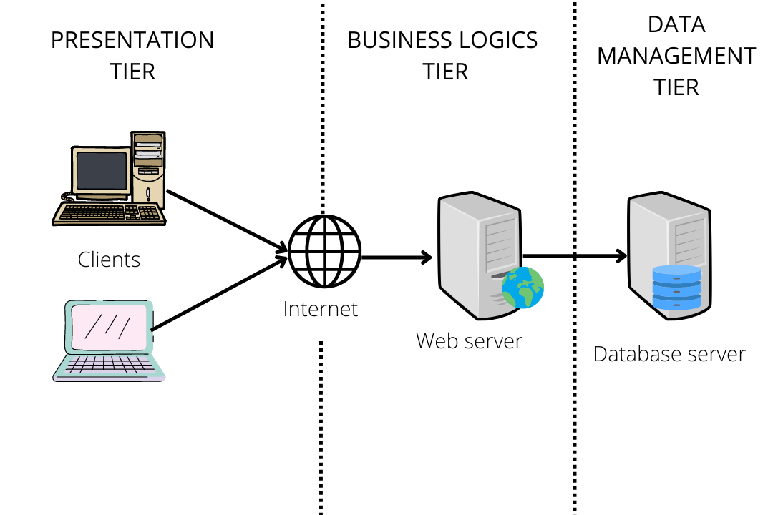

Figure 66: **Network Topology**

Figure 66 illustrates the network topology of the system, you can see the arrangement of the devices starting from the clients which is the computer users that connect to the router which provides them connection to the web cloud and hub to collect data from the server and then back to the clients. The star topology is applied to this system as this system is part of a centralized web server, so when the user prompts and searches for the system., then it will send to the router to fetch data from the web cloud to the hub then to the server and back to the user. The system can only be used when there is an internet connection. As for the network model, the three-tier architecture is applied the same to the network topology, as most of us know, three-tier architecture is a client-server architecture in which the functional process logic, data access, computer data storage and user interface are developed and maintained as independent modules on separate platforms. The computer plays an important role to smoothly access and use the system.

**Development Phase**

**Technology Stack Diagram**

The layers of components or services that make up a technology stack diagram are employed to provide a software solution or application. The figure below shows the required specifications for the users:

**Table 23**

**Technology Stack Diagram**

|  |  |
| --- | --- |
| **Web Development** | **Future Development** |
| ASP.NET  C#  HTML  JavaScript  Jquery  MS SQL | Android Studio  ADT |

**Software Specification**

The system will be developed using a variety of software. In order to implement, the proponents will use the following components as part of the system: ASP.NET, C#, HTML, CSS, JavaScript, JQuery. The proponents will use HTML because it's the most popular. Many web developers utilize this standard markup language while creating websites. For the design and layout, the proponents will use CSS and Bootstrap to develop and layout the web pages. JavaScript is a rapid scripting language and it will be used to enhance other languages because it is simple to learn, implement, and works well with them for the web application's functionality.

The proponents used an integrated development environment (IDE) made by Microsoft that is called Visual Studio Community Edition. It is used to develop computer programs, as well as websites, web apps, web services and mobile apps. Microsoft's software development platforms, including Windows Store, Windows Presentation Foundation, Windows API, and Windows Forms, are used by Visual Studio. Both native and managed code can be generated by it. Visual Studio is a code editor that supports code refactoring and IntelliSense (the code completion feature) is a feature of Visual Studio. Both a source-level debugger and a machine-level debugger can be used with the integrated debugger. A code profiler, designer for creating GUI apps, web designer, class designer, and database schema designer are further built-in tools. It accepts plug-ins that increase functionality at almost every level, such as adding support for source control programs (such as Subversion and Git) and new toolkits, such as editors and visual designers for programming languages with specialized functions, or toolkits for different stages of the software development lifecycle (like the Azure DevOps client: Team Explorer). The figure below shows the software specifications for the web application development:

**Table 24**

**Software Specification in System Development**

|  |  |
| --- | --- |
| Language | ASP.NET, HTML, CSS, JavaScript, Jquery |
| DBMS | MS SQL |
| Operating System | Windows 10 |
| Text Editor / IDE | Visual Studio Community Edition |
| Image Editor | Adobe Photoshop |
| Web Browser | Mozilla Firefox, Opera, Google Chrome, Safari |

**Table 25**

**Web Browsers**

|  |  |
| --- | --- |
| Web Browsers | Google Chrome  Mozilla Firefox  Opera Browser  Saffari |

**Hardware Specification**

This system will use a Central Processing Unit (CPU), either of the two most used CPU the Intel or the AMD. The random access Memory (RAM) for the computer must be at least with the minimum of 2GB for it to run without problems and for it to run smoothly and with at least 50GB or more free disk storage space.

The user's desktop application might function on any computer with an AMD or Intel CPU in the system’s deployment. The system might need a computer with random access memory (RAM) of at least 512 MB and an internal storage of at least 1 GB to function without any issues and for it to run smoothly. Additionally, the device needs to be connected to the internet either wired, wireless, or DSL-connection, as long as it is connected to the internet.

**Table 26**

**Hardware Specification in System Development**

|  |  |
| --- | --- |
| Central Processing Unit (CPU) | AMD or Intel |
| RAM | Minimum of 2 Gb  Required of 4 Gb and up |
| Disk Storage Free Space | At least 50 Gb |
| Internet Connection | Ethernet / Wireless / DSL |

**Program Specification**

**List of Modules**

**Table 27**

**List of Modules**

|  |  |  |  |  |  |  |
| --- | --- | --- | --- | --- | --- | --- |
| **Programmer** | | **Module** | **School Admin** | **Instructor** | **Dean** | **Student** |
| Marviquint Bahio | | **Create Account** |  |  |  |  |
| * Create | * |  |  |  |
| * Retrieve |  |  |  |  |
| * Update |  |  |  |  |
| * Delete |  |  |  |  |
| No. of Points | | | 1 |  |  |  |
| Bobby Mark Berden | | **Bulk Upload** |  |  |  |  |
| * Create | * |  | * |  |
| * Retrieve |  |  |  |  |
| * Update |  |  |  |  |
| * Delete |  |  |  |  |
| No. of Points | | | 1 |  |  |  |
| Marviquint Bahio | | **Subscription** |  |  |  |  |
| * Payment | * |  |  |  |
| No. of Points | | | 1 |  |  |  |
| Bobby Mark Berden | | **Manage Students** |  |  |  |  |
| * Create | * |  | * |  |
| * Retrieve | * |  | * |  |
| * Update | * |  | * |  |
| * Delete | * |  | * |  |
| No. of Points | | | 1 |  |  |  |
| Bobby Mark Berden | | **Manage Profile** |  |  |  |  |
| * Create | * | * | * | * |
| * Retrieve | * | * | * | * |
| * Update |  |  |  |  |
| * Delete |  |  |  |  |
| No. of Points | | | 1 |  |  |  |
| Bobby Mark Berden | | **Manage Faculty** |  |  |  |  |
| * Create | * |  | * |  |
| * Retrieve | * |  | * |  |
| * Update | * |  | * |  |
| * Delete | * |  | * |  |
| No. of Points | | | 1 |  |  |  |
| Bobby Mark Berden | | **Manage Department** |  |  |  |  |
| * Create | * |  |  |  |
| * Retrieve | * |  |  |  |
| * Update | * |  |  |  |
| * Delete | * |  |  |  |
| No. of Points | | | 1 |  |  |  |
| Bobby Mark Berden | | **Manage Course** |  |  |  |  |
| * Create | * |  | * |  |
| * Retrieve | * |  | * |  |
| * Update | * |  | * |  |
| * Delete | * |  | * |  |
| No. of Points | | | 1 |  |  |  |
| Bobby Mark Berden | | **Manage Subject** |  |  |  |  |
| * Create | * |  | * |  |
| * Retrieve | * |  | * |  |
| * Update | * |  | * |  |
| * Delete | * |  | * |  |
| No. of Points | | | 1 |  |  |  |
| Bobby Mark Berden | **Manage Section** | |  |  |  |  |
| * Create | | * |  | * |  |
| * Retrieve | | * |  | * |  |
| * Update | | * |  | * |  |
| * Delete | | * |  | * |  |
| No. of Points | | | 1 |  |  |  |
| Bobby Mark Berden | | **Manage Semester** |  |  |  |  |
| * Create | * |  |  |  |
| * Retrieve | * |  |  |  |
| * Update | * |  |  |  |
| * Delete | * |  |  |  |
| No. of Points | | | 1 |  |  |  |
| Bobby Mark Berden | | **Manage Category** |  |  |  |  |
| * Create | * |  |  |  |
| * Retrieve | * |  |  |  |
| * Update | * |  |  |  |
| * Delete | * |  |  |  |
| No. of Points | | | 1 |  |  |  |
| Bobby Mark Berden | | **Manage Questions** |  |  |  |  |
| * Create | * |  |  |  |
| * Retrieve | * |  |  |  |
| * Update | * |  |  |  |
| * Delete | * |  |  |  |
| No. of Points | | | 1 |  |  |  |
| Bobby Mark Berden | | **Reports** |  |  |  |  |
| * Create |  |  |  |  |
| * Retrieve | * |  |  |  |
| * Update |  |  |  |  |
| * Delete |  |  |  |  |
| No. of Points | | | 1 |  |  |  |
| Marviquint Bahio | **Notifications** | |  |  |  |  |
| * Create | |  |  |  |  |
| * Retrieve | | * |  |  |  |
| * Update | |  |  |  |  |
| * Delete | | * |  |  |  |
| No. of Points | | | 1 |  |  |  |
| Anny Christ Villarin / Andrea Agbay | **Instructor Evaluation** | |  |  |  |  |
| * Create | |  |  |  | * |
| * Retrieve | |  |  |  | * |
| * Update | |  |  |  |  |
| * Delete | |  |  |  |  |
| No. of Points | | | 1 |  |  |  |
| Anny Christ Villarin / Andrea Agbay | **Peer to Peer Evaluation** | |  |  |  |  |
| * Create | |  | * | * |  |
| * Retrieve | |  | * | * |  |
| * Update | |  |  |  |  |
| * Delete | |  |  |  |  |
| No. of Points | | | 1 |  |  |  |
| Anny Christ Villarin / Andrea Agbay | **Self-Evaluation** | |  |  |  |  |
| * Create | |  | * | * |  |
| * Retrieve | |  | * | * |  |
| * Update | |  |  |  |  |
| * Delete | |  |  |  |  |
| No. of Points | | | 1 |  |  |  |
| Marviquint Bahio | **Skill Test** | |  |  |  |  |
| * Create | | * |  | * |  |
| * Retrieve | | * |  | * |  |
| * Update | | * |  | * |  |
| * Delete | | * |  | * |  |
| No. of Points | | |  |  |  |  |
| Bobby Mark Berden | **Results** | |  |  |  |  |
| * Create | |  |  |  |  |
| * Retrieve | | * | * | * |  |
| * Update | |  |  |  |  |
| * Delete | |  |  |  |  |
| No. of Points | | | 1 |  |  |  |
| Bobby Mark Berden | **Rankings** | |  |  |  |  |
| * Create | |  |  |  |  |
| * Retrieve | | * |  | * |  |
| * Update | |  |  |  |  |
| * Delete | |  |  |  |  |
| No. of Points | | | 1 |  |  |  |
| Marviquint Bahio | **Login** | |  |  |  |  |
| * Create | |  |  |  |  |
| * Retrieve | | * | * | * | * |
| * Update | |  |  |  |  |
| * Delete | |  |  |  |  |
| No. of Points | | | 1 |  |  |  |
| Total number of modules | | | 22 |  |  |  |

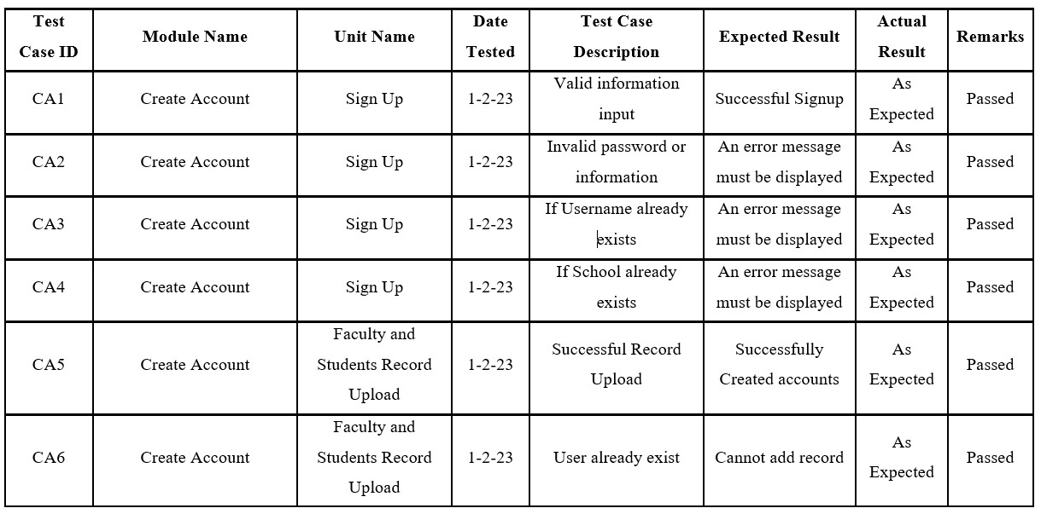

**Testing Phase**

**Table 28**

**Unit Testing**

**Testing Phase**

**Table 28**

**Unit Testing**

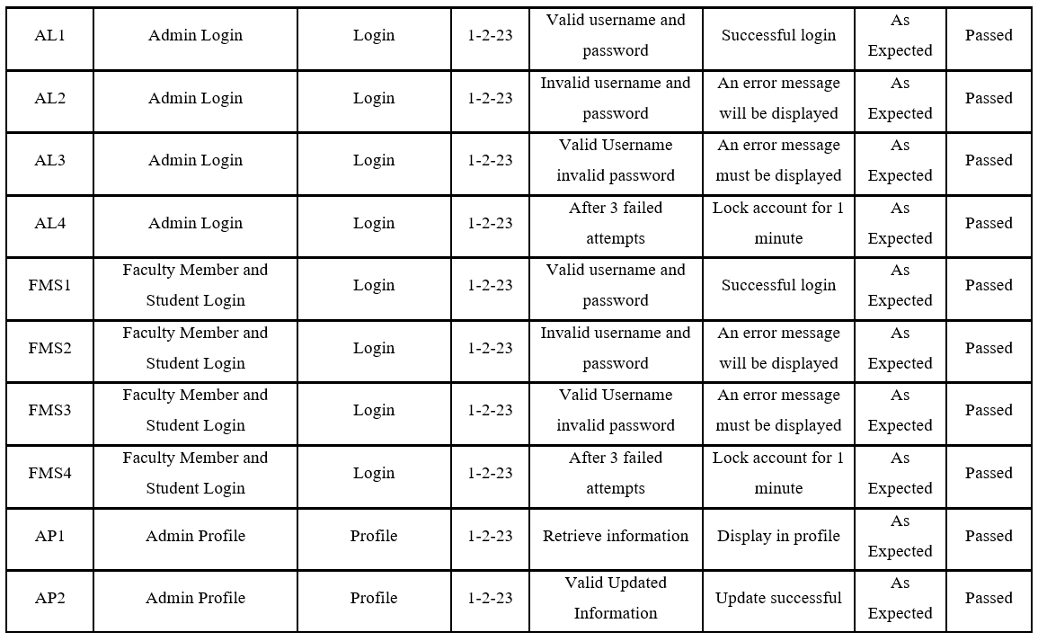

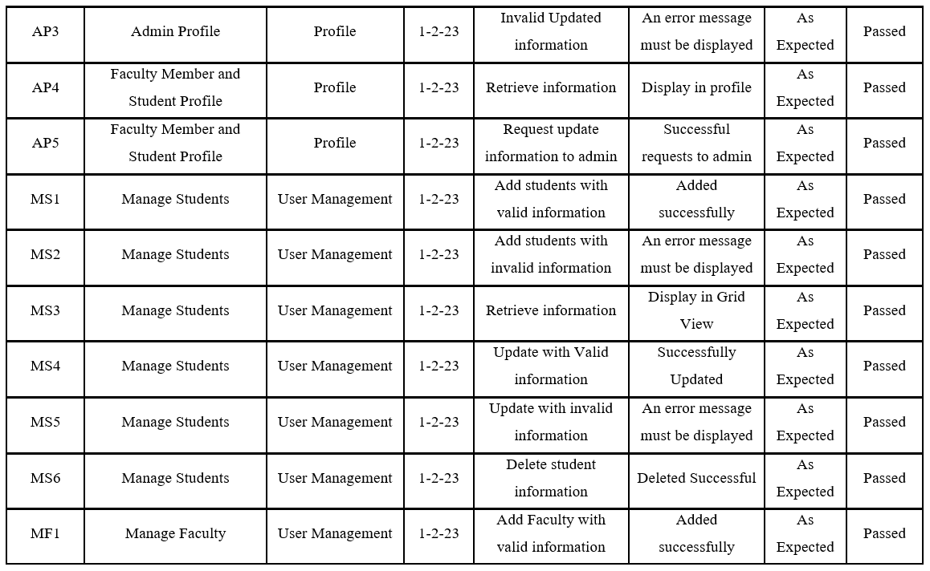

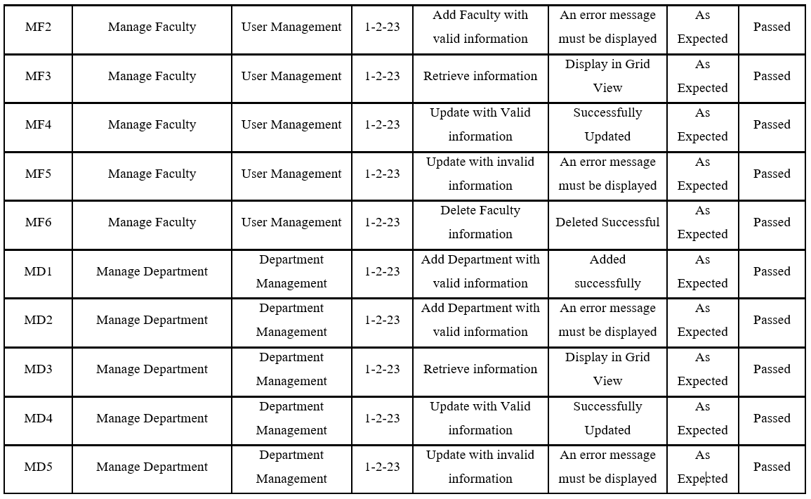

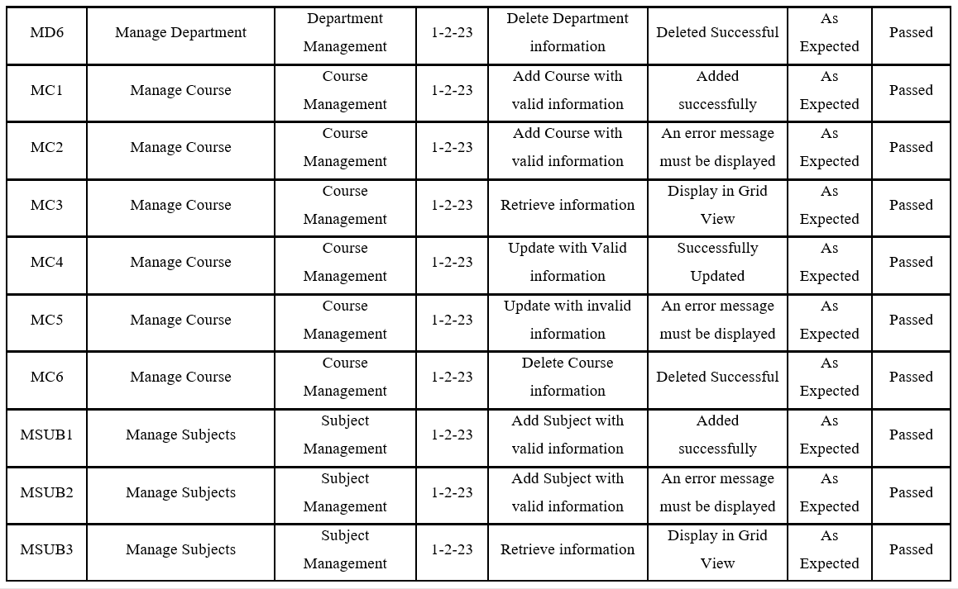

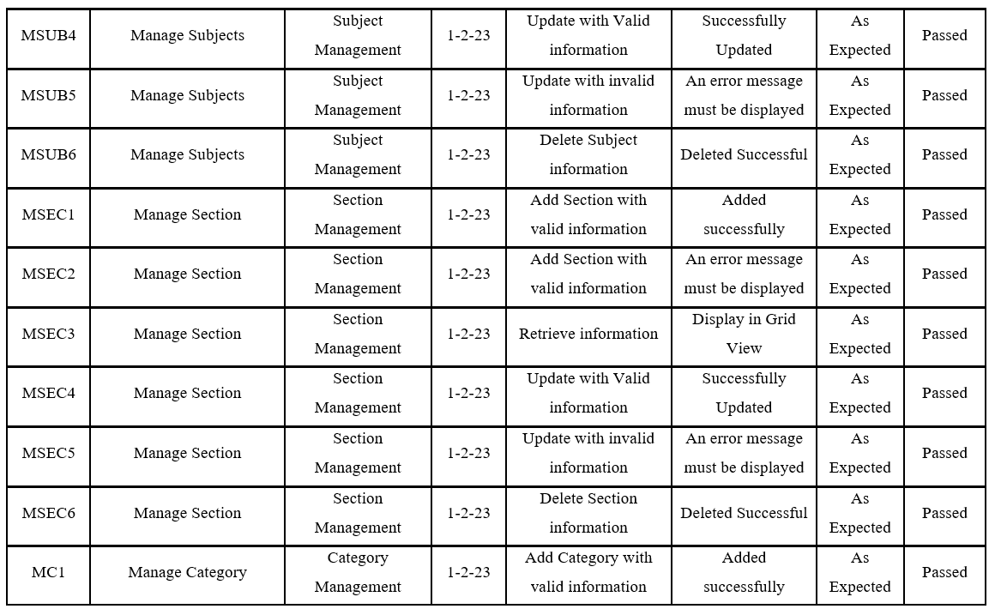

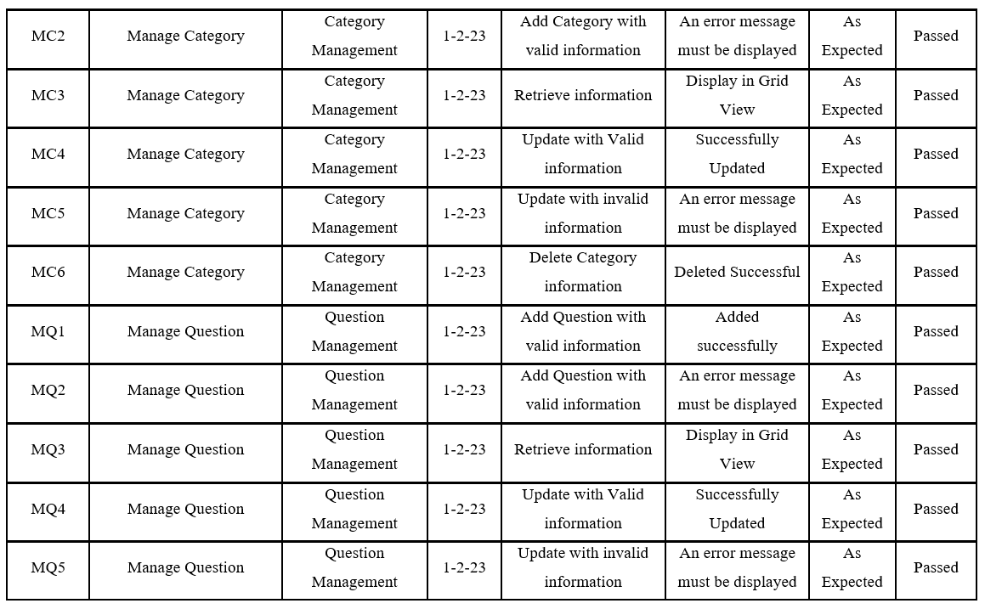

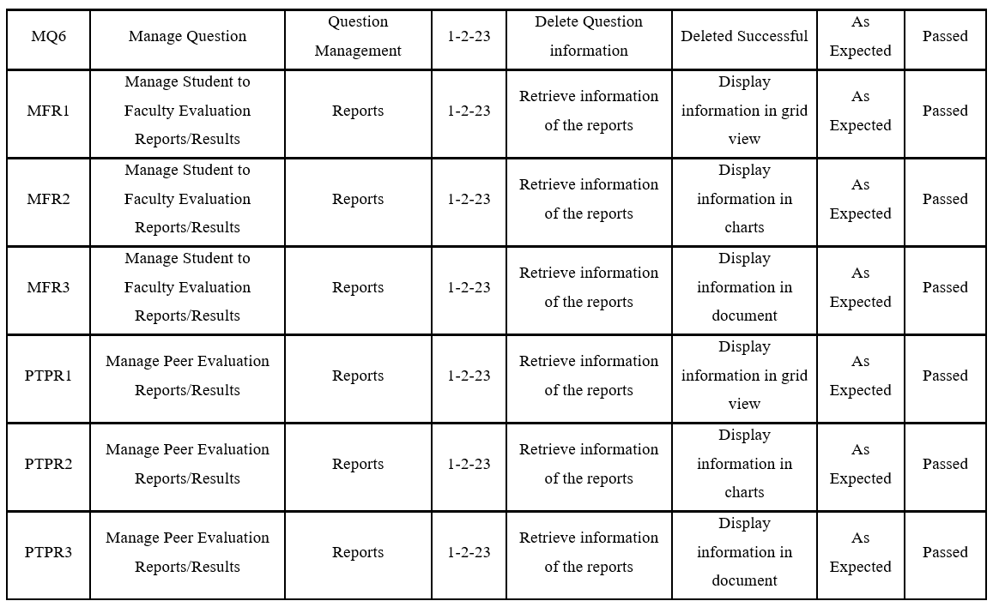

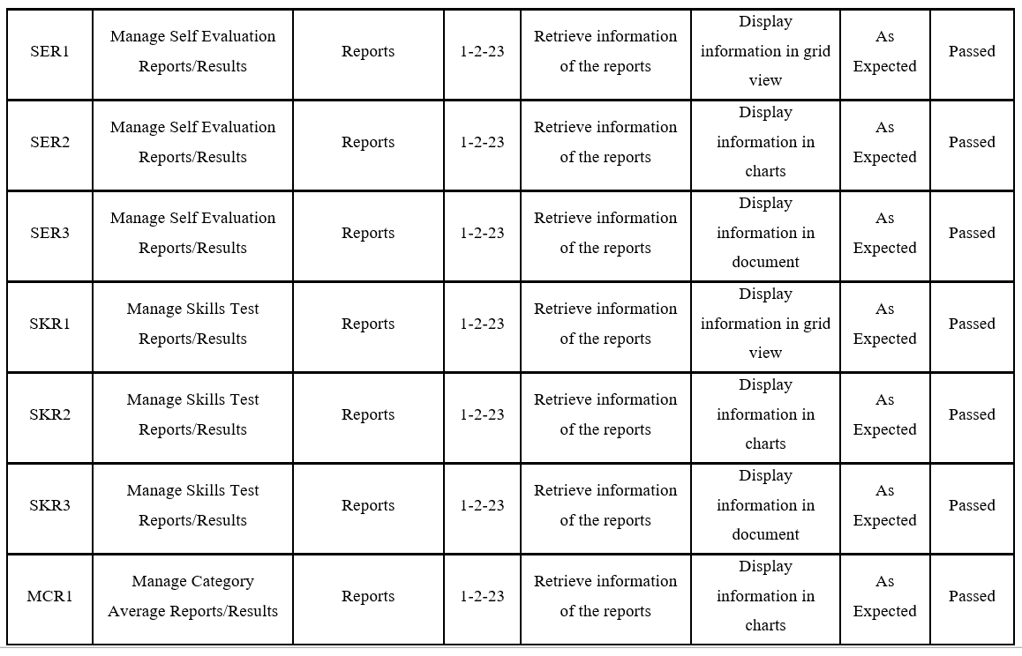

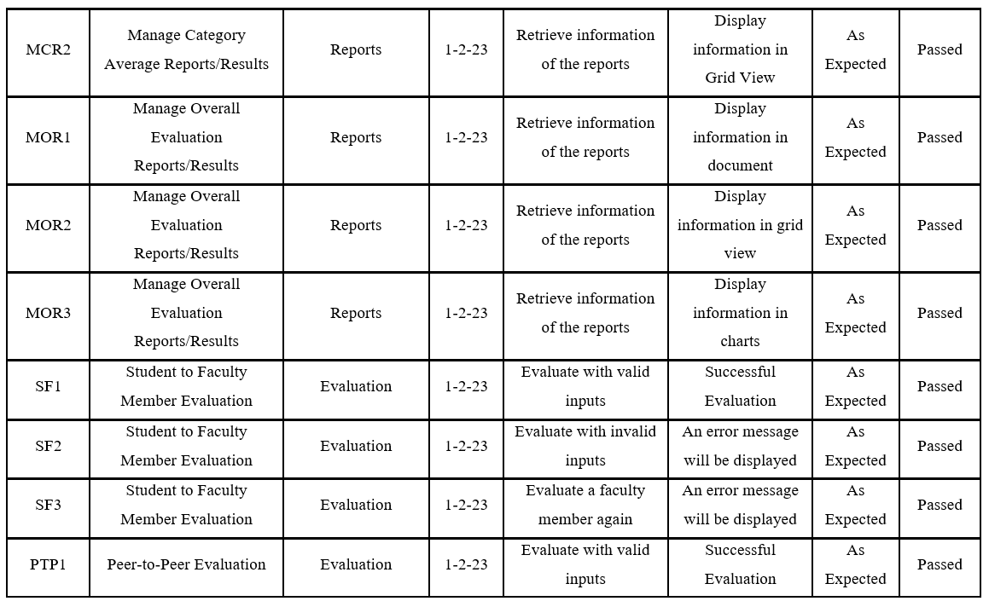

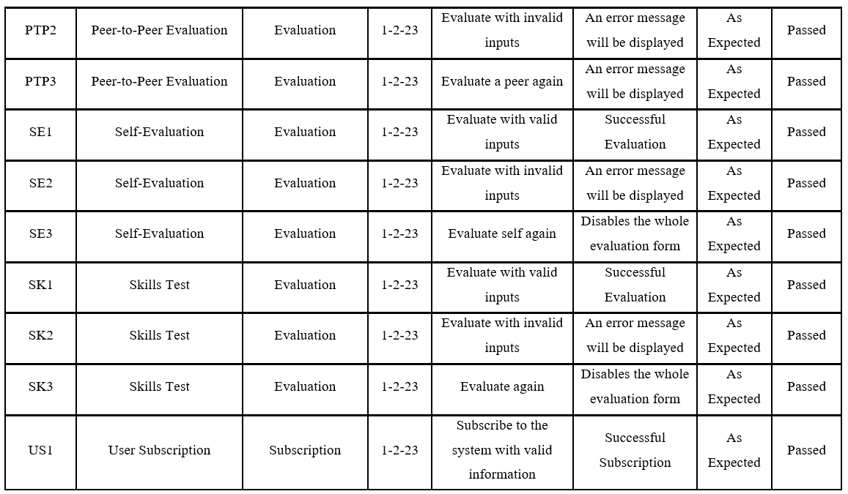

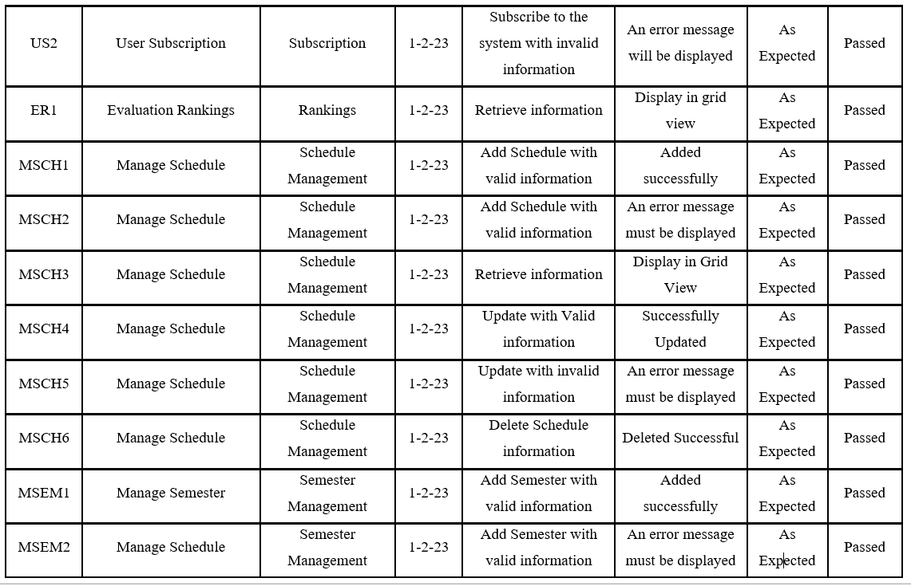

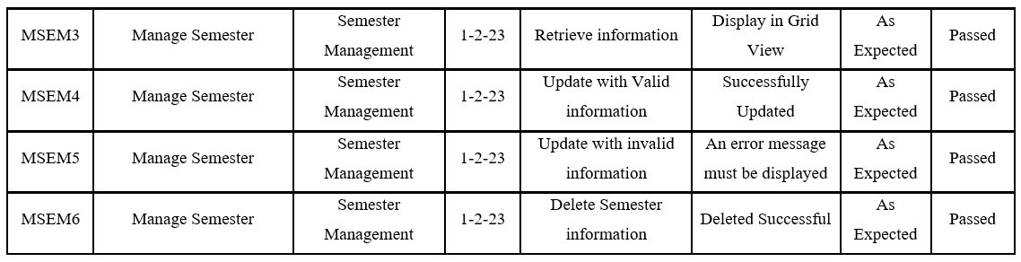 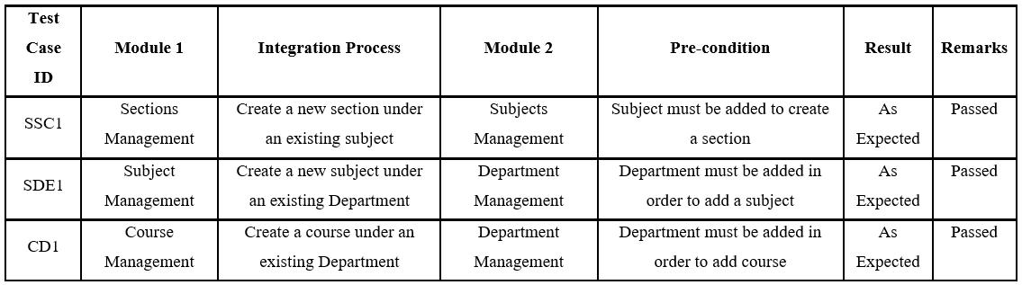

**Table 29**

**Integration Testing**

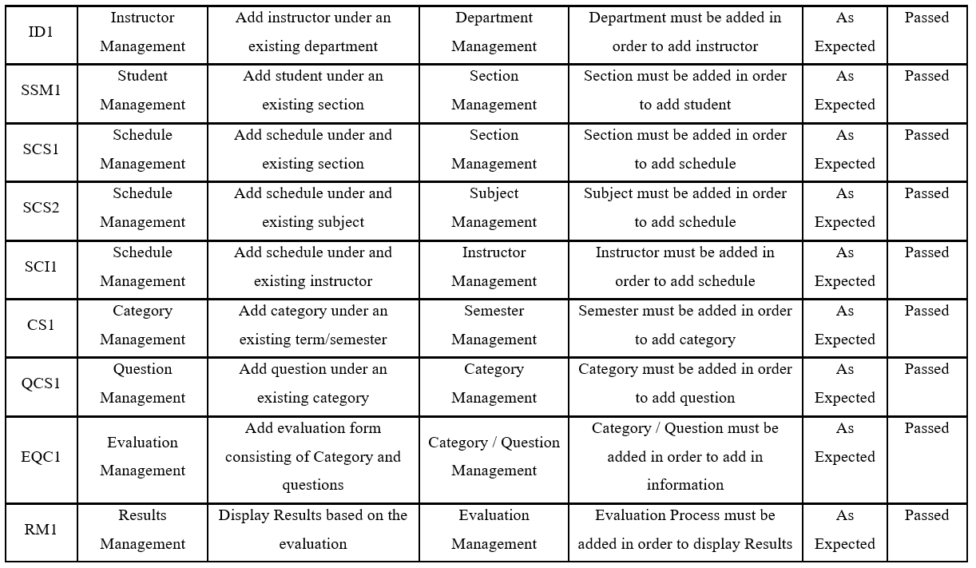

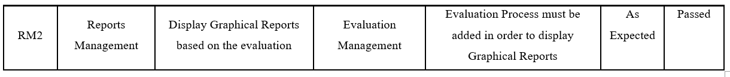

**Implementation/Deployment Phase**

**Software Specification**

The system will be developed using a variety of software. In order to implement, the proponents will use the following components as part of the system: ASP.NET, C#, HTML, CSS, JavaScript, JQuery. The proponents will use HTML because it's the most popular. Many web developers utilize this standard markup language while creating websites. For the design and layout, the proponents will use CSS and Bootstrap to develop and layout the web pages. JavaScript is a rapid scripting language and it will be used to enhance other languages because it is simple to learn, implement, and works well with them for the web application's functionality.

The proponents used an integrated development environment (IDE) made by Microsoft that is called Visual Studio Community Edition. It is used to develop computer programs, as well as websites, web apps, web services and mobile apps. Microsoft's software development platforms, including Windows Store, Windows Presentation Foundation, Windows API, and Windows Forms, are used by Visual Studio. Both native and managed code can be generated by it. Visual Studio is a code editor that supports code refactoring and IntelliSense (the code completion feature) is a feature of Visual Studio. Both a source-level debugger and a machine-level debugger can be used with the integrated debugger. A code profiler, designer for creating GUI apps, web designer, class designer, and database schema designer are further built-in tools. It accepts plug-ins that increase functionality at almost every level, such as adding support for source control programs (such as Subversion and Git) and new toolkits, such as editors and visual designers for programming languages with specialized functions, or toolkits for different stages of the software development lifecycle (like the Azure DevOps client: Team Explorer). The figure below shows the software specifications for the web application development:

**Table 30**

**Software Specification in System Development**

|  |  |
| --- | --- |
| Language | ASP.NET, HTML, CSS, JavaScript, Jquery |
| DBMS | MS SQL |
| Operating System | Windows 10 |
| Text Editor / IDE | Visual Studio Community Edition |
| Image Editor | Adobe Photoshop |
| Web Browser | Mozilla Firefox, Opera, Google Chrome, Safari |

**Table 31**

**Web Browsers**

|  |  |
| --- | --- |
| Web Browsers | Google Chrome  Mozilla Firefox  Opera Browser  Saffari |

**Hardware Specification**

This system will use a Central Processing Unit (CPU), either of the two most used CPU the Intel or the AMD. The random access Memory (RAM) for the computer must be at least with the minimum of 2GB for it to run without problems and for it to run smoothly and with at least 50GB or more free disk storage space.

The user's desktop application might function on any computer with an AMD or Intel CPU in the system’s deployment. The system might need a computer with random access memory (RAM) of at least 512 MB and an internal storage of at least 1 GB to function without any issues and for it to run smoothly. Additionally, the device needs to be connected to the internet either wired, wireless, or DSL-connection, as long as it is connected to the internet.

**Table 32**

**Hardware Specification in System Development**

|  |  |
| --- | --- |
| Central Processing Unit (CPU) | AMD or Intel |
| RAM | Minimum of 2 Gb  Required of 4 Gb and up |
| Disk Storage Free Space | At least 50 Gb |
| Internet Connection | Ethernet / Wireless / DSL |

**User Guide**

There are 4 types of user namely the admin, dean, instructor and student.

**Home Page**

1. Search [www.amber.com](http://www.amber.com) in web browser
2. For the school admin Sign up ang login is in the navigation bar. Take note, only the school admin can create an account.

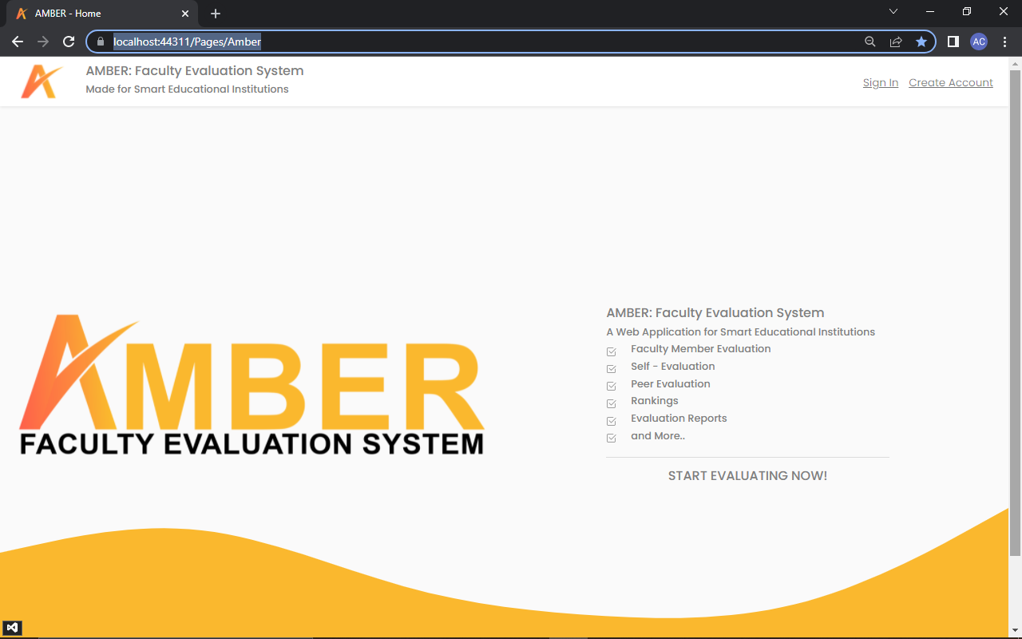

Figure 67: **Home Page**

In figure 67 is the home page. This is the first thing every user will see once they go to the given link and to start either the user sign in directly or create an account.

**Admin**

1. In creating account, input all details that is needed, then click “Create Account” and continue.

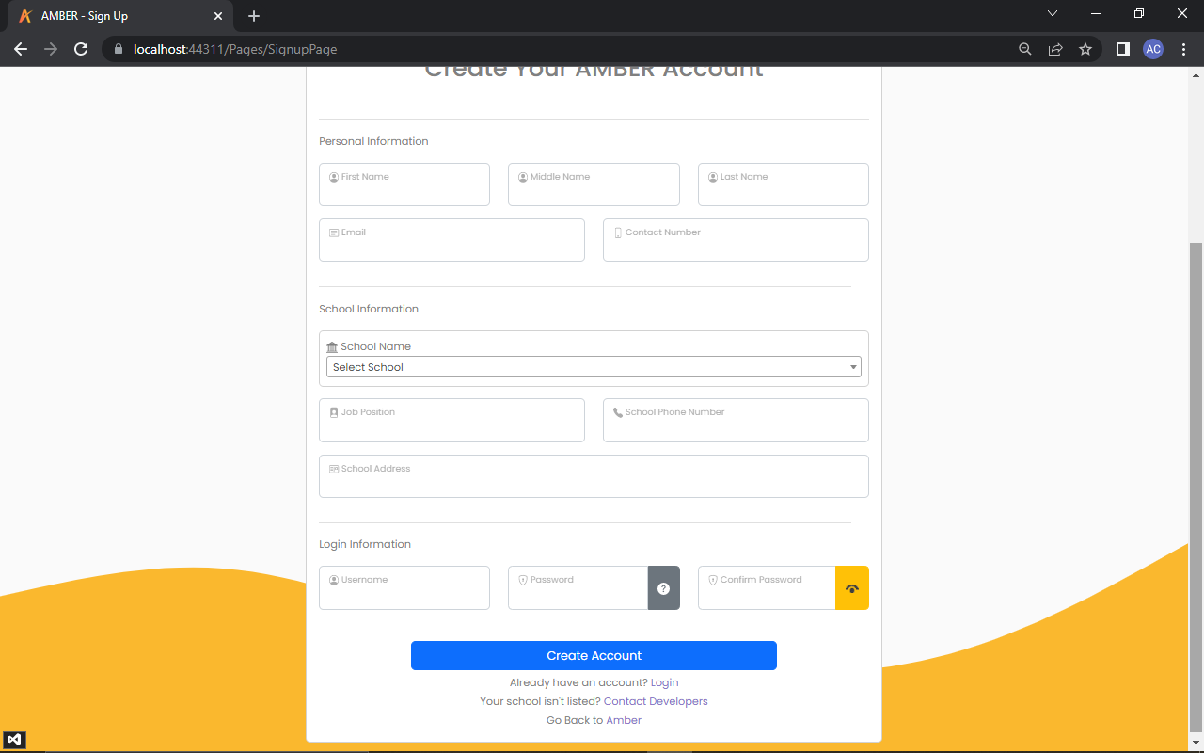

Figure 68: **Create Account**

In figure 68 is the create account. Users are required to fill-out what is being asked in creating an amber account.

1. The system will send a verification code to your Gmail account, get and input the verification code here then click “Verify” to proceed.

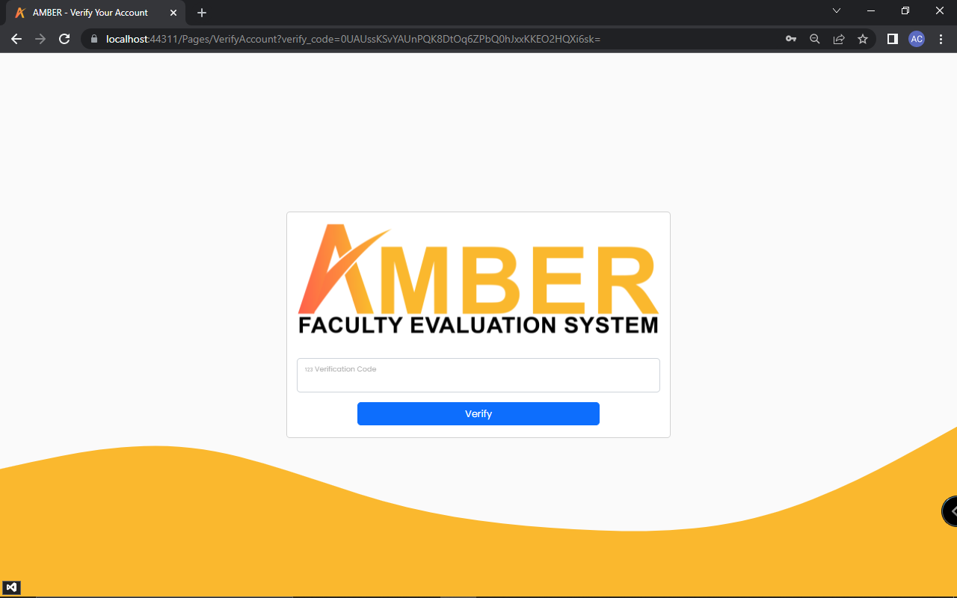

Figure 69: **Input Verification Code**

In figure 69 is the input verification code. After creating account users are then asked for a verification in order to proceed.

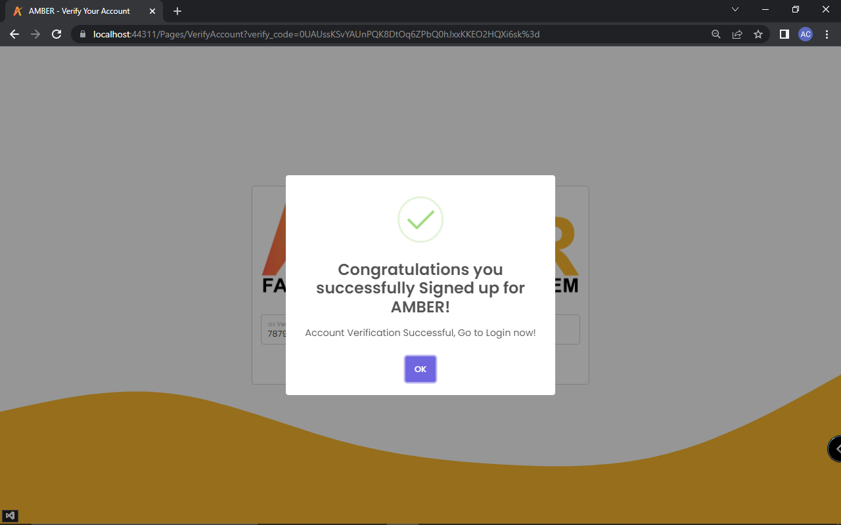

Figure 70: **Successfully Signed up**

In figure 70 is the successfully signed up. If verification succeeds then this will show, users will have to login to continue.

1. AMBER Account Login.

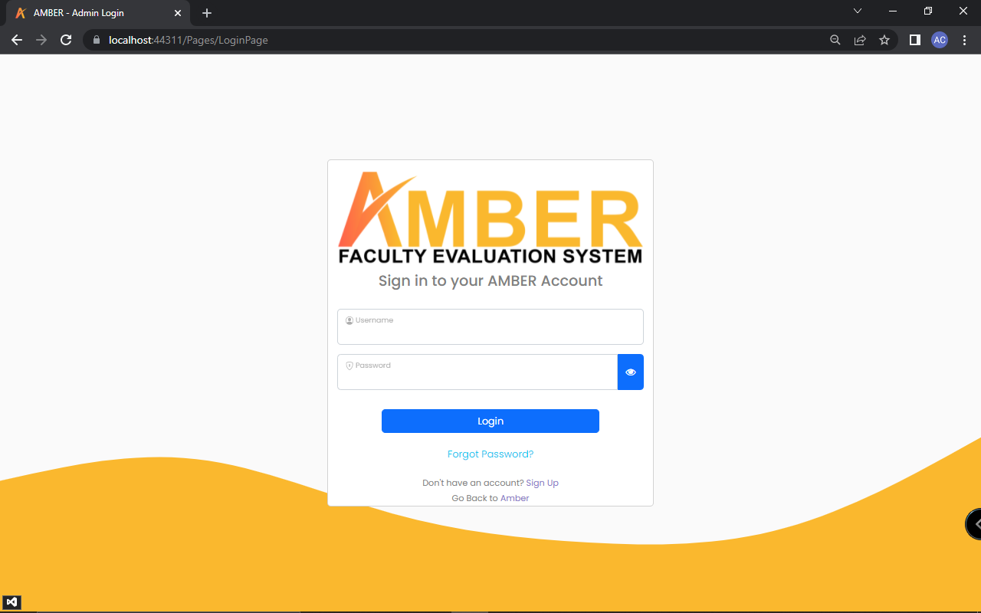

Figure 71: **Admin Login**

In figure 71 is the admin login. After the account was verified, it will be redirected to the login page of the Admin. Login the registered account to access the system.

1. Pop up message.

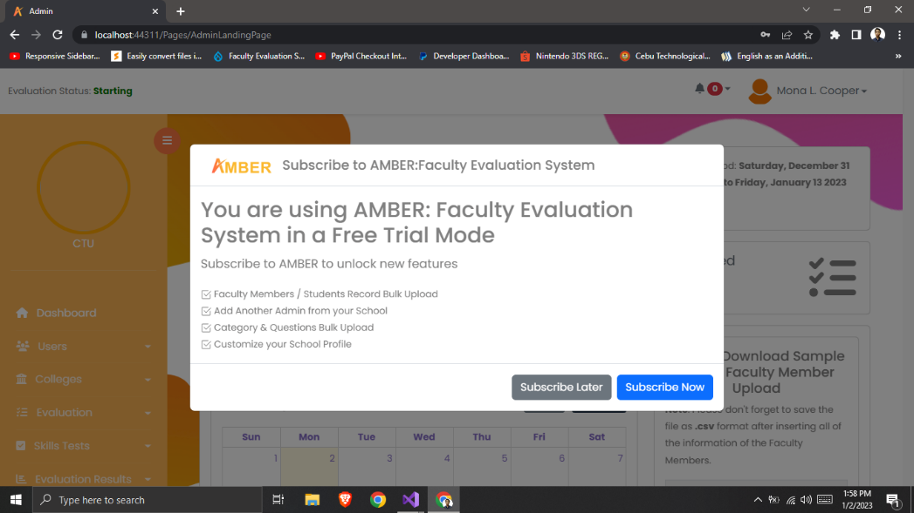

Figure 72: **Pop up message for subscription**

In figure 72 is the pop-up message for subscription. After logging in, a pop-up message will show to let you know that you are using the web application in a free trial mode. The user must subscribe in order to fully access more offered features.

1. Landing page once you access the application.

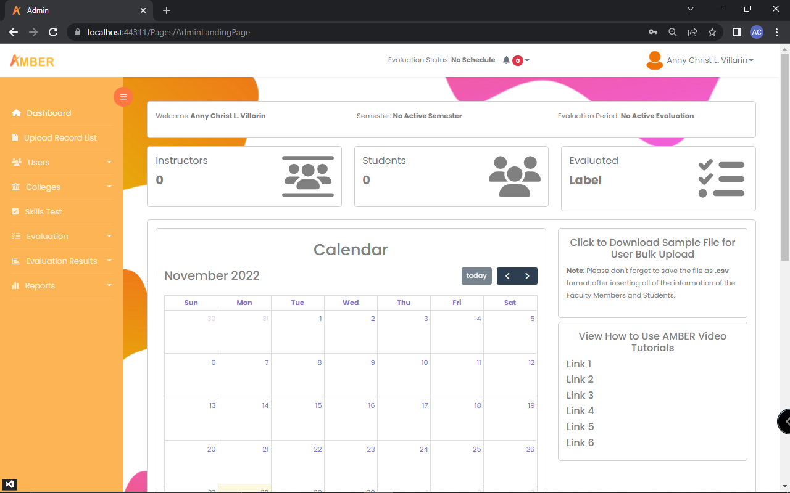

Figure 73: **Admin Landing Page**

In figure 73 is the admin landing page. If the user happens to decide on subscribing later and still have a month to try the “free trial” then the pop message will close after. The landing page will be viewed by then.

1. On the Upload list.

User Record Upload is where list of users are uploaded.

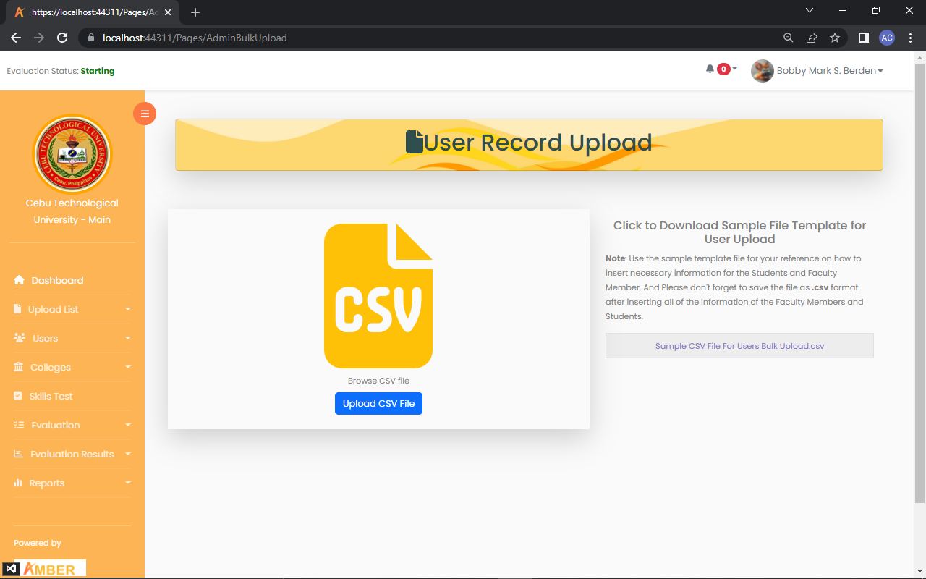

Figure 74: **Upload Users**

In figure 74 is the upload users. Bulk upload of user, click yellow icon, choose file (csv file), then click upload.

Category & Questions Upload is where a list of categories and questions are uploaded.

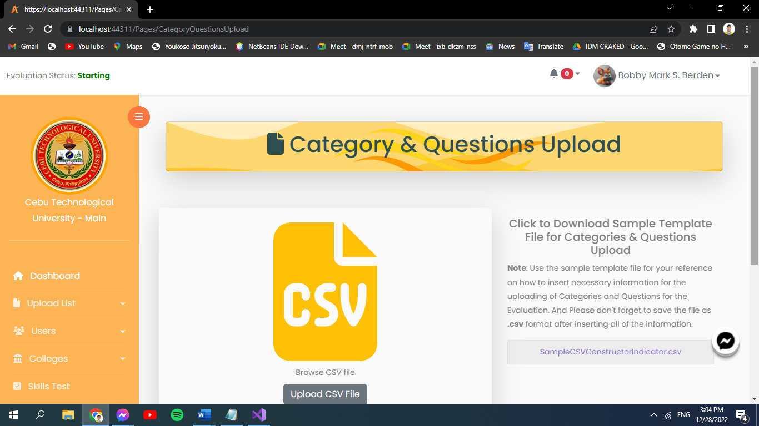

Figure 75: **Upload Category and Questions**

In figure 75 is the upload category and questions. Bulk upload of category and question, click yellow icon, choose file (csv file), then click upload.

1. On the User.

This part is where you can see the list of admin.

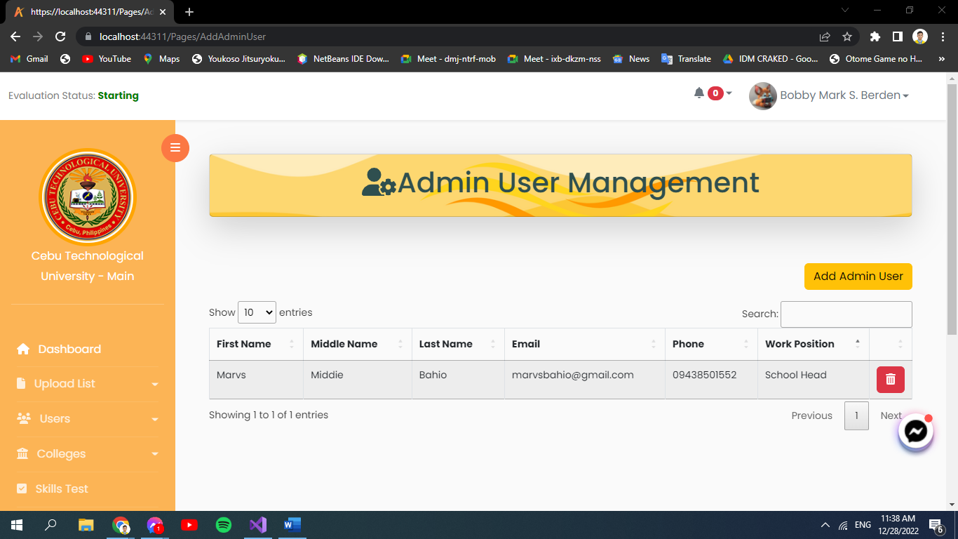

Figure 76: **Admin Management**

In figure 76 is the admin management. The uploaded file will be viewed here, two different list can be seen on the picture: the faculty member list and as well as the student list and in here you can manage adding instructor, edit and delete and upload csv file.

List of Faculty Members.

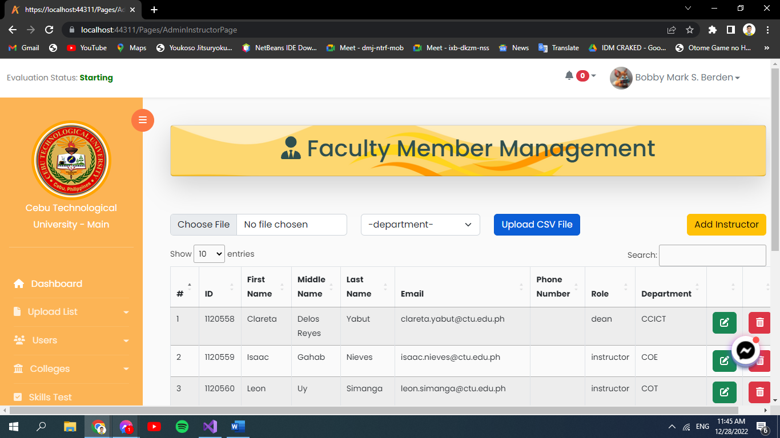

Figure 77: **Manage Faculty**

In figure 77 is the manage faculty. This shows a list of faculty members.

List of Students.

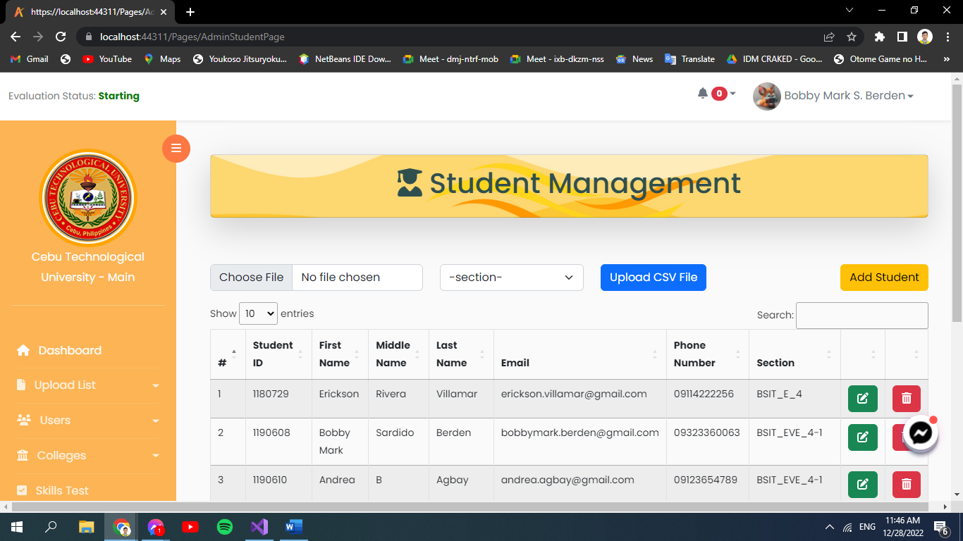

Figure 78: **Manage Student**

In figure 78 is the manage student. This shows a list of students.

1. On the Colleges.

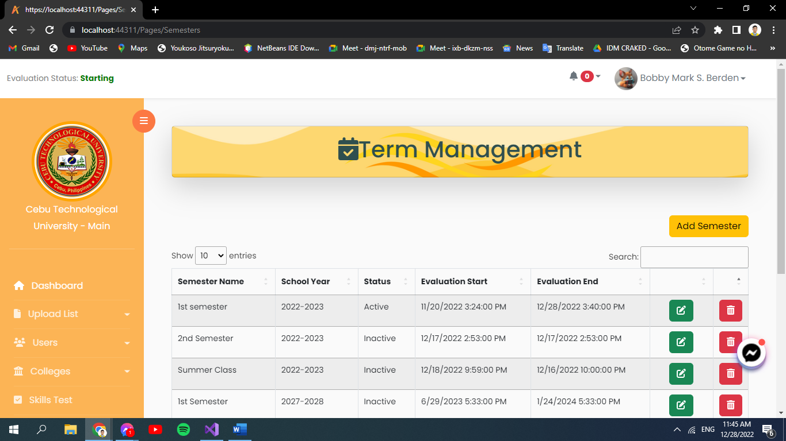

Figure 79: **Term Management**

In figure 79 is the term management. This is where the admin will manage adding a semester, can edit and delete entries.

1. On the Department.

In this part admin manage adding department, then edit and delete entries.

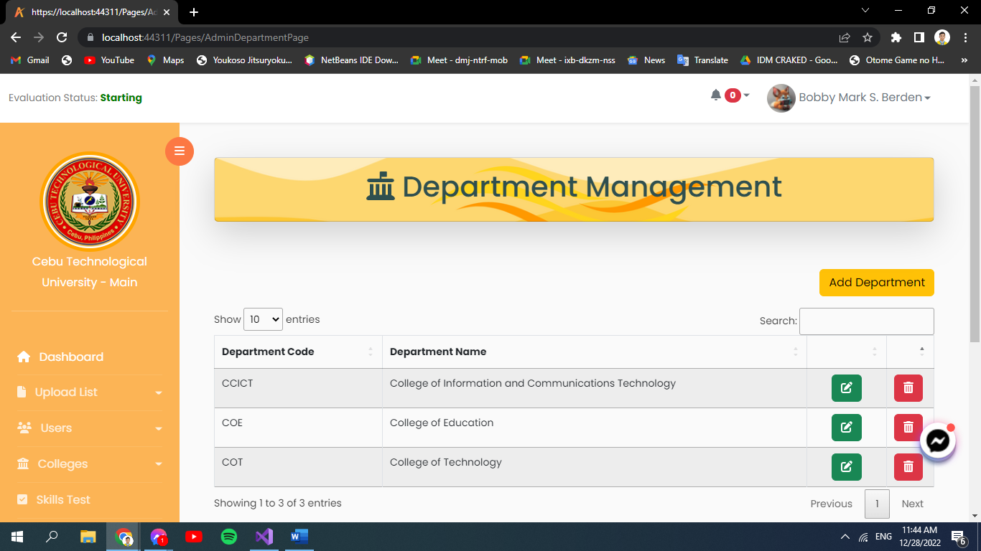

Figure 80: **Department Management**

In figure 80 is the department management. In this part admin manage adding department, then edit and delete entries.

1. On the Course.

In here, admin can manage adding course then edit and delete entries.



Figure 81: **Course Management**

In figure 81 is the course management. In here, admin can manage adding course then edit and delete entries.

1. On the Section.

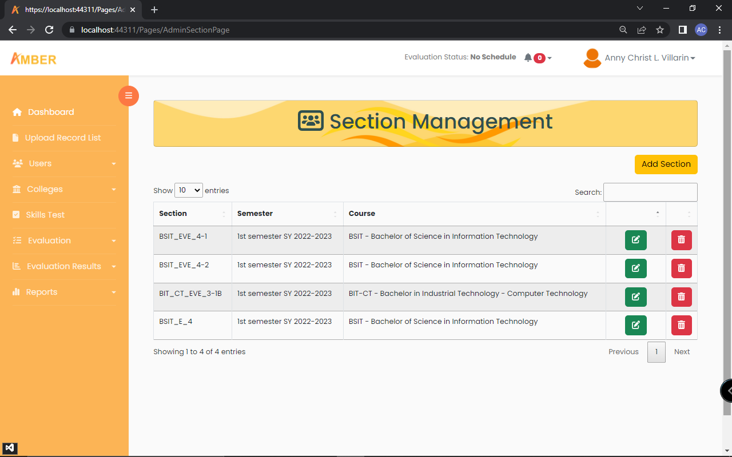

Figure 82: **Section Management**

In figure 82 is the section management. Managing of adding sections then edit and delete entries.

1. On the Subject.

Manage of adding subjects then edit and delete entries are done in this part.

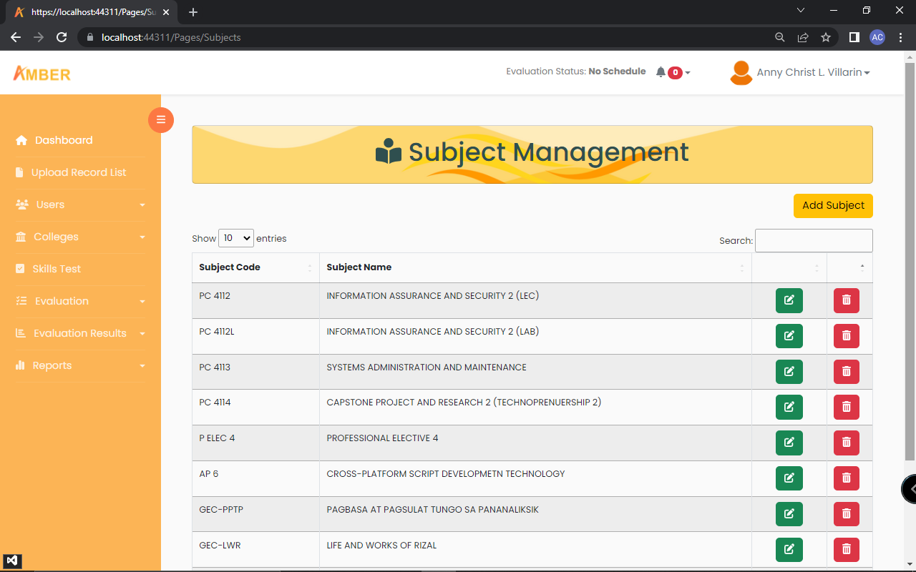

Figure 83: **Subject Management**

In figure 83 is the subject management. Manage of adding subjects then edit and delete entries are done in this part.

1. On the Schedule.

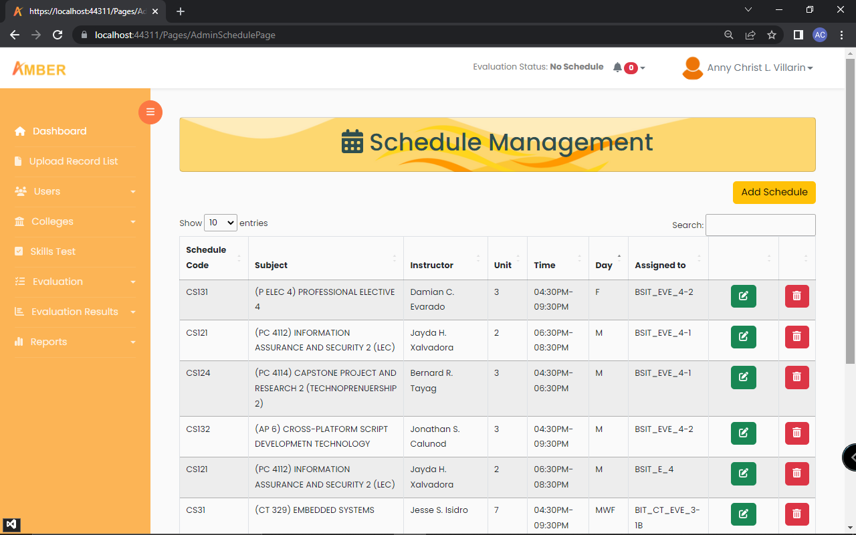

Figure 84: **Schedule Management**

In figure 84 is the schedule management. Admin can do the managing of schedule here by adding schedules then edit and delete entries.

1. Under Evaluation, Schedule.

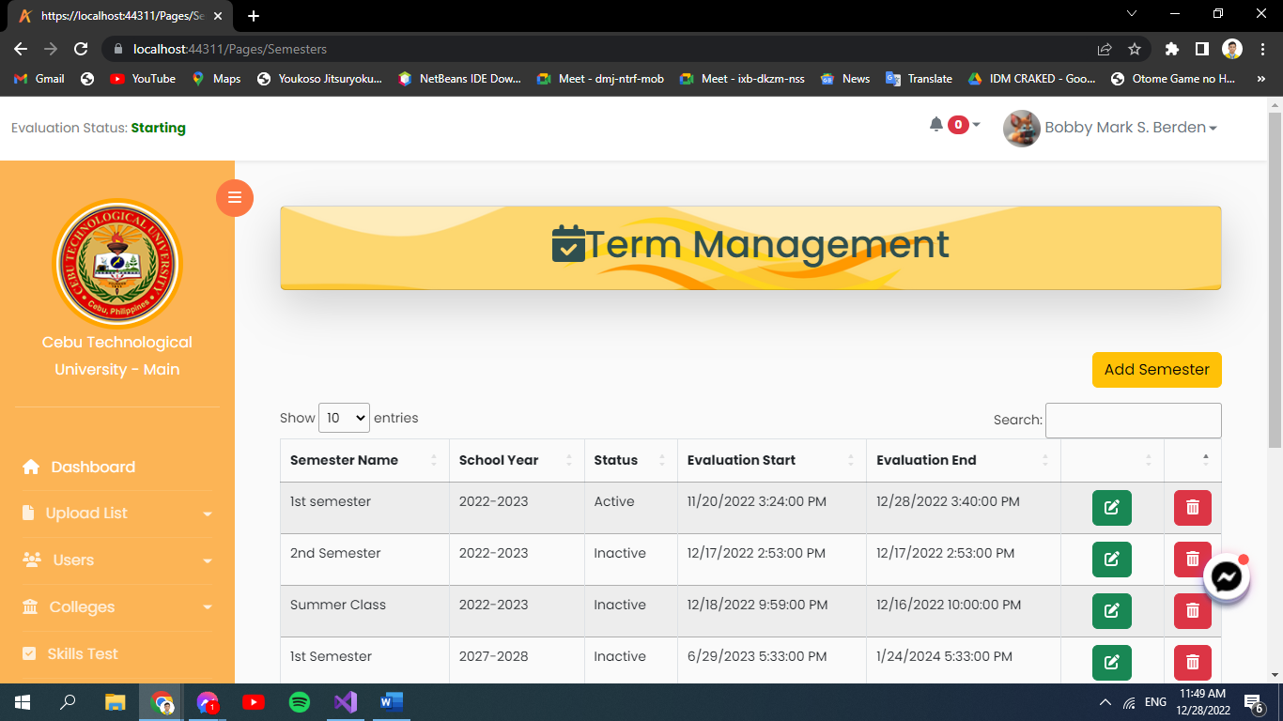

Figure 85: **Evaluation Schedule**

In figure 85 is the evaluation schedule. In here, admin will update the semester in order to activate the evaluation by activating the status and evaluation period.

1. Generate Evaluation Link

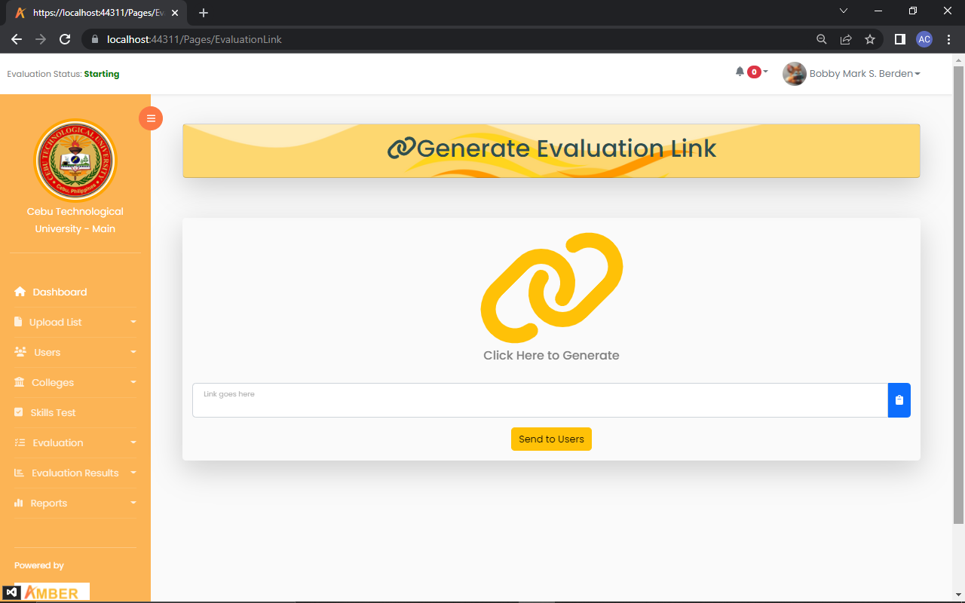

Figure 86: **Generate Evaluation Link**

In figure 86 is the generate evaluation link. In here, admin will click the icon to generate a link for evaluation and it will be sent to users, which are the instructors and students by clicking the Send button to User.

1. On the Category.

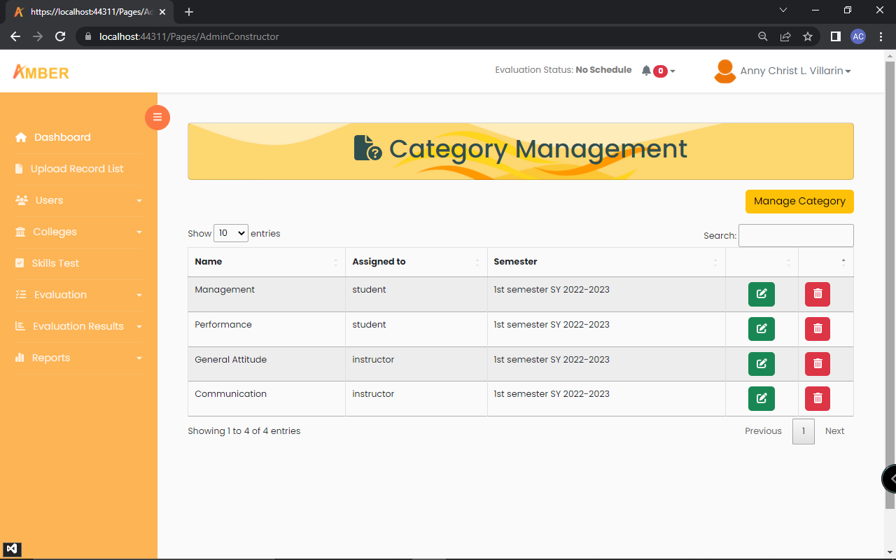

Figure 87: **Category Management**

In figure 87 is the category management. This is where admin can manage the category then edit and delete entries.

1. On the Questions.

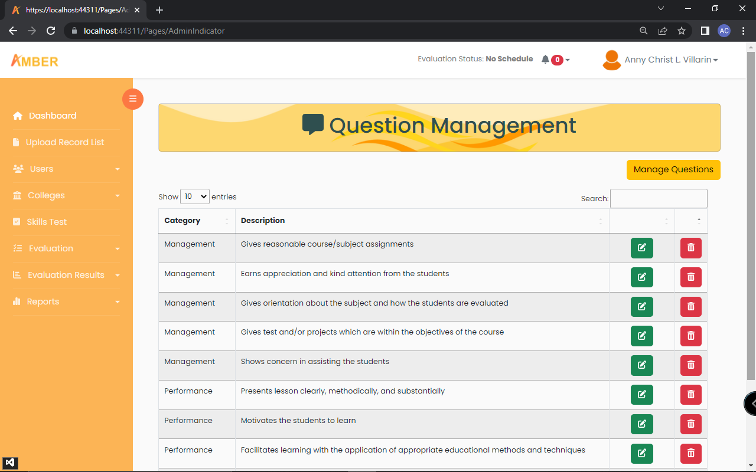

Figure 88: **Question Management**

In figure 88 is the question management. This is the part where admin manages the questions by editing and deleting entries.

1. On the Evaluation Result.

Rankings of Evaluation

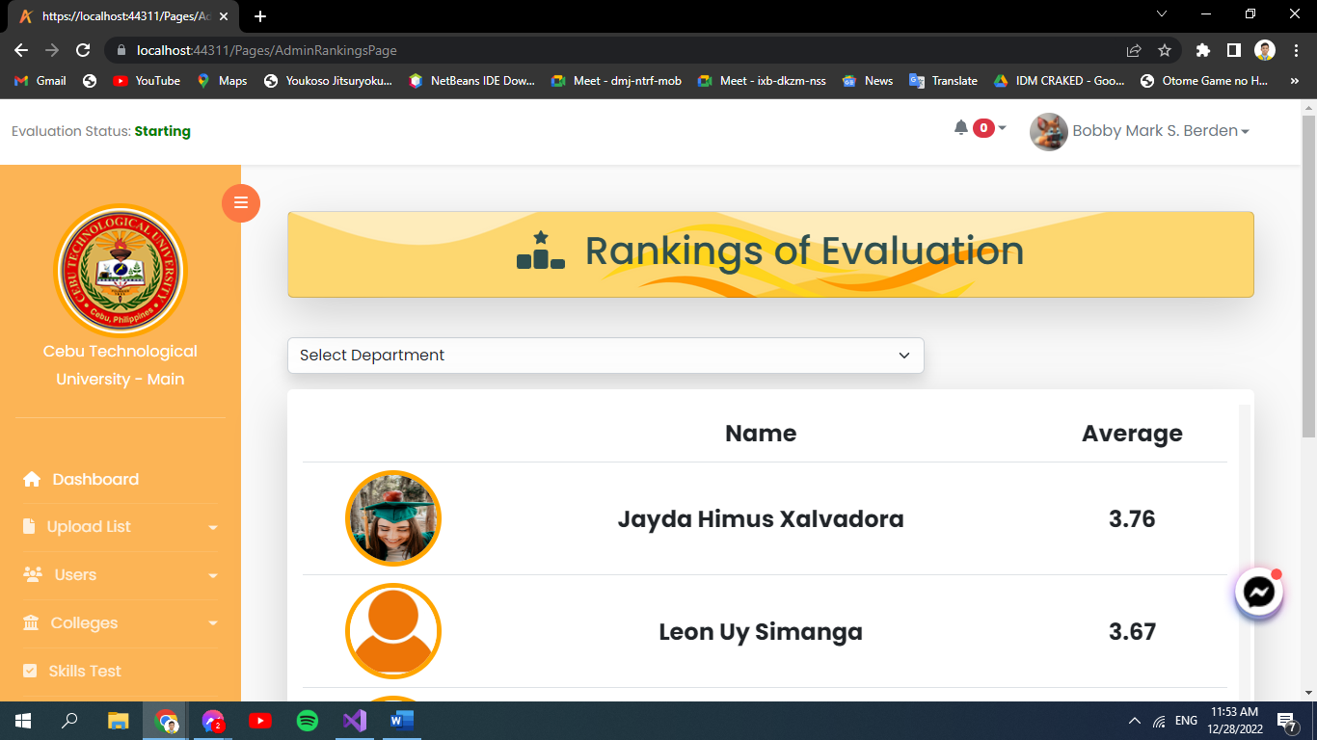

Figure 89: **Rankings**

In figure 89 is the rankings. Rankings are shown after receiving the Evaluation Result.

1. Skill Test.

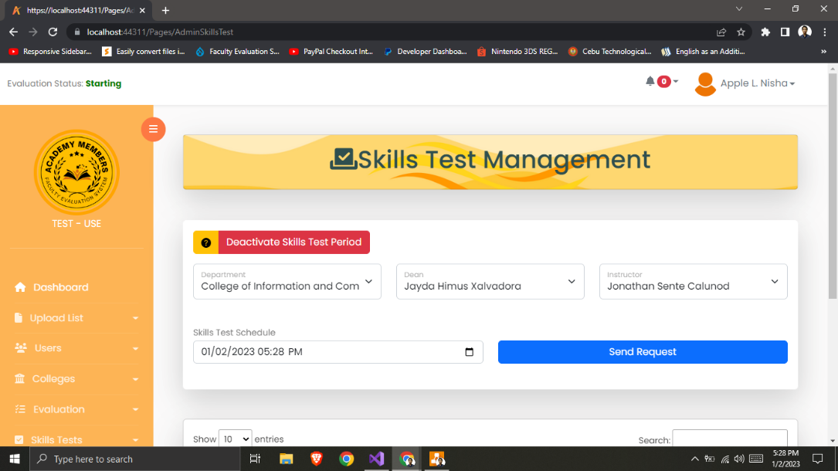

Figure 90: **Admin Request Skill Test**

In figure 90 is admin skill test. Admin requesting dean for a skill test whenever there is a fair to poor rate.

Admin can view the evaluation result done by all evaluators from different departments.

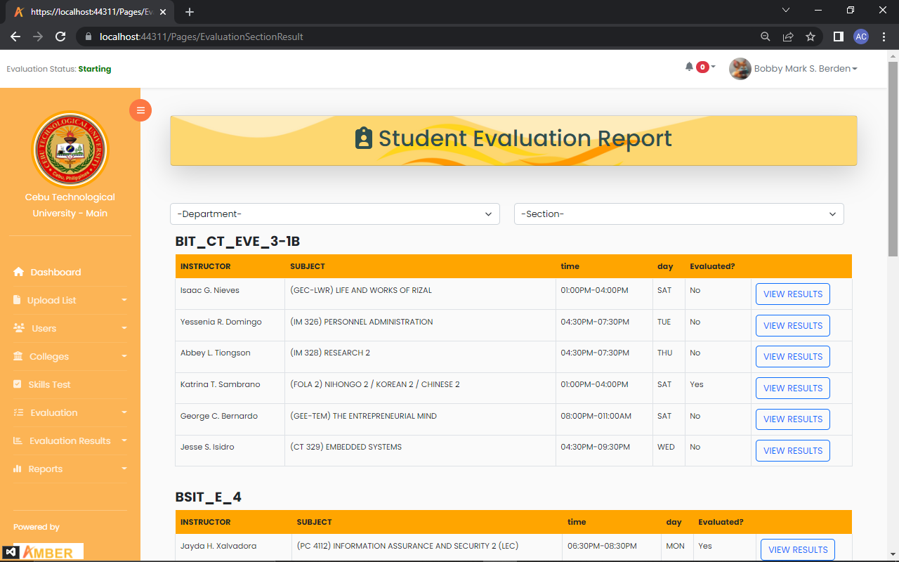

Figure 91: **Student Evaluation Report**

In figure 91 is the student evaluation report. Shown here is the Student Evaluation Report where all evaluation results are displayed.

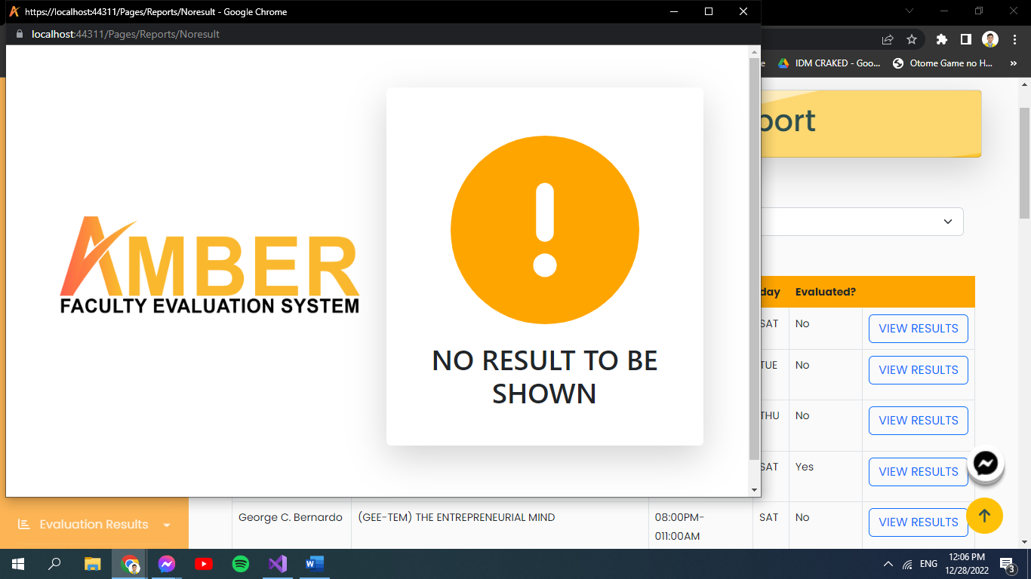

Figure 92: **No Result**

In figure 92 is the no result. This is shown whenever there is no evaluation done.

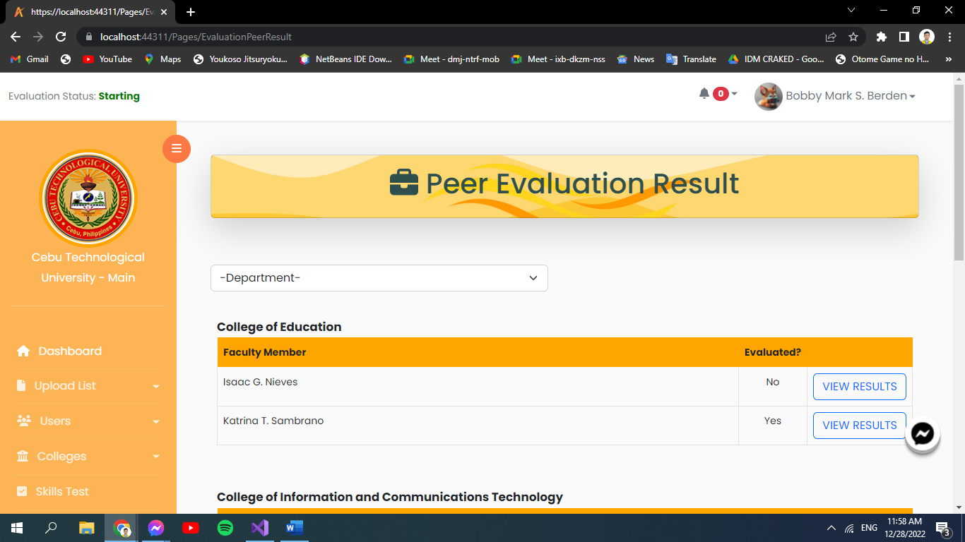

Figure 93: **Peer Evaluation Result**

In figure 93 is the peer evaluation result. Shown here is the Peer Evaluation Result where all evaluation results are displayed.

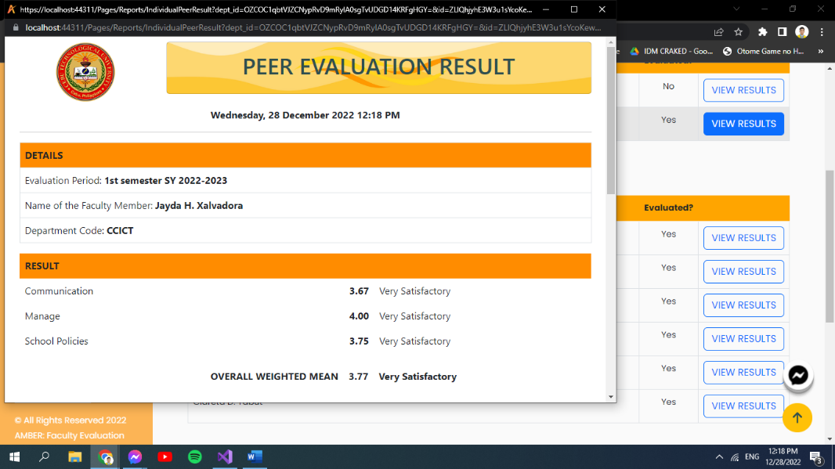

Figure 94: **Peer Evaluation Result to be printed**

In figure 94 is the peer evaluation result to be printed. This is shown whenever there is evaluation done.

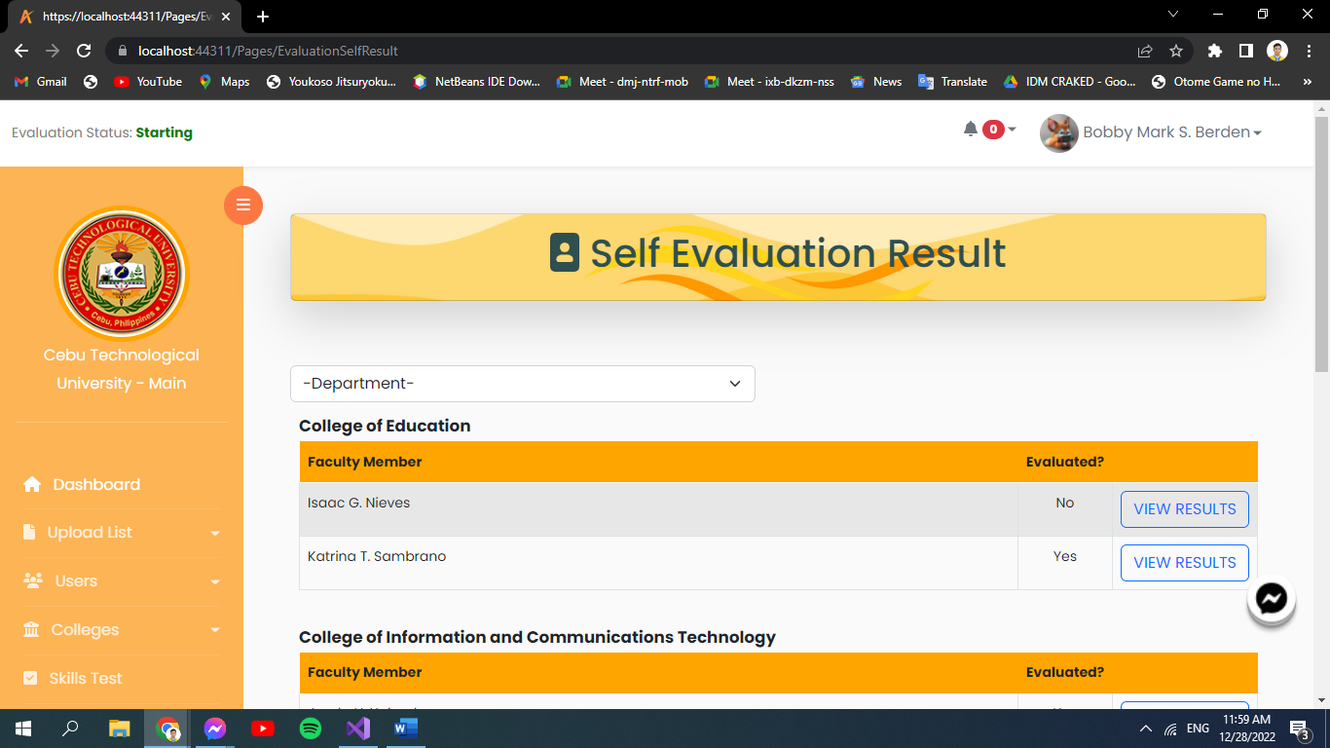

Figure 95: **Self Evaluation Result**

In figure 95 is the self-evaluation result. Shown here is the Self Evaluation Result where all self-evaluation results are displayed.

1. Under Reports.

Ratings from the overall report by category and by question are shown here, as well as the overall result and the department results.

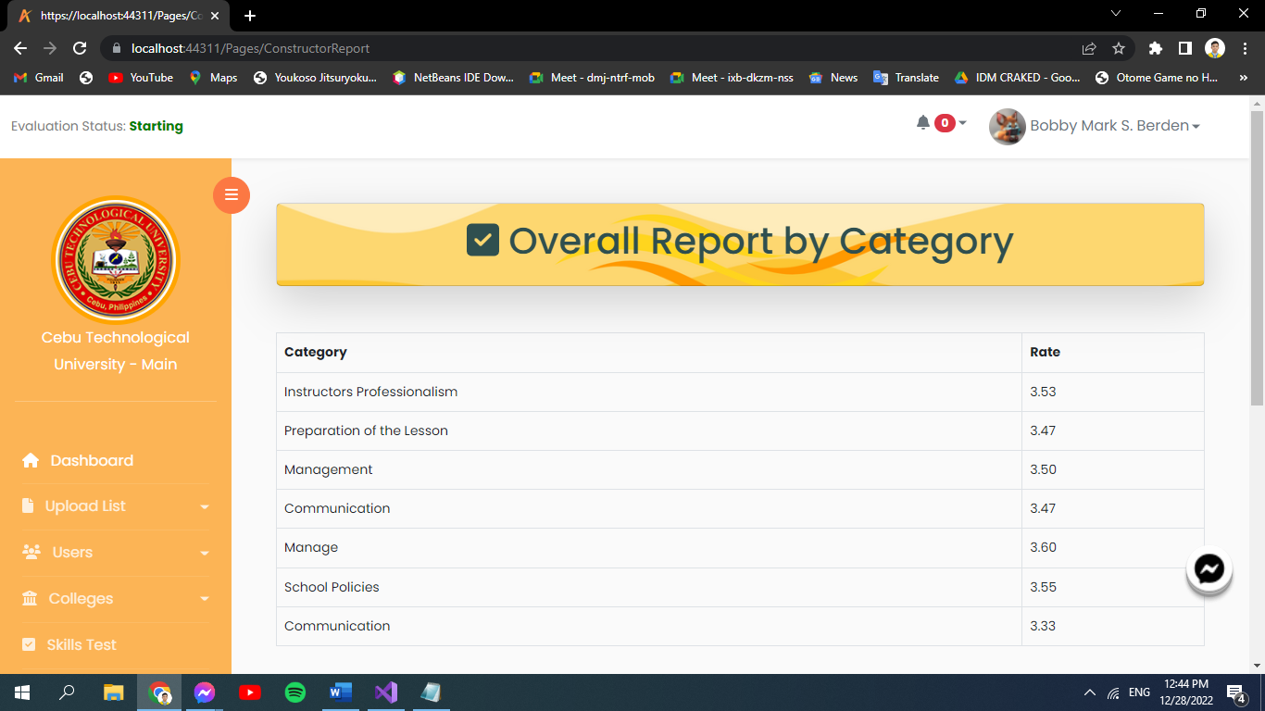

Figure 96: **Overall Report by Category**

In figure 96 is the overall report by category. For overall report by category.

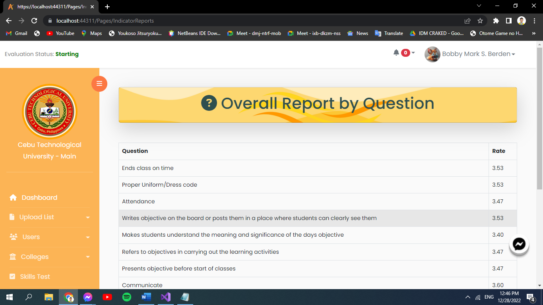

Figure 97: **Overall report by Question**

In figure 97 is the overall report by question. For overall report by question

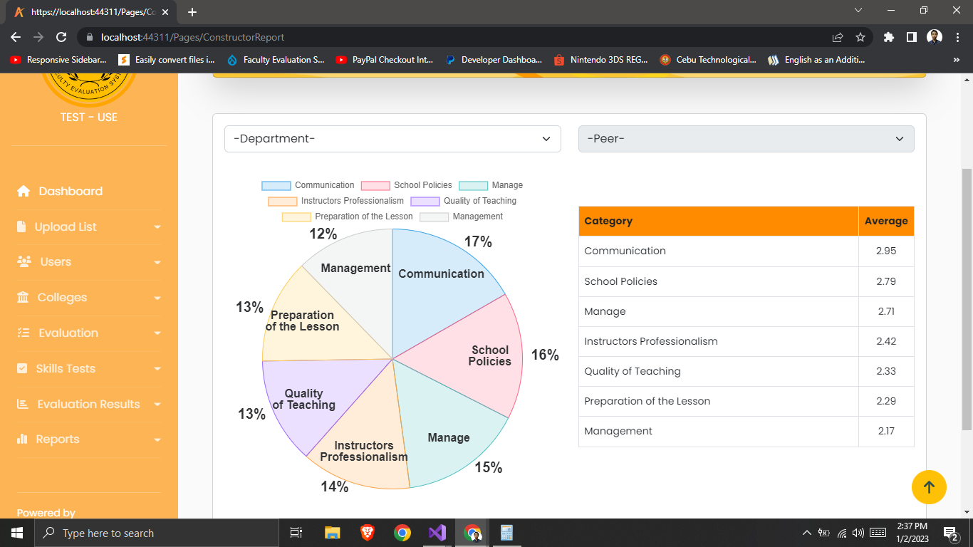

Figure 98: **Department Reports**

In figure 98, it shows the departmental reports of the evaluation.

1. Admin Profile.

Admin can view their personal information here as well as the school’s profile and subscription details.

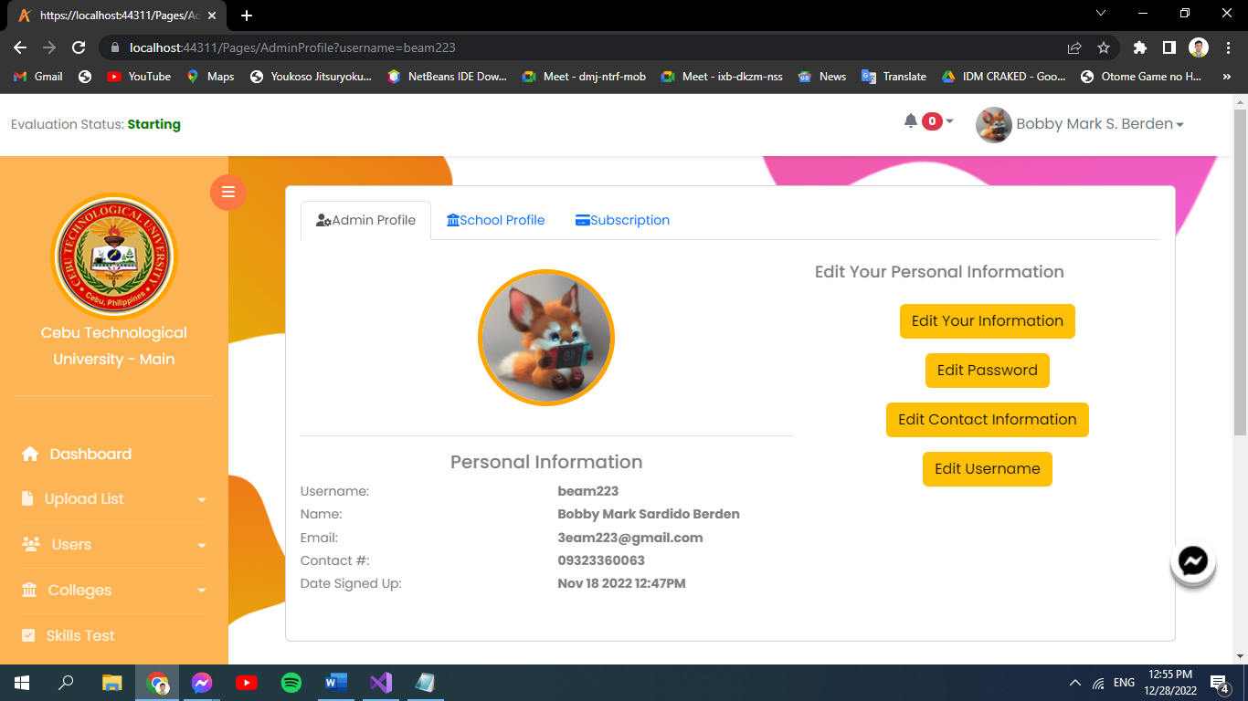

Figure 99: **Admin Profile**

In figure 99 is the admin profile. They can change or upload profile picture, edit password, contacts, their information and username. In order to upload their image, just hover the profile picture then click the camera icon.

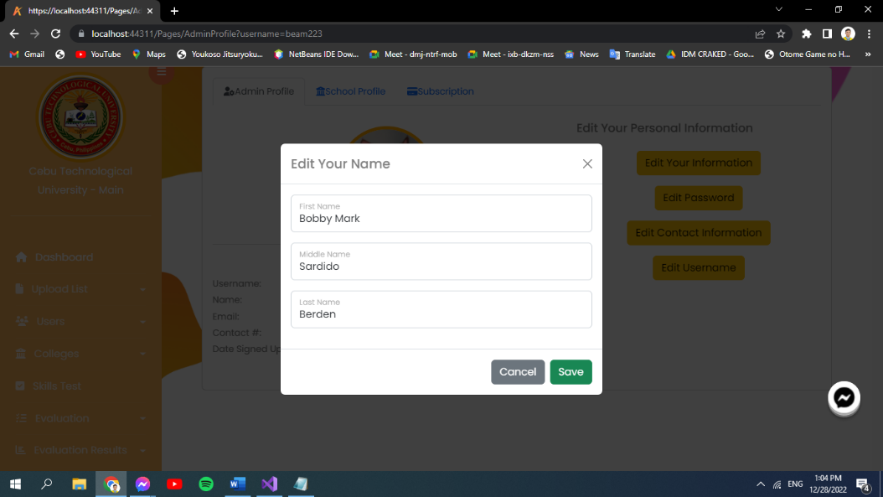

Figure 100: **Edit Information**

In figure 100 is the edit information. Click Edit your information and change details about you.

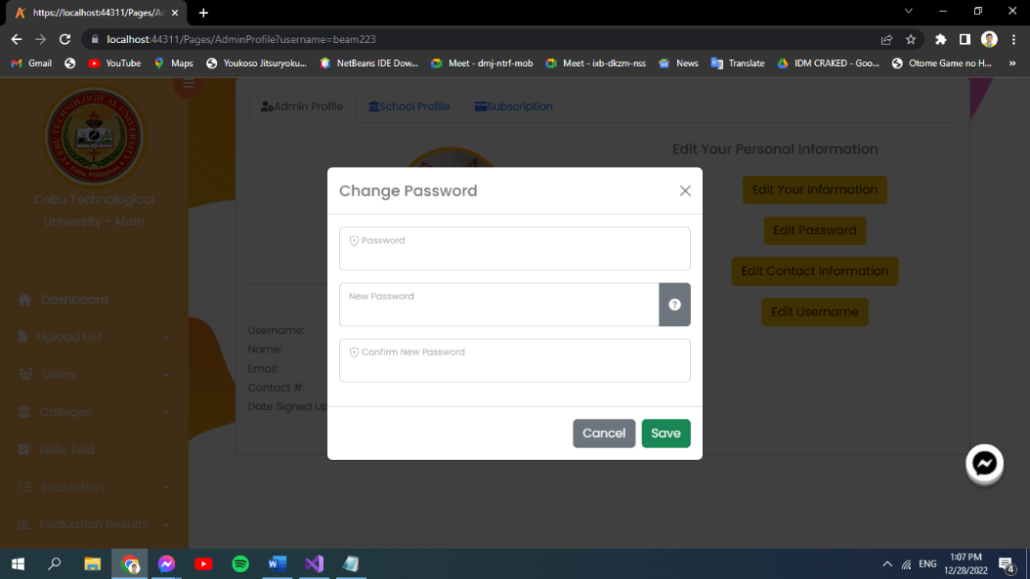

Figure 101: **Edit Password**

In figure 101 is the edit password. By clicking “Edit Password”, admin can change and save their password.

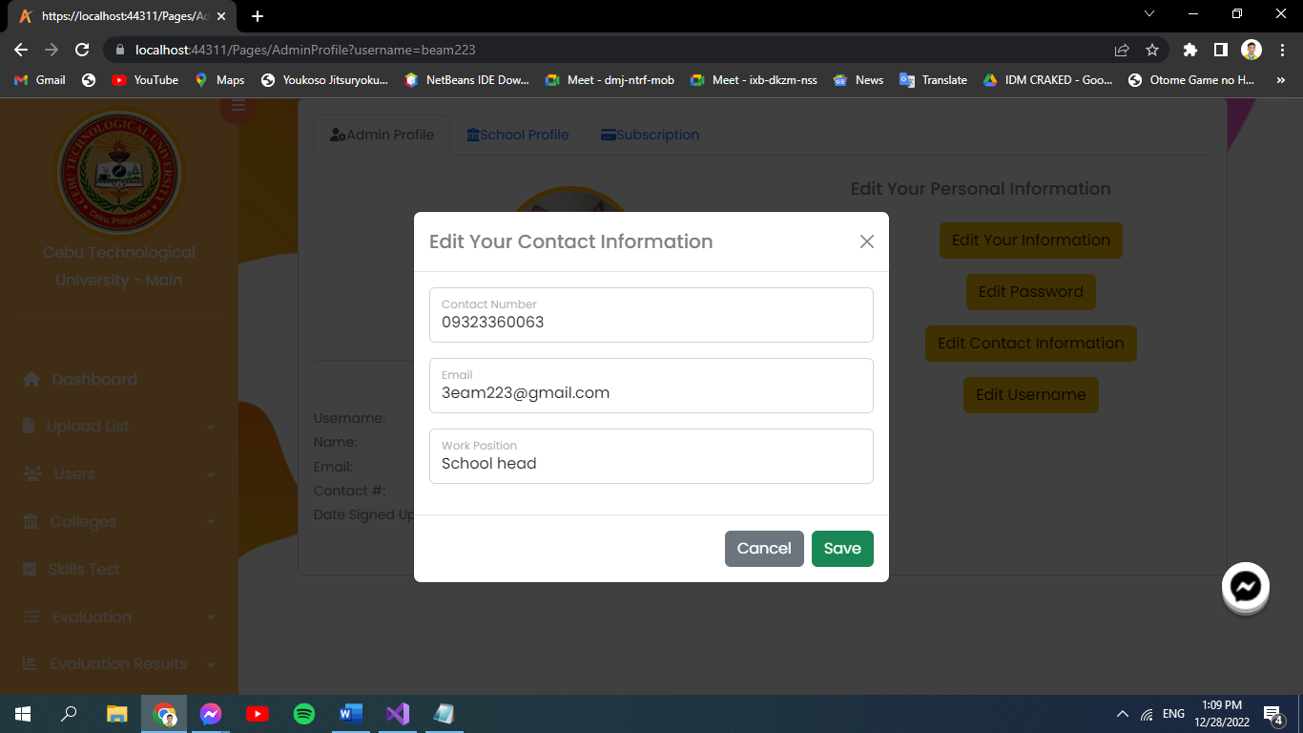

Figure 102: **Edit Contact Information**

In figure 102 is the edit contact information. By clicking “Edit Contact Information”, admin can change and save their contact.

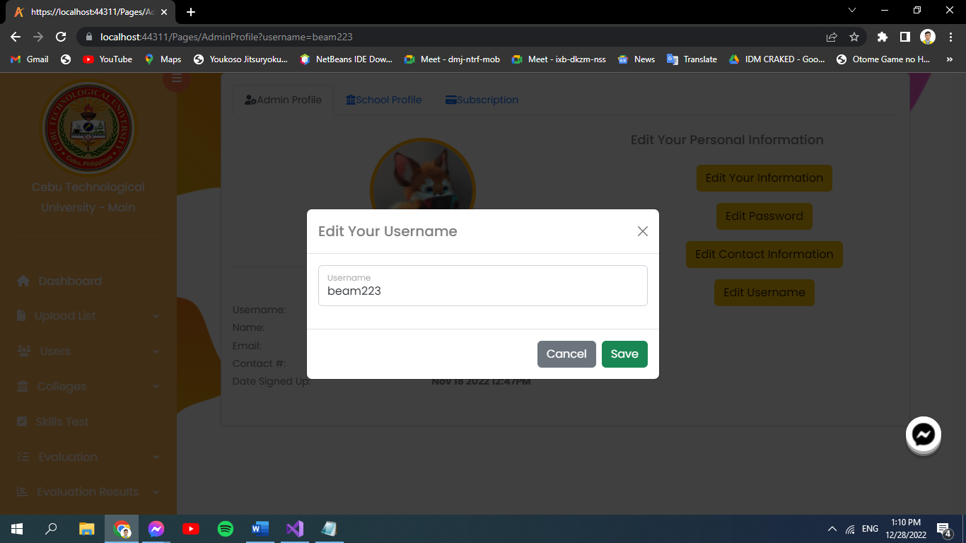

Figure 103: **Edit Username**

In figure 103 is the edit username. Click Edit your username and change it into your liking.



Figure 104: **School Information**

In figure 104 is the school information. They can change or upload school picture by clicking the camera icon, view its details and edit school information.

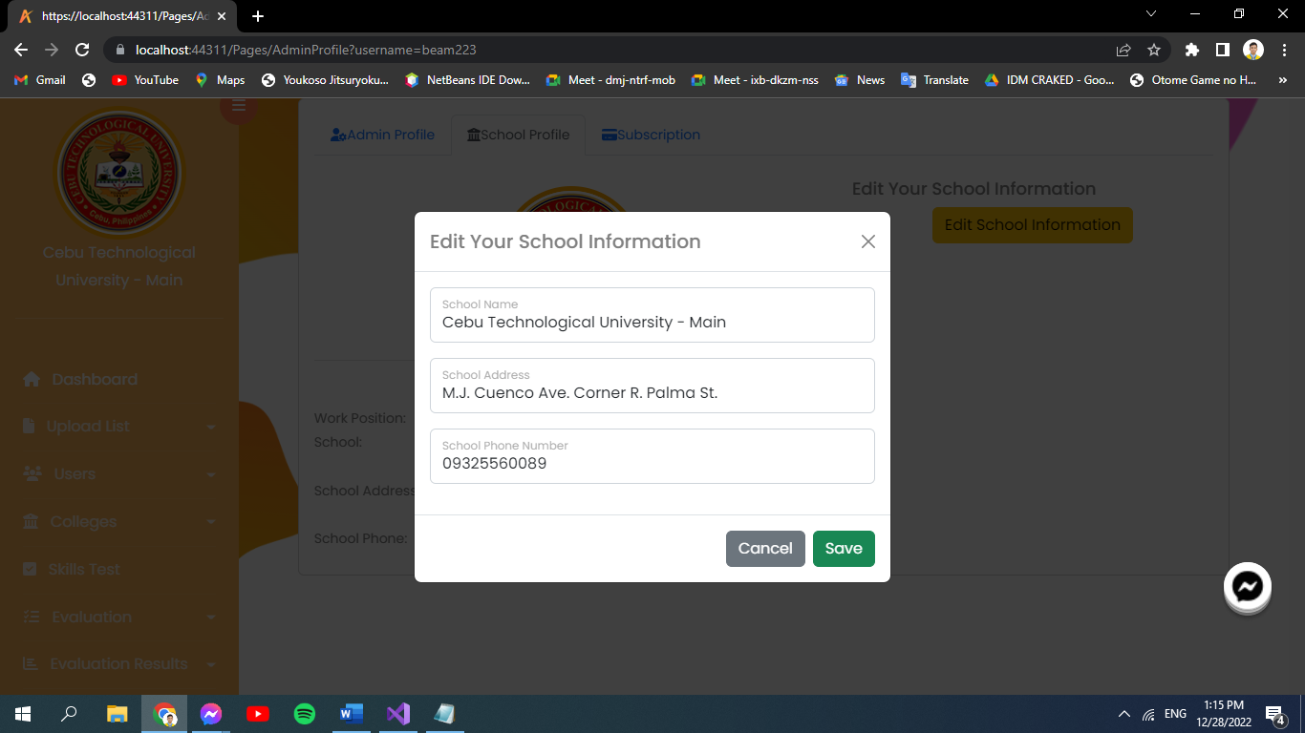

Figure 105: **Edit School Information**

In figure 105 is the edit school information. Clicking the edit school information, you can change its details and save it.

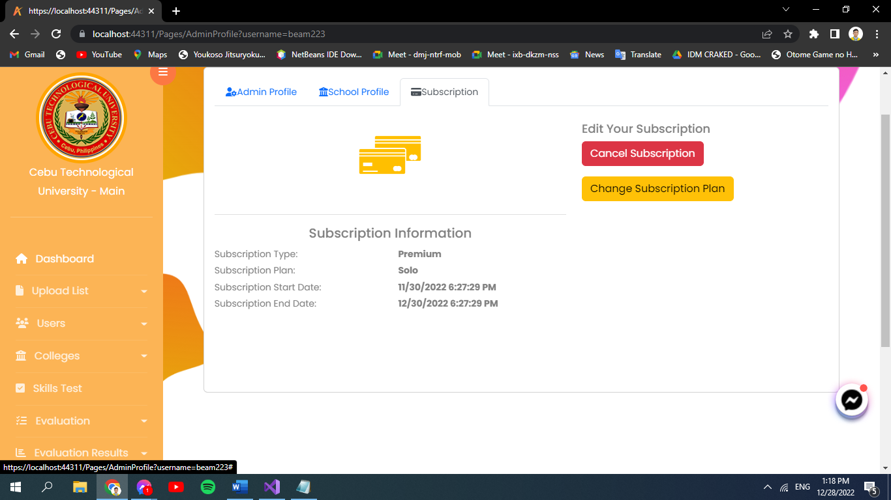

Figure 106: **Subscription Page**

In figure 106 is the subscription page. View subscription information and can cancel or change subscription plan.

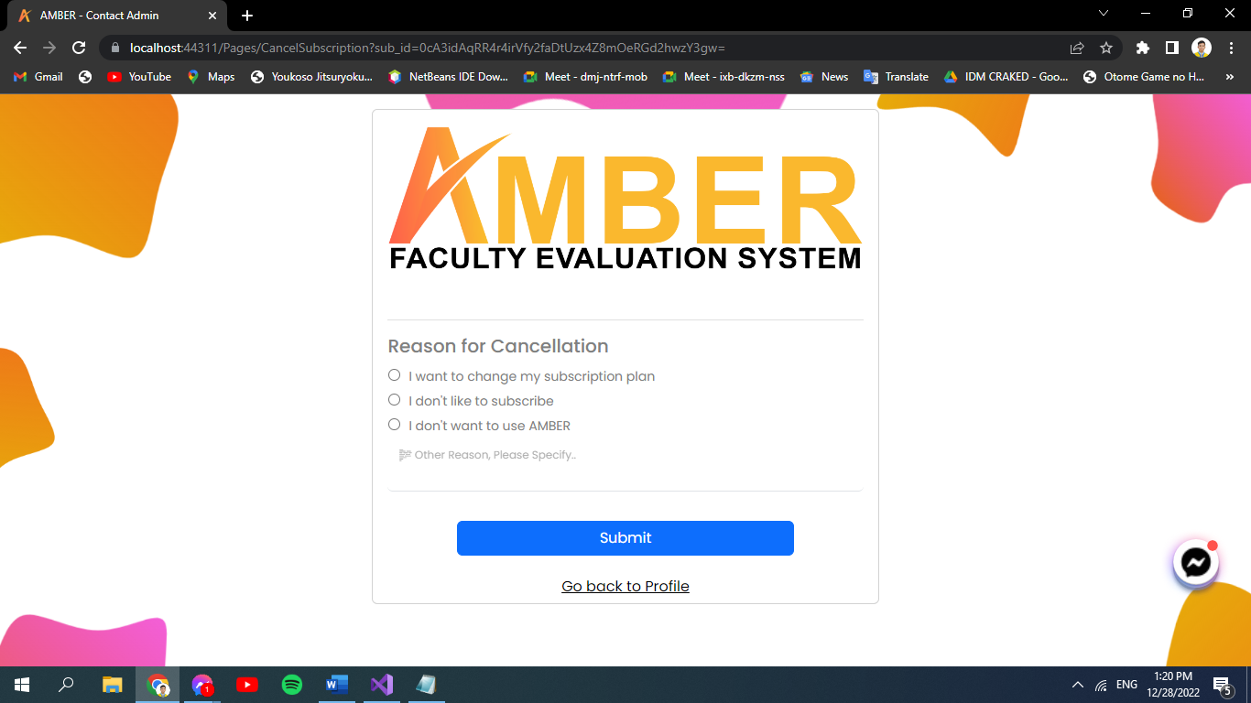

Figure 107: **Reason for Cancellation**

In figure 107 is the reason for cancellation. After clicking the cancel subscription button system then redirected admin to this page and will require to click reason for cancellation.

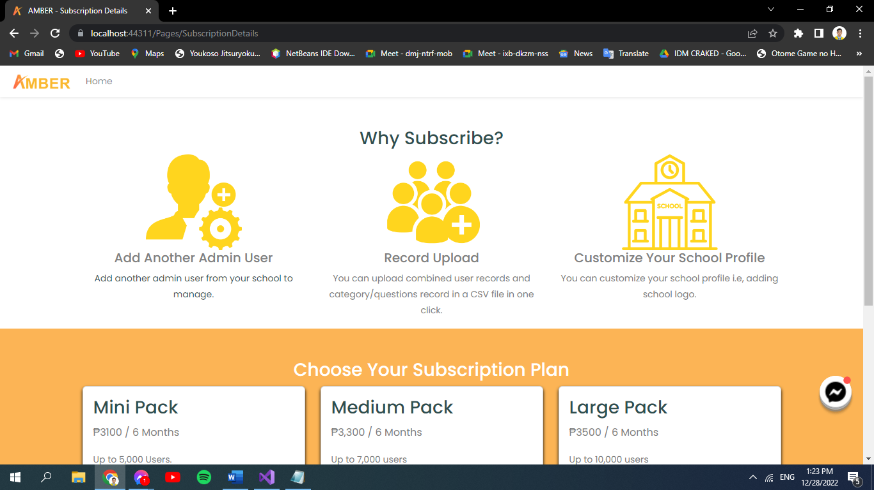

Figure 108: **Subscription Plan**

In figure 108 is the subscription plan. This part will then show after clicking change subscription plan.

1. Admin Logout.

If admin wants to logout then simply click the dropdown arrow located at the upper right corner of the web.

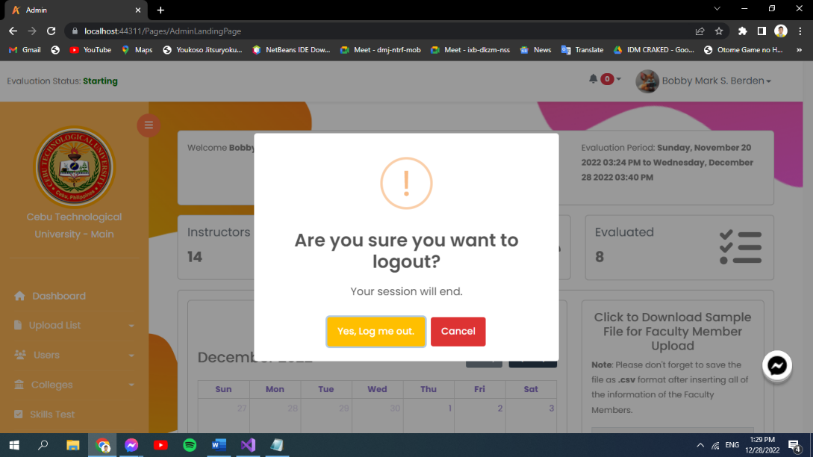  
Figure 109: **Confirmation Logout**

In figure 109 is the confirmation logout. If admin wants to logout then simply click the dropdown arrow located at the upper right corner of the web.

1. Subscription Page.

This shows where admin can pay its subscription.

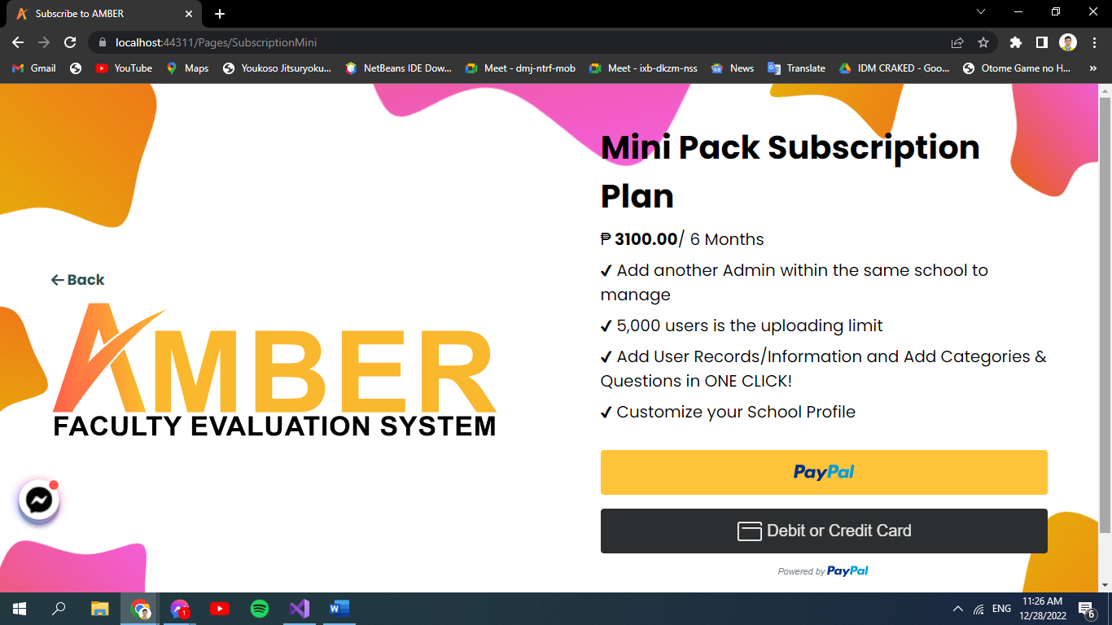

Figure 110: **Mini Pack Subscription Plan**

In figure 110 is the mini pack subscription plan. For Mini Pack Subscription.

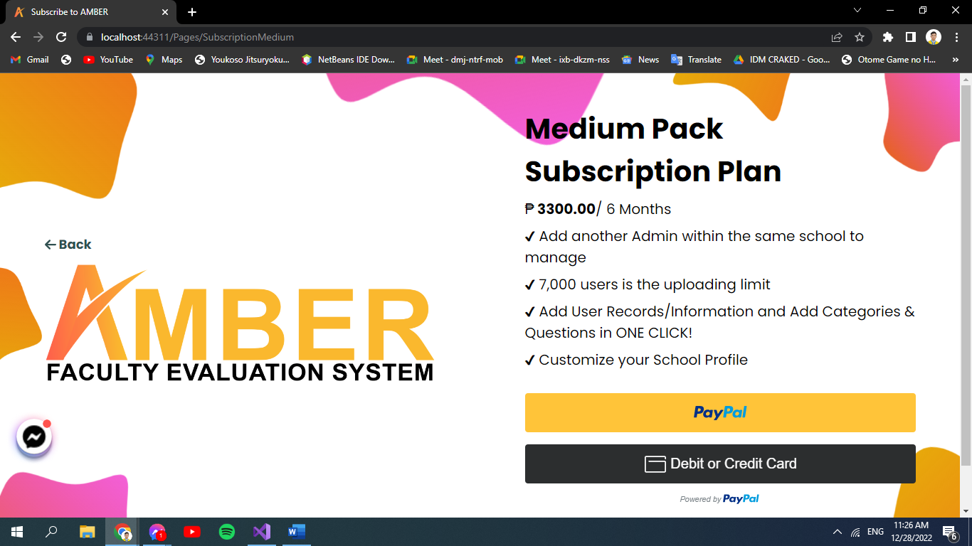

Figure 111: **Medium Pack Subscription Plan**

In figure 111 is the medium pack subscription plan. For Medium Pack Subscription.

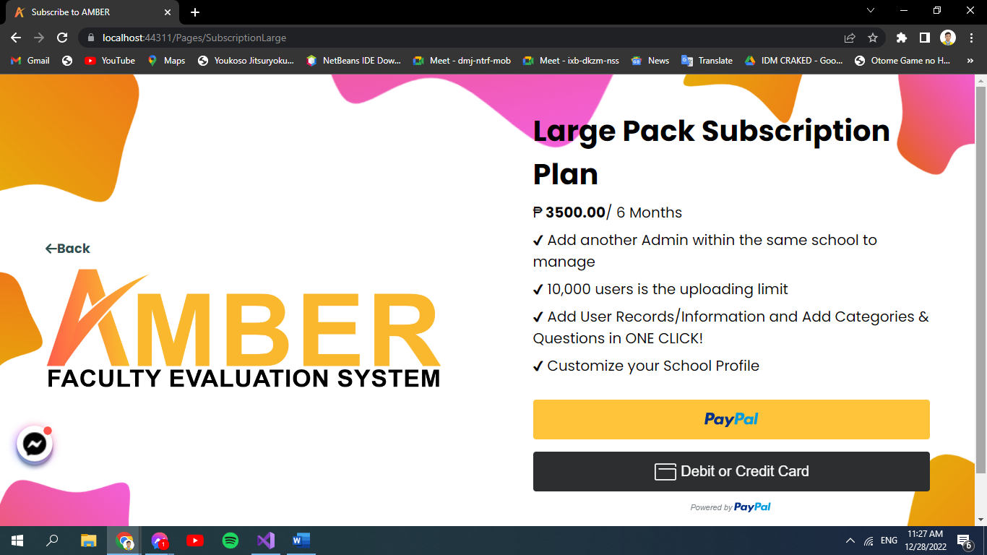

Figure 112: **Large Pack Subscription Plan**

In figure 112 is the large pack subscription plan. For Large Pack Subscription.

1. Subscription Plan

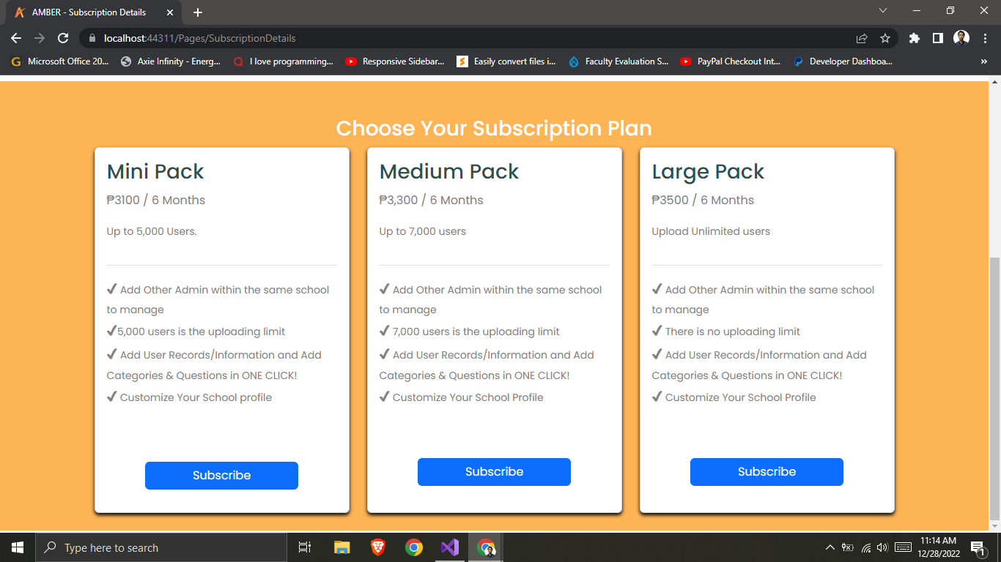

Figure 113: **Subscription Plan Details**

In figure 113 is the subscription plan details. This is where the admin can choose its subscription plan. It offers Mini, Medium and Large Pack Subscription Plan.

**Faculty and Student**

1. Faculty.

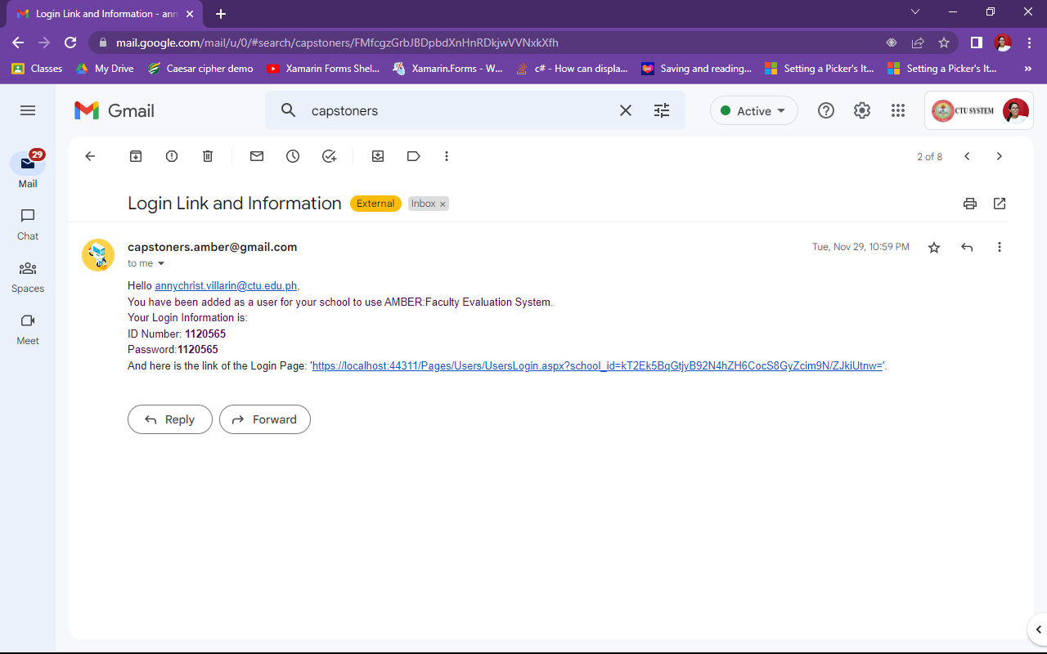

Figure 114: **Email Received**

In figure 114 is the email received. Check your email for account details and evaluation link. Note: In order for you to evaluate you must receive an email containing the account details and evaluation link.

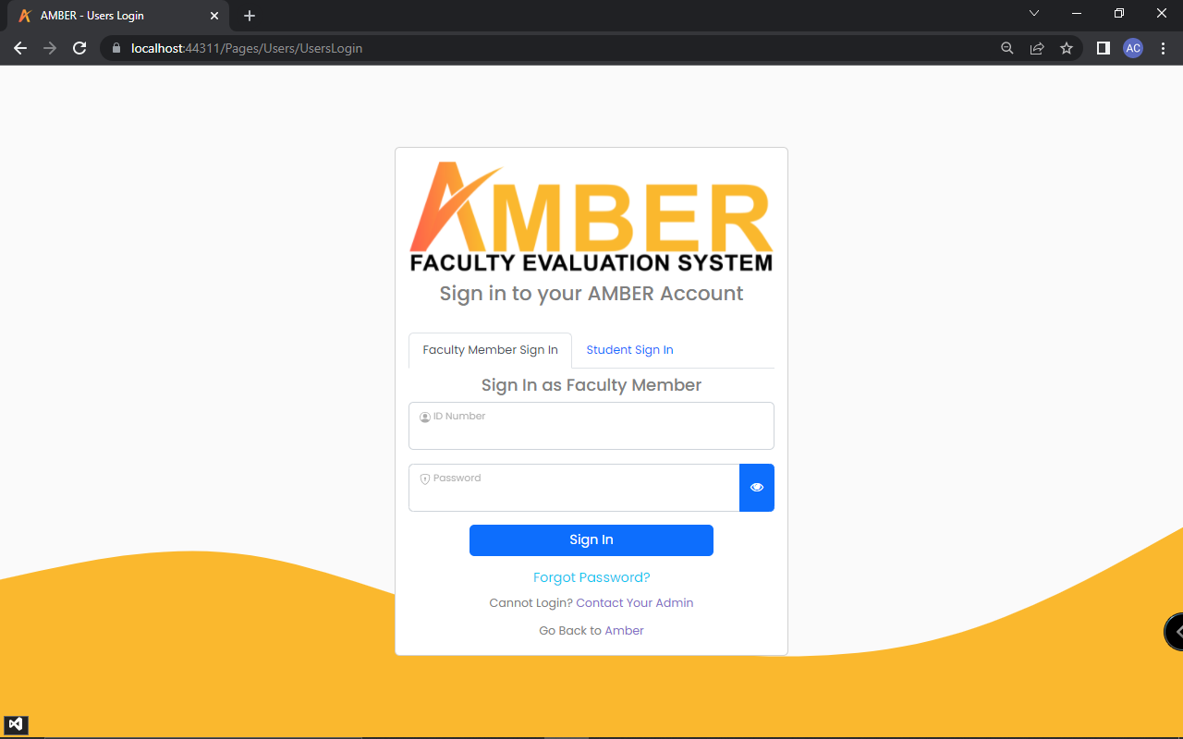

Figure 115: **Faculty Login Page**

In figure 115 is the faculty login page. Click Faculty Member Sign in if user is a faculty member on the web application. Then input what is being asked.

1. Student.

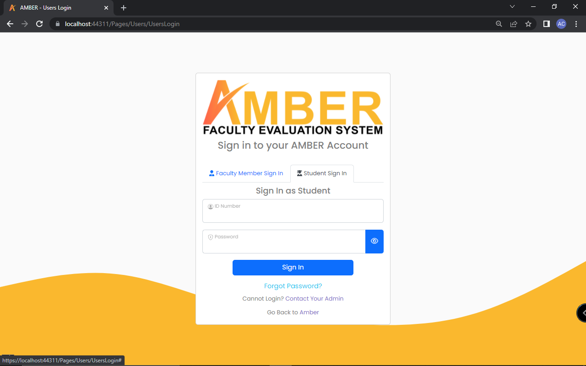

Figure 116: **Student Login**

In figure 116 is the student login. Click Student Sign in if user is a faculty member on the web application. Then input what is being asked.

1. Student Verification.

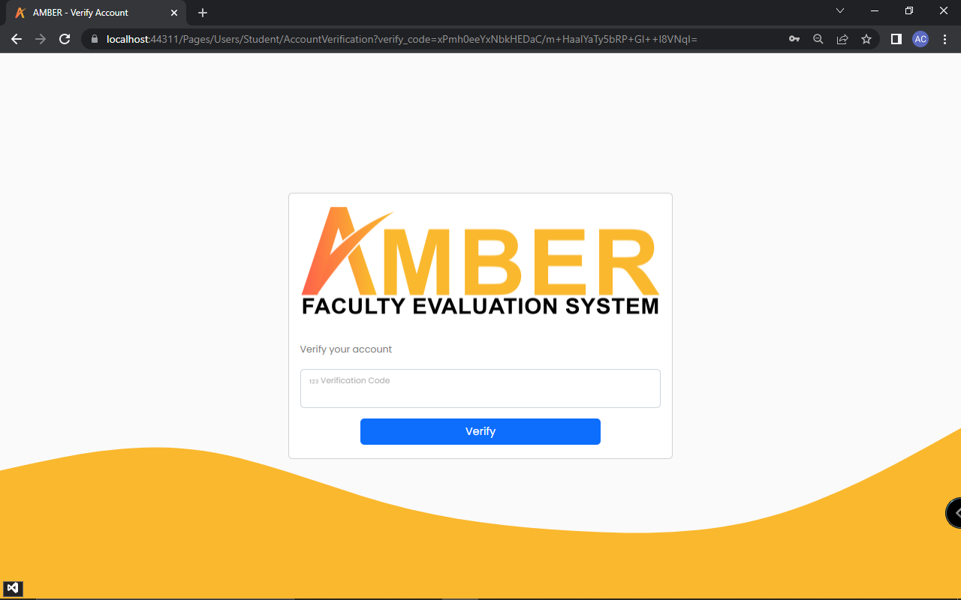

Figure 117: **Student Verification**

In figure 117 is the student verification. Right after signing in, users are sent a verification code to their email. In order to proceed, users are required to input the verification code.

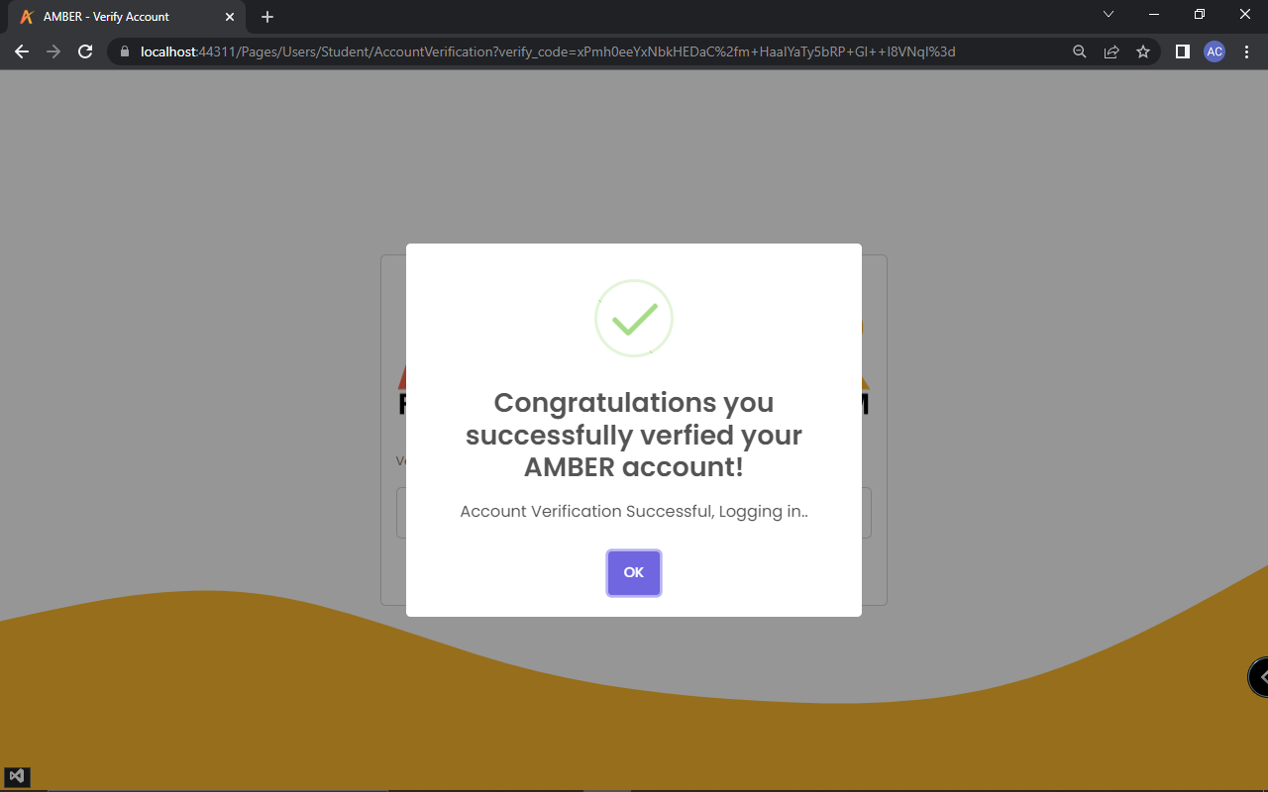

Figure 118: **Successfully Verified**

In figure 118 is the successfully verified. This shows if verification is successfully done.

1. Student Landing Page.

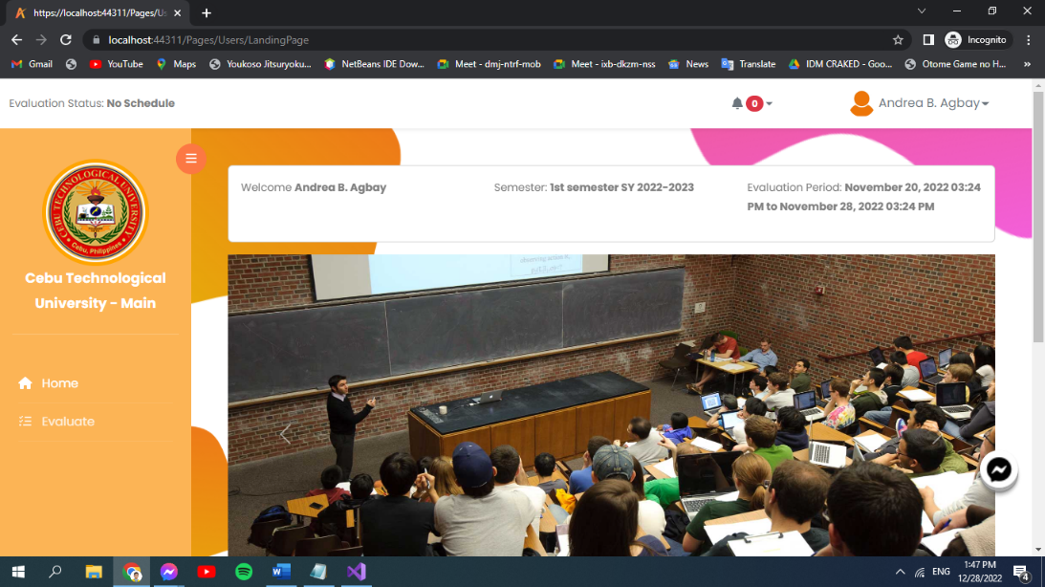

Figure 119: **Student Landing Page**

In figure 119 student landing page. It shows slides of images and some primary features for student users. Then what semester it is and evaluation period.

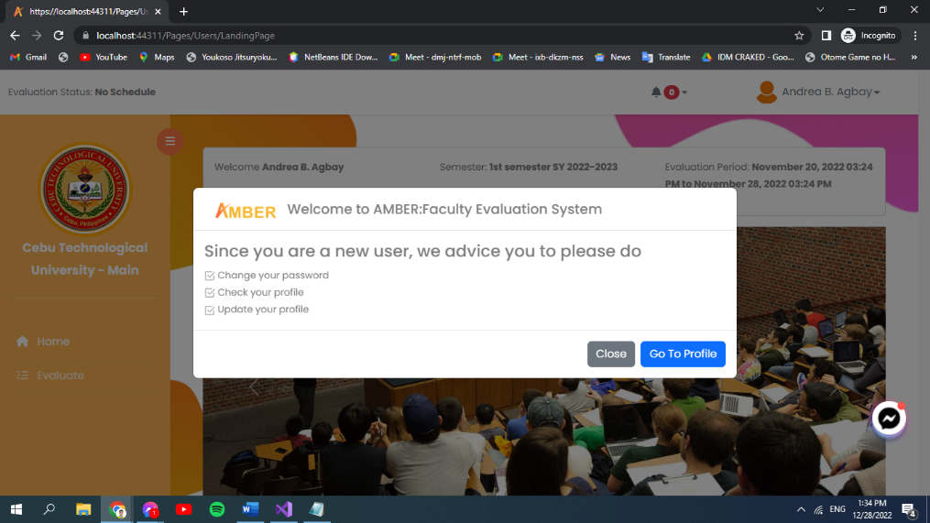

Figure 120: **Pop up Message for New User**

In figure 120 is the pop up message for new user. If you are a new user something like this will pop out.

1. Evaluation.

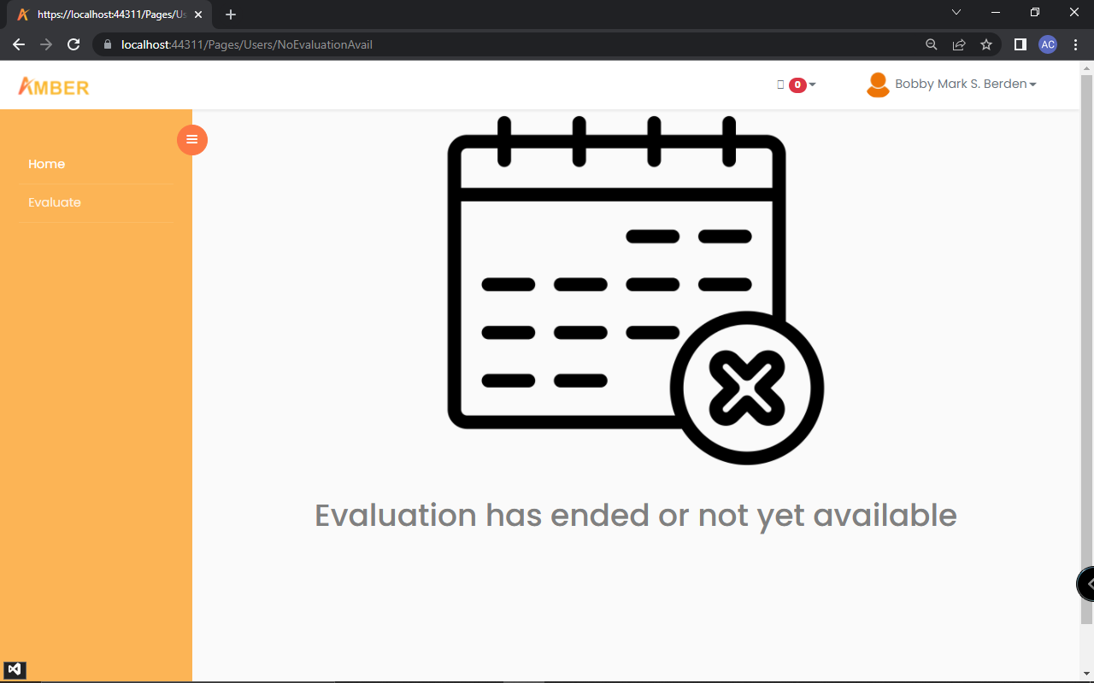

Figure 121: **No Evaluation Available**

In figure 121 is the no evaluation available. In here shows that there is no Evaluation form available or is already ended.

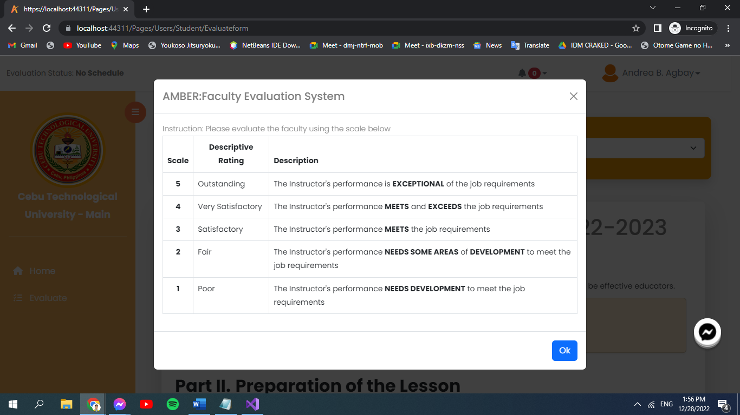

Figure 122: **Descriptive Rating**

In figure 122 is the descriptive rating. Before evaluating, the system will show instructions on how you should evaluate.

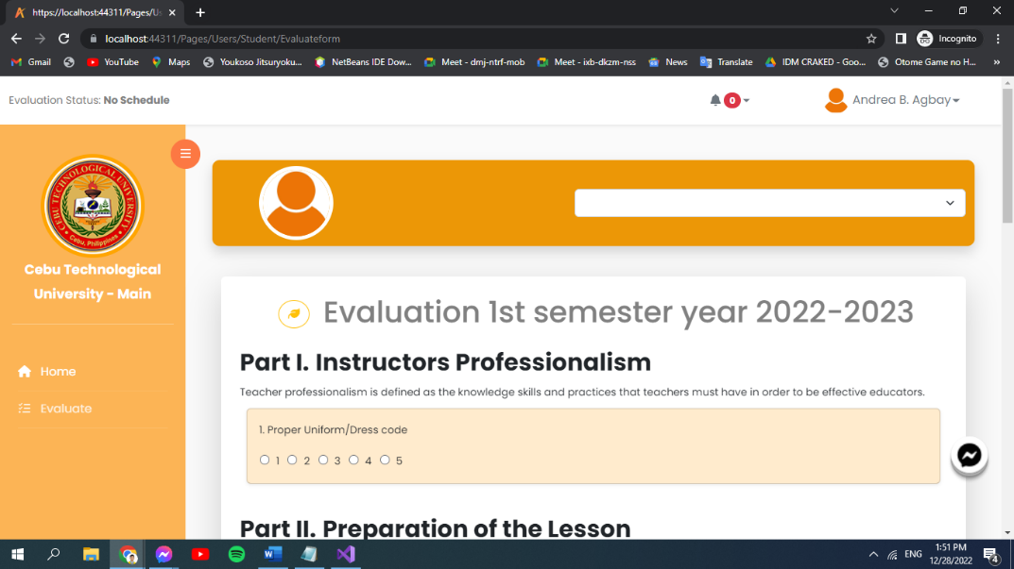

Figure 123: **Evaluation Form**

In figure 123 is the evaluation form. This where evaluation is done.

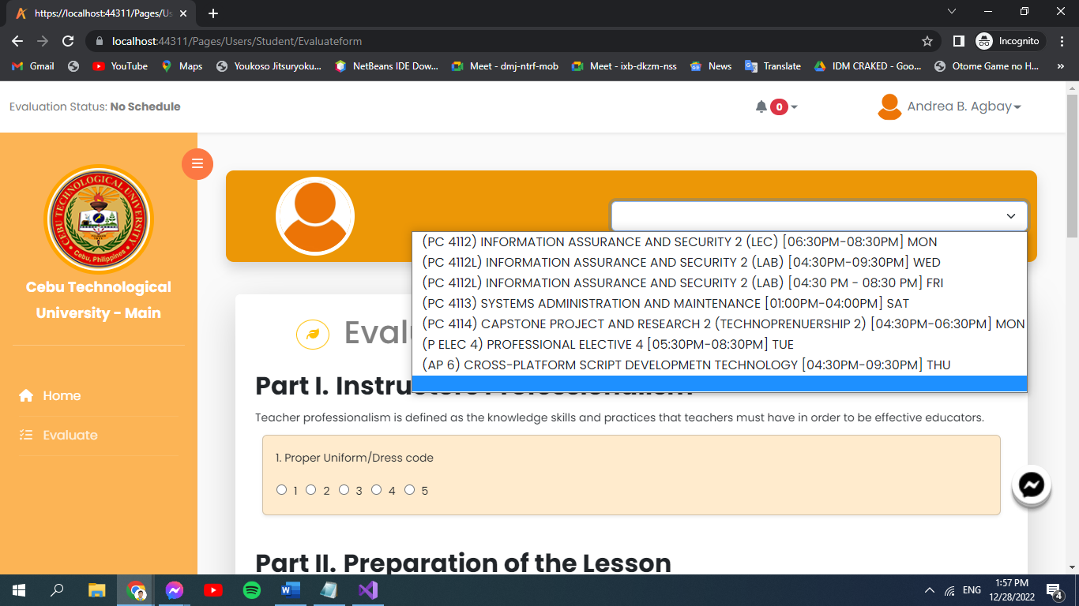

Figure 124: **Selecting instructor**

In figure 124 is the selecting instructor. This shows that before the students evaluate, they have to select which subject teacher is to be evaluated. Then after which, you can now start the evaluation by answering given questions.

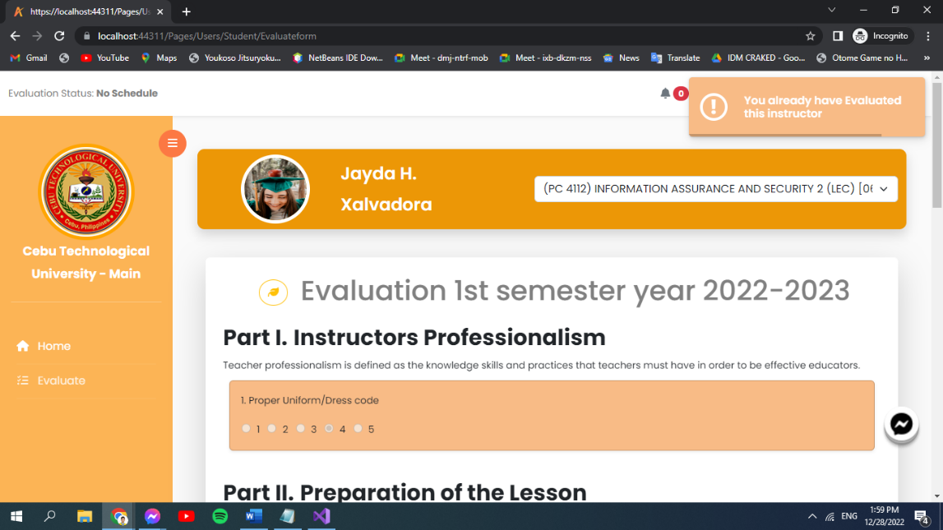

Figure 125: **Already Evaluated Instructor**

In figure 125 is the already evaluated instructor. This shows if ever the evaluator had already evaluated a particular instructor.

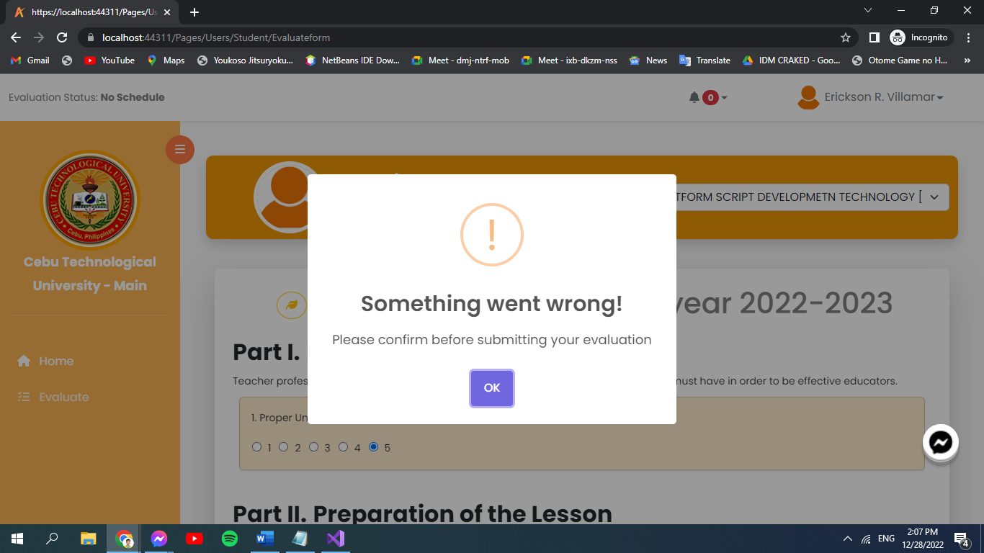

Figure 126: **Error When Submitting**

In figure 126 is the error when submitting. This will display if you don’t confirm first before clicking submit.

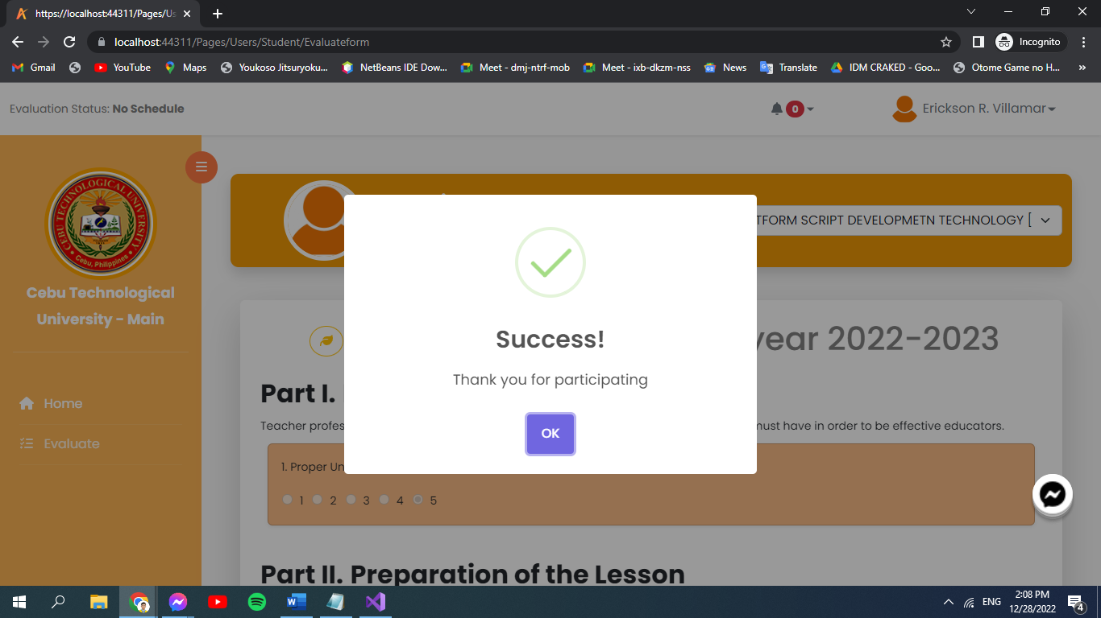

Figure 127: **Successfully Evaluated**

In figure 127 is the successfully evaluated. Then this will display after you have finished answering and have submitted the evaluation form.

1. Profile

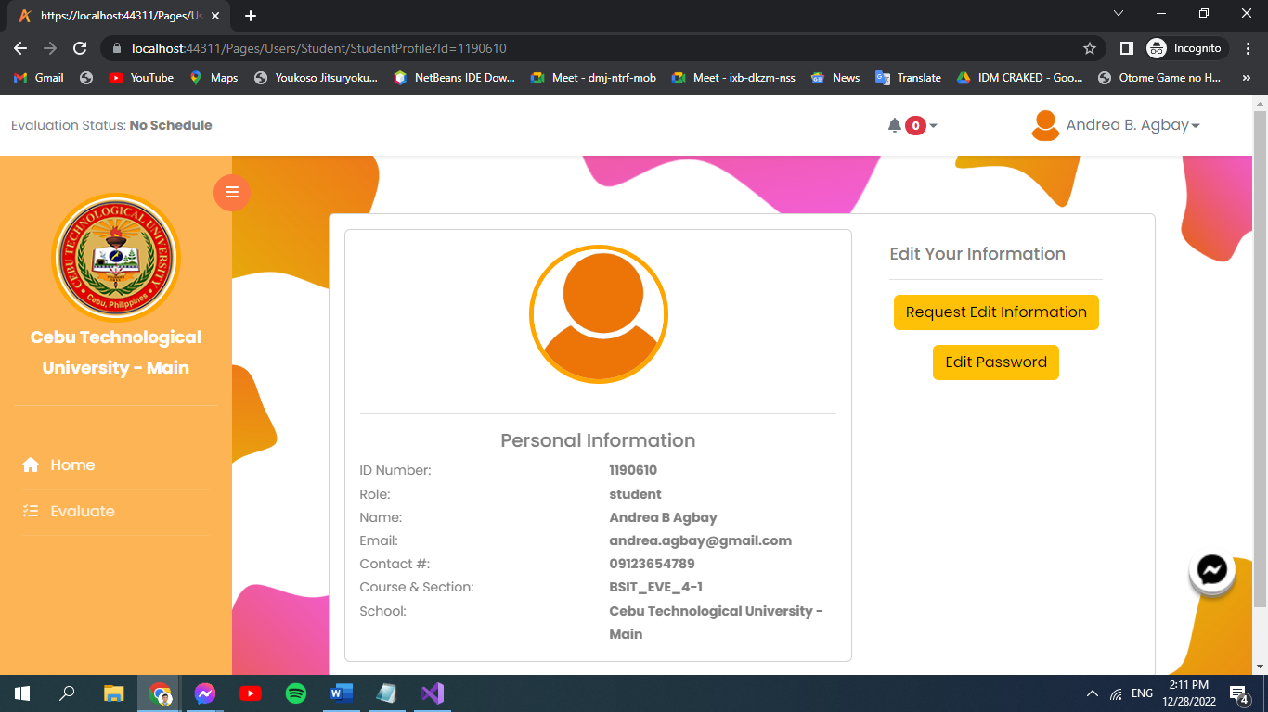

Figure 128: **Student’s Profile**

In figure 128 is the student’s profile. Then students can also visit and view their profile, then send request to edit user’s information and password then save all the changes.

1. Notification.

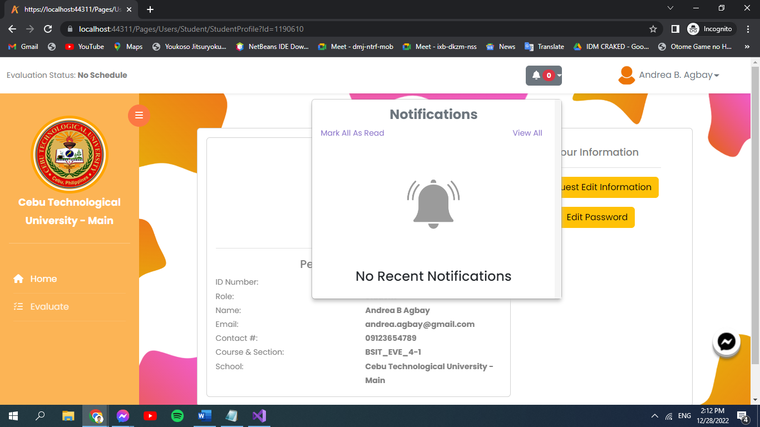

Figure 129: **Student’s Notification**

In figure 129 is the student’s notification. Students are notified if evaluation is open and more.

1. Student Logout.

Then if students want to logout, they are asked first for confirmation.

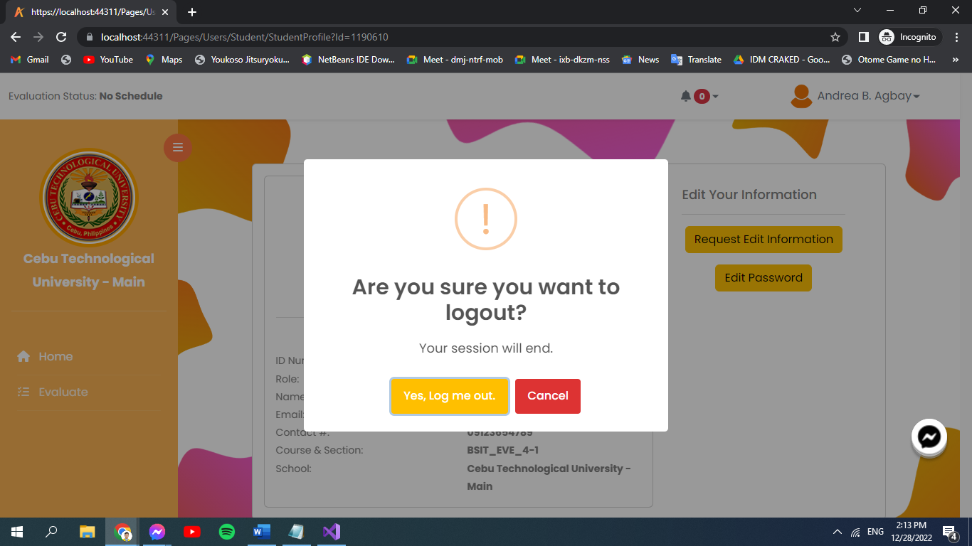

Figure 130: **Confirmation to Logout**

In figure 130 is the confirmation to logout. Then if students want to logout, they are asked first for confirmation.

1. Faculty.

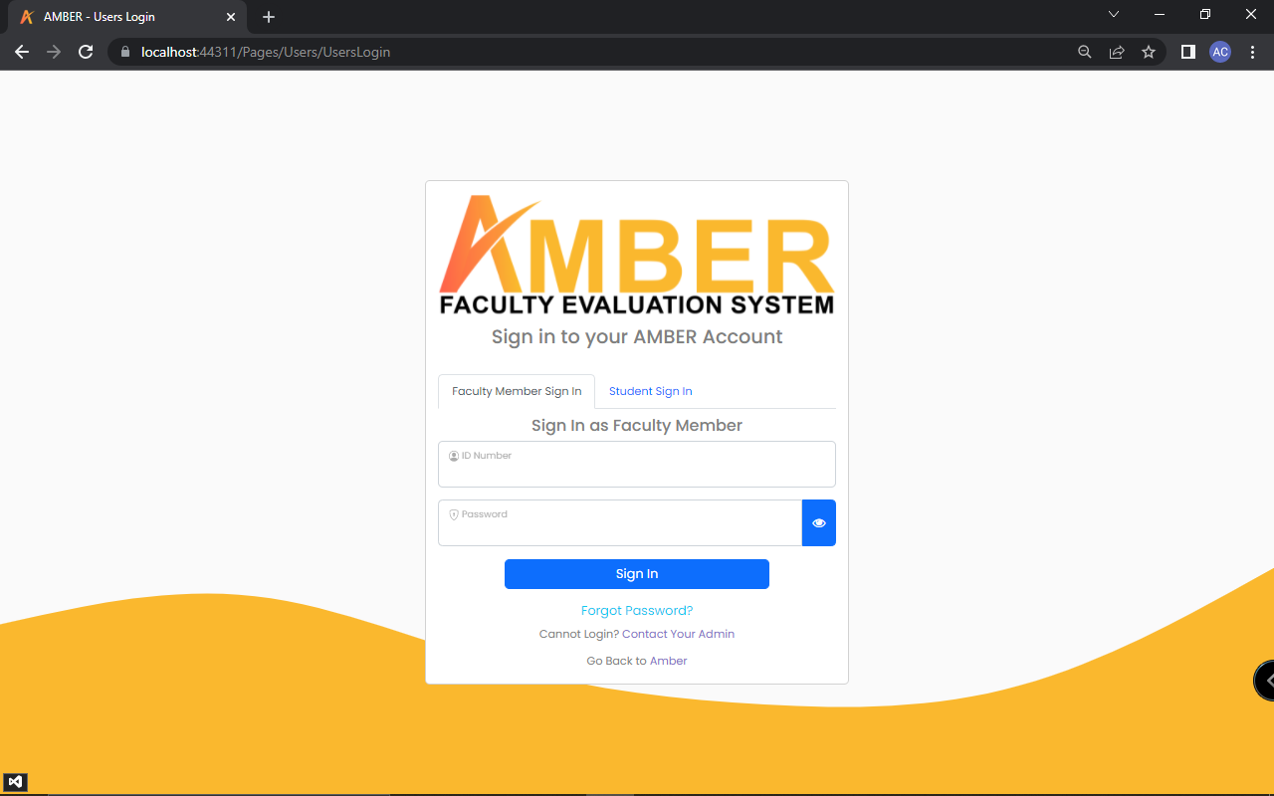

Figure 131: **Faculty Login**

In figure 131 is the faculty login. Click Faculty Member Sign in if user is a faculty member on the web application. Then input what is being asked.

1. Faculty Verification. 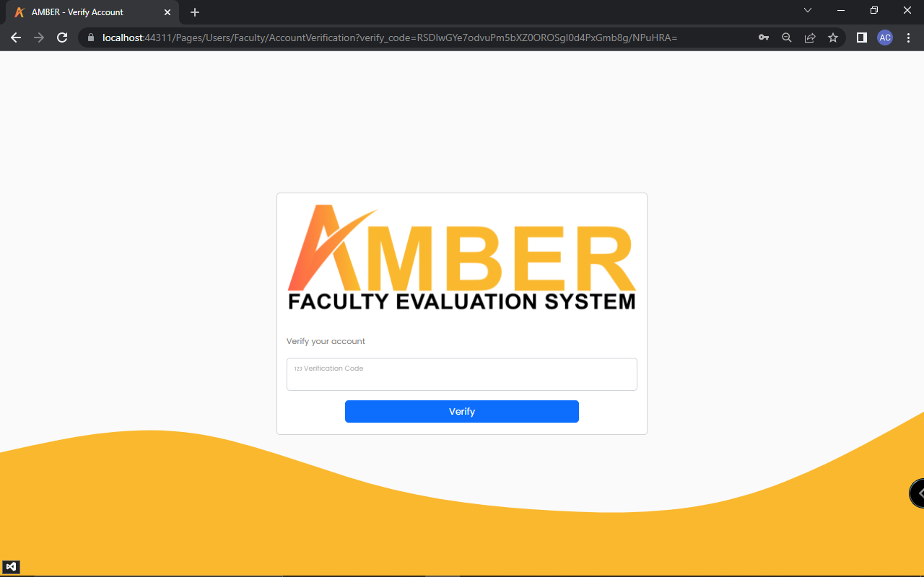

Figure 132: **Verify Account**

In figure 132 is the verify account. Right after signing in, users are sent a verification code to their email. In order to proceed, users are required to input the verification code

1. Faculty Landing Page.

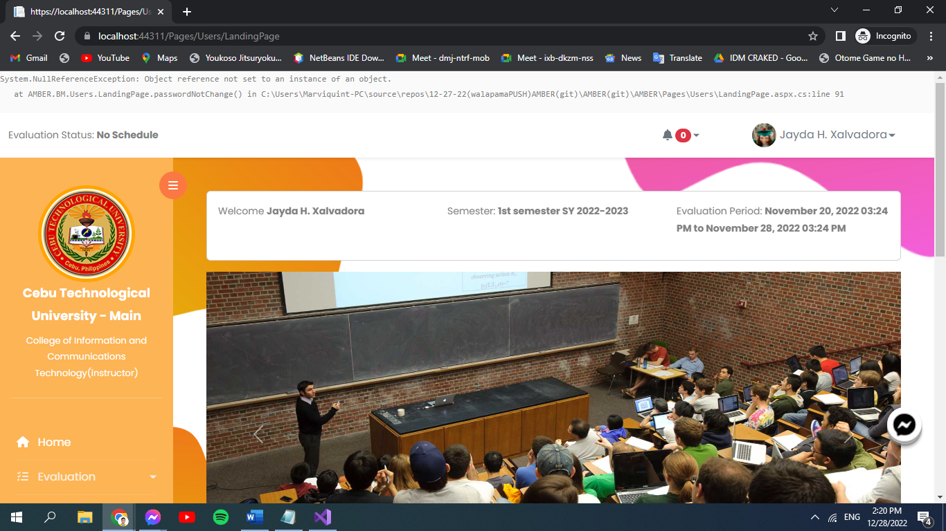

Figure 133: **Faculty Landing Page**

In figure 133 is the faculty landing page. It shows slides of images and some primary features for faculty users. Then what semester it is and evaluation period.

1. Peer Evaluation.

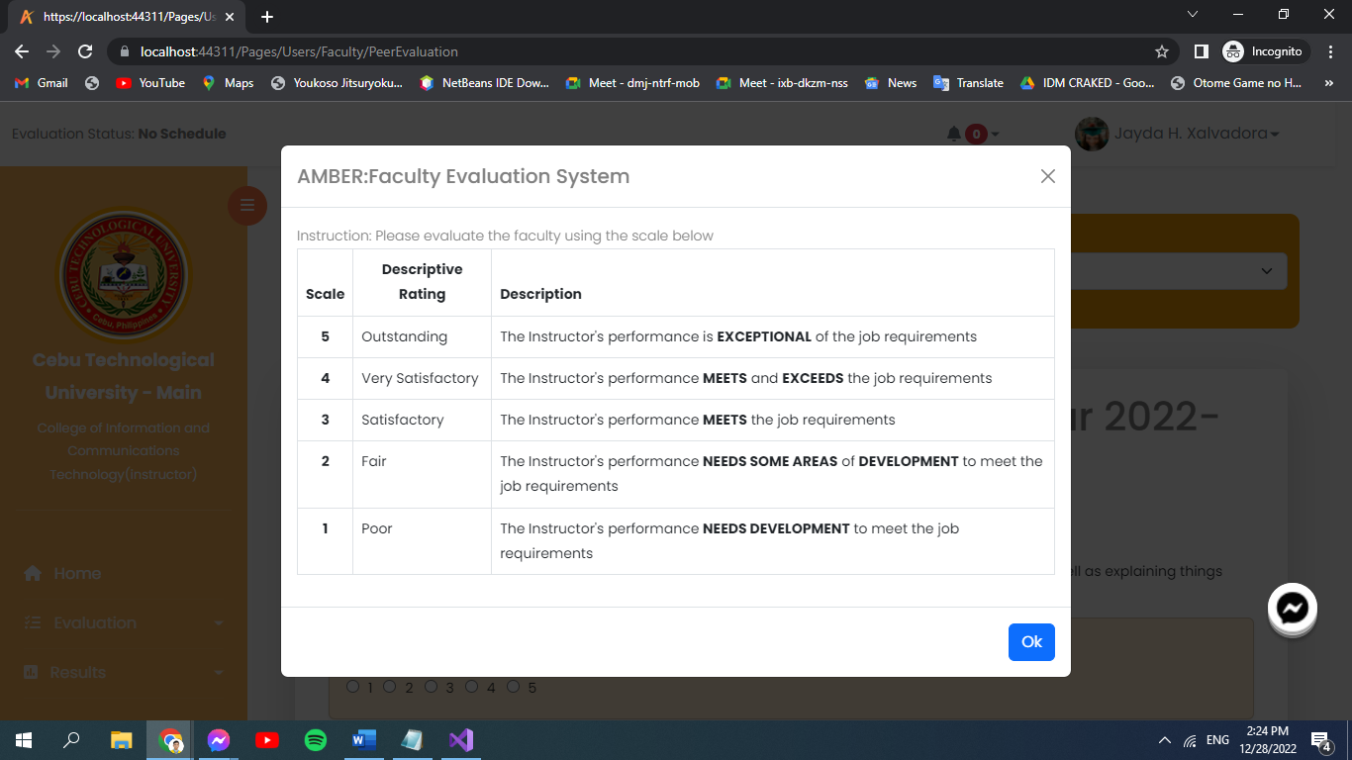

Figure 134: **Descriptive Rating**

In figure 134 is the Descriptive rating. Before evaluating, the system will show instructions on how you should evaluate.

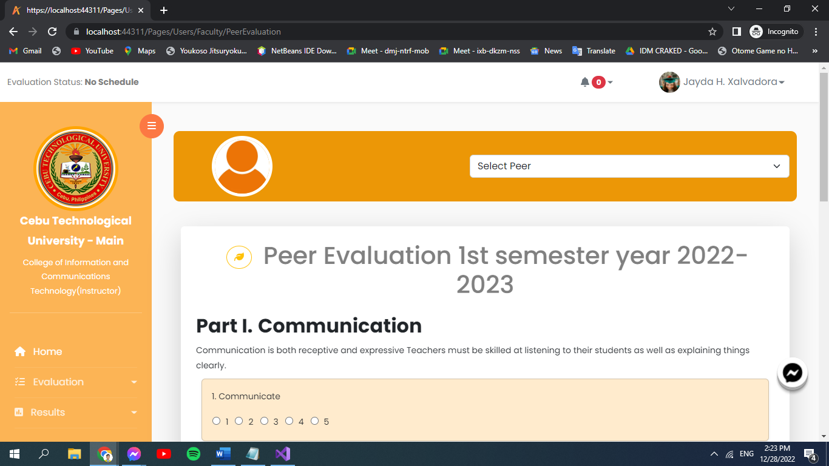

Figure 135: **Evaluation Form**

In figure 135 is the evaluation form. Faculty members are to select which peer before starting to evaluate. Then after which, you can now start the evaluation by answering given questions.

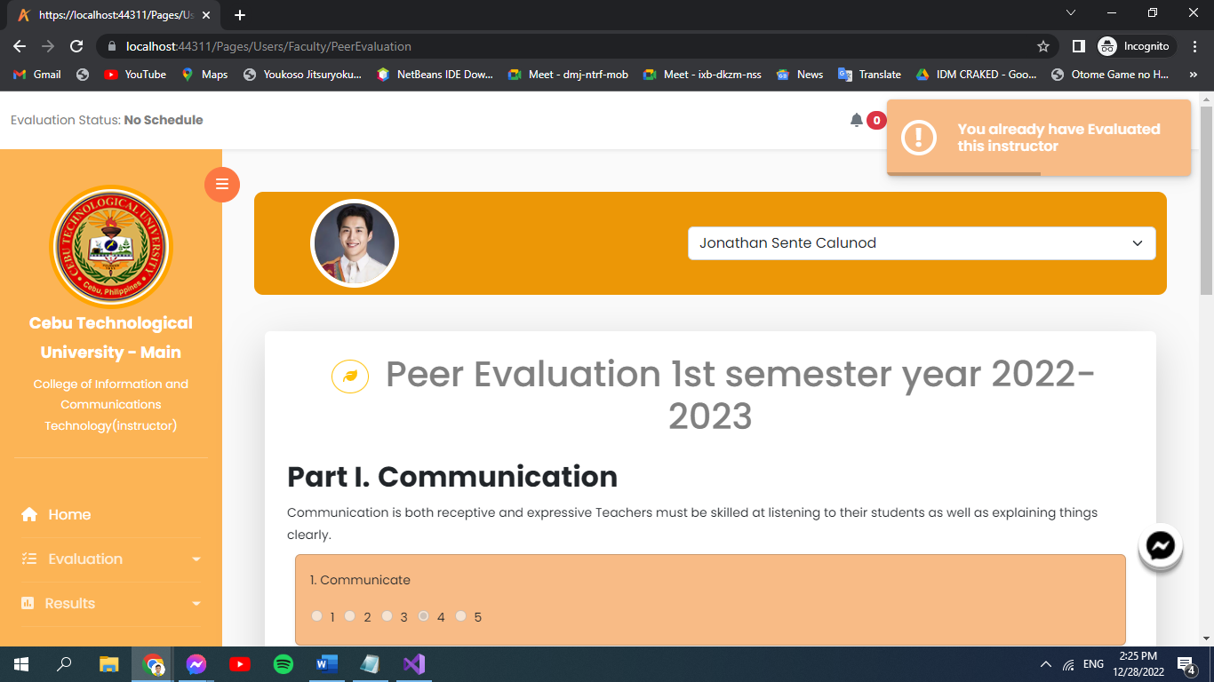

Figure 136: **Instructor Already Evaluated**

In figure 136 is the instructor already evaluated. This shows if ever the evaluator had already evaluated a particular instructor.

1. Self-Evaluation.

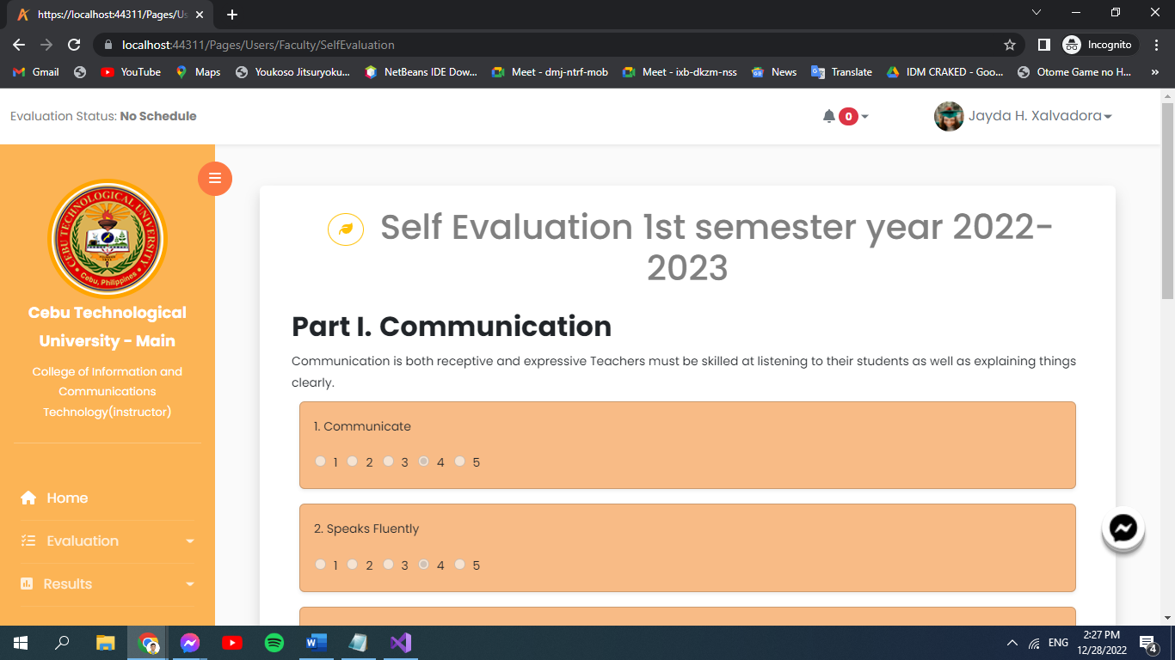

Figure 137: **Self Evaluation**

In figure 137 is the Self-Evaluation. Faculty members are encouraged to do an honest evaluation on themselves, evaluation process is the same.

1. Evaluation Result.

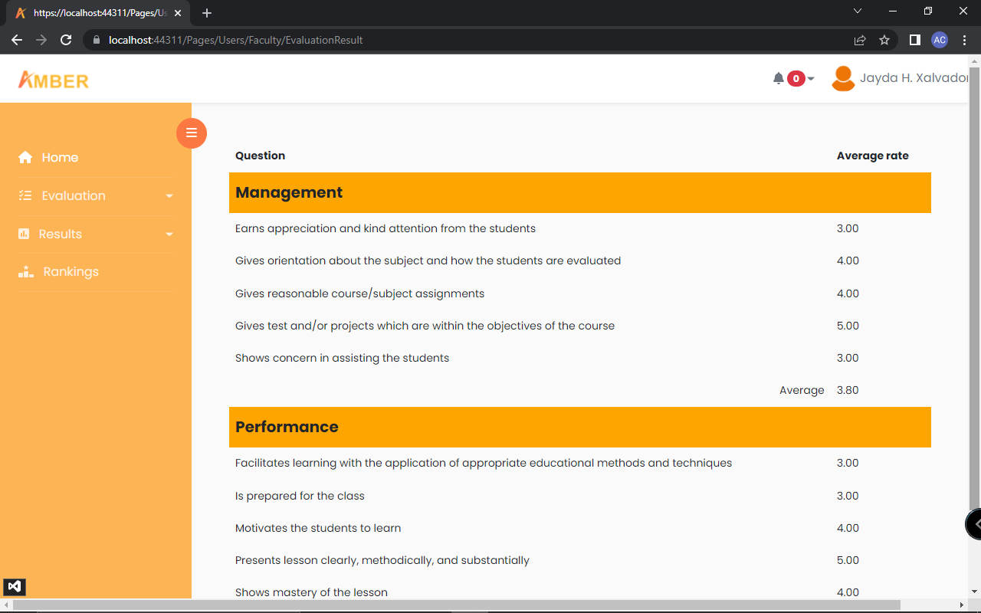

Figure 138: **Evaluation Result**

In figure 138 is the evaluation result. Faculty members can view the overall rate they’ve got from the student's submitted evaluation.

1. Notification.

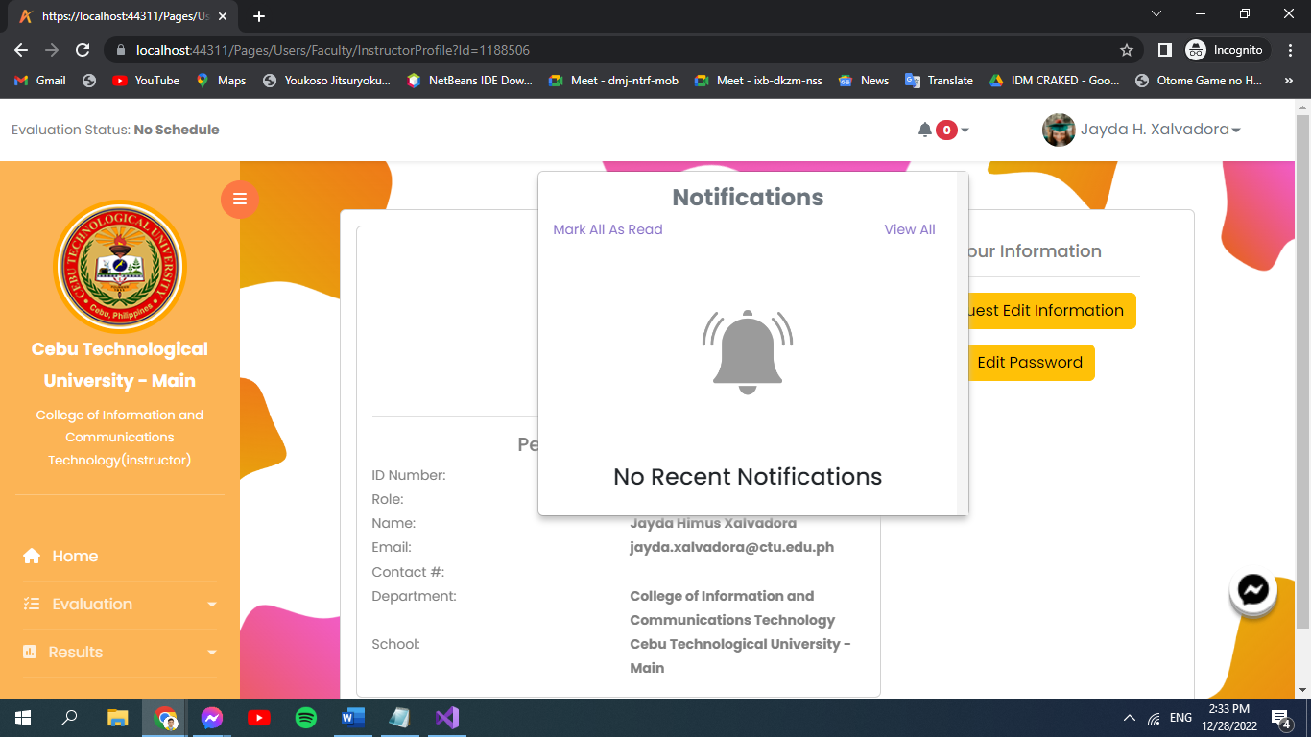

Figure 139: **Faculty’s Notification**

In figure 139 is the faculty’s notification. Faculty members are notified if evaluation is open and more.

1. Faculty Profile.

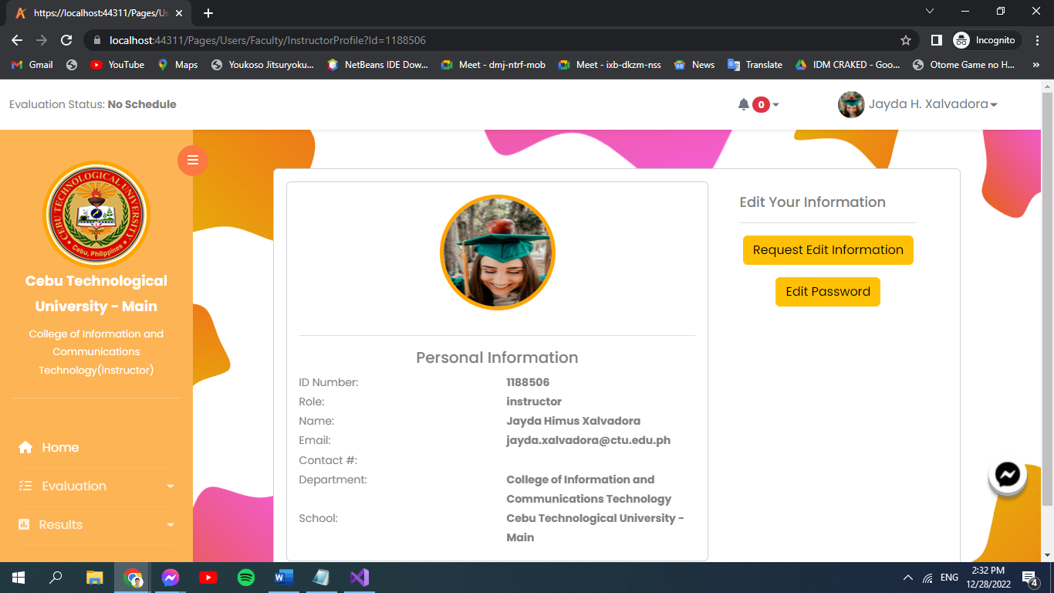

Figure 140: **Faculty’s Profile**

In figure 140 is the faculty’s profile. The faculty members can also visit and view their profile, then send request to edit user’s information and password then save all the changes.

1. Request Edit Information.

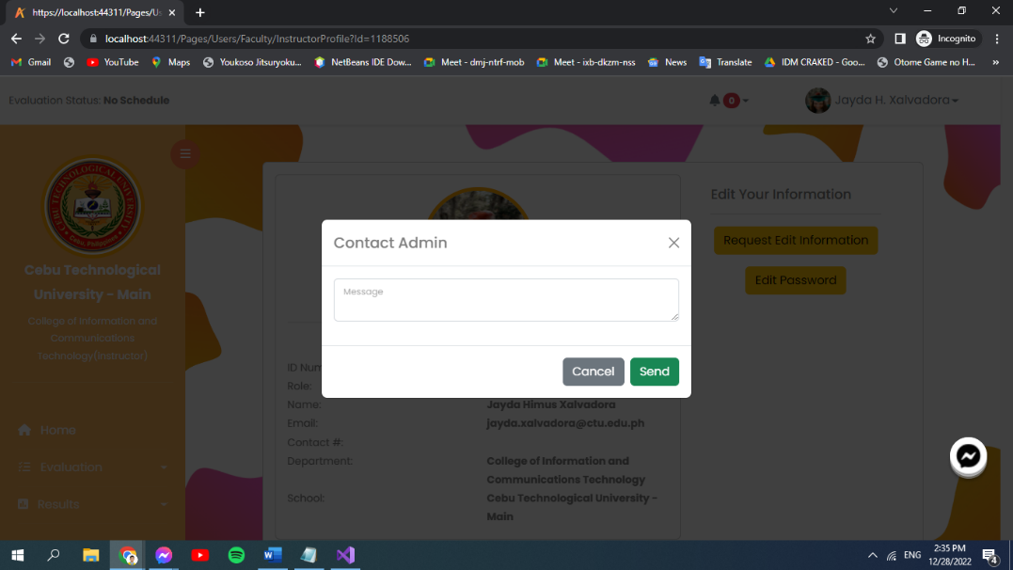

Figure 141: **Contact Admin**

In figure 141 is the faculty’s profile. This here shows that you have to contact the admin to send request edit the faculty member’s information.

1. Password.

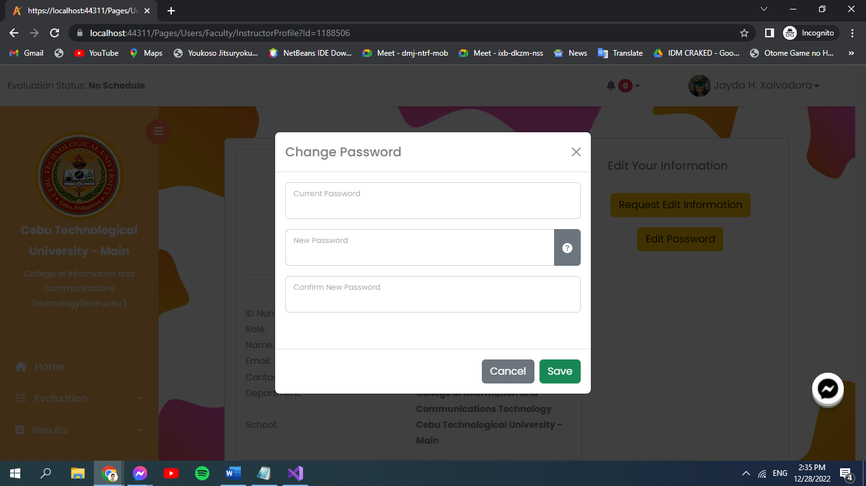

Figure 142: **Change Password**

In figure 142 is the change password. Users can change their password and save the new one.

**Dean**



Figure 143: **Dean’s Profile**

In figure 143 is dean’s profile. This is where the dean can view its information and request edit on it.



Figure 144: **Student Management**

In figure 144 is the student management. This is where the dean can add, edit and delete a student information.



Figure 145: **Faculty Member Management**

In figure 145 is the faculty member management. This is where the dean can add, edit and delete a faculty member.



Figure 146: **Section Management**

In figure 146 is the section management. This is where the dean can add, edit, and delete a section.



Figure 147: **Course Management**

In figure 147 is the course management. This is where the dean can manage the course.



Figure 148: **Subject Management**

In figure 148 is the subject management. This is where the dean manages the subject.



Figure 149: **Evaluation Ranking**

In figure 149 is the ranking. This is where the dean can view the ranks of the instructor.

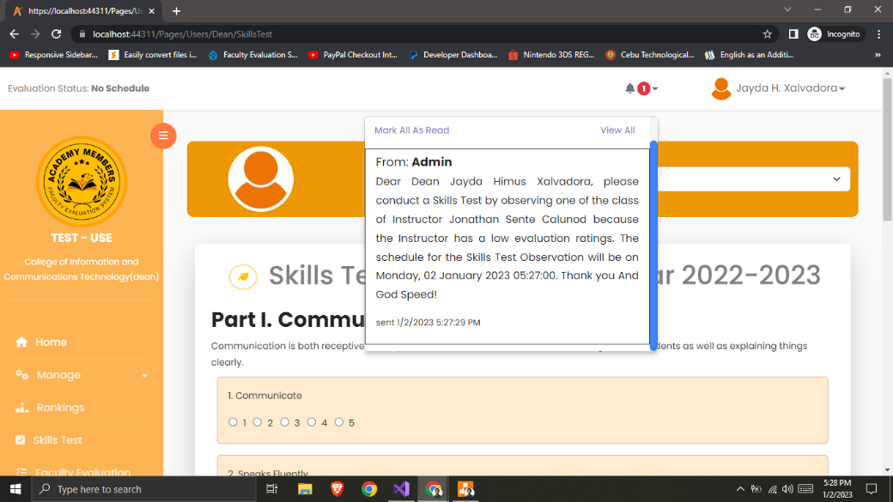

Figure 150: **Skill Test Notification from Admin**

In figure 150 is the Skill Test Notification from admin. This is after admin sent a request for skill test.

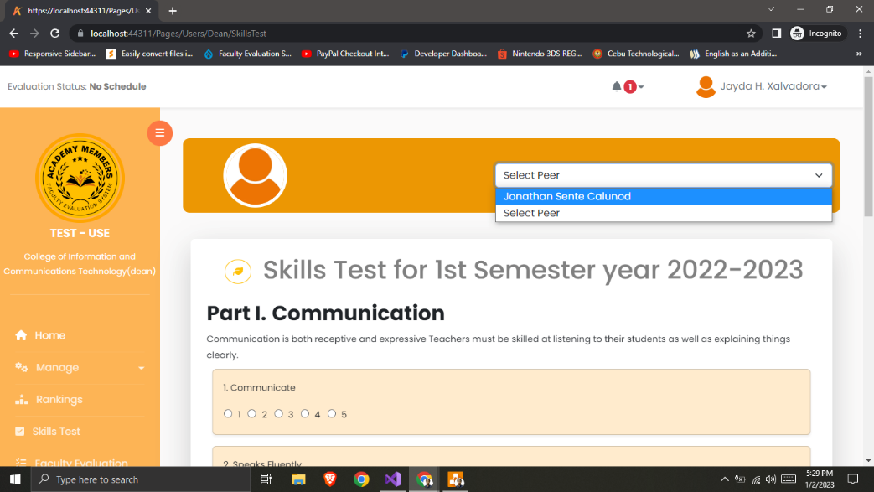

Figure 151: **Select Instructor for Skill Test**

In figure 151 is the select instructor for skill test. This is used in evaluating the instructor performance during skill test.



Figure 152: **Student Evaluation Report**

In figure 152 is the student evaluation report. This is where the dean can view, if the instructor of that subject has been evaluated.



Figure 153: **Peer Evaluation Report**

In figure 153 is the peer evaluation result. This is where the admin can view the evaluation result of the instructor.

**Roadmap**

Project roadmaps aid in the visualization of the timeframe for the objectives, responsibilities, and tasks of the project. In most cases, their beginning and end dates are predetermined. Project roadmaps allow you to match the phases of the project lifecycle, such as the initiation, planning, implementation, and closing phases, or the full project's timetable. When deciding on priorities and tracking the progress toward the objectives, the roadmap is used to inform the project team on the objectives and milestones.

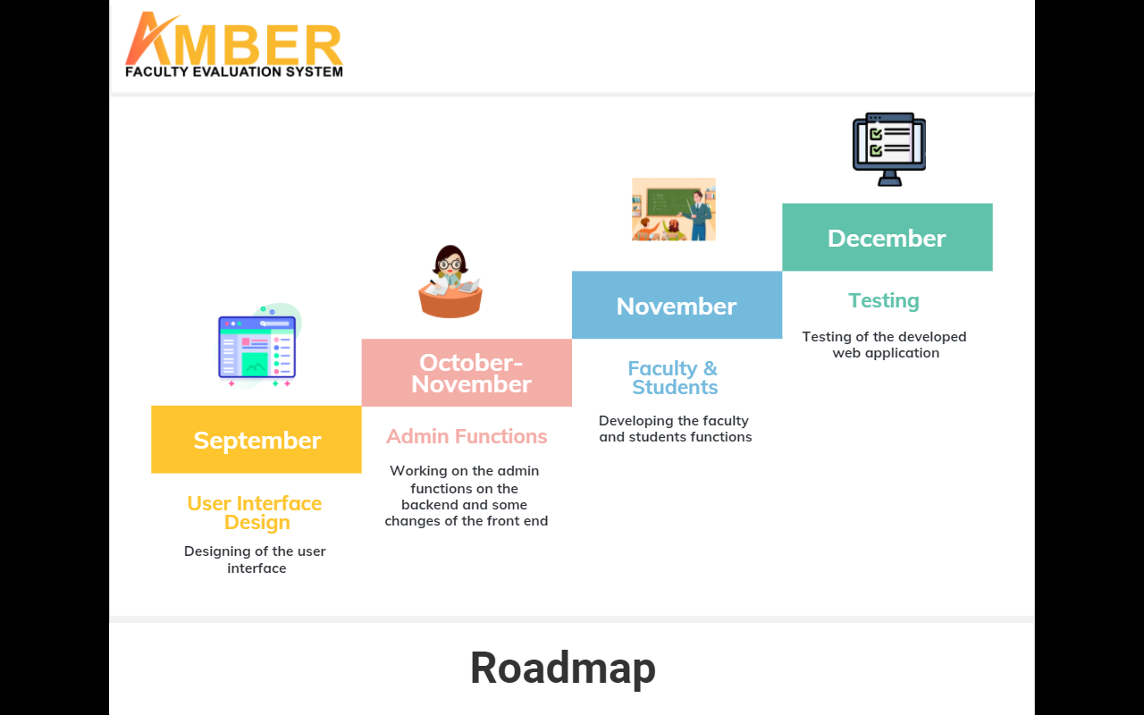

Figure 154: **Roadmap**

Figure 154 shows a project's objectives and key deliverables (tasks, milestones) are arranged on a timetable in a single visual representation or graphic called a roadmap as a strategic planning approach.

**CONCLUSION**

* In AMBER Web Application, the administrator of the university can manage profile, the users, can view reports, can manage the results with data analytics, can manage evaluation, can requests the skill test, can manage academic details (university wide), can give recommendations and see displayed rankings based from the results of student evaluation.
* The said web application can also let the dean manage their own profile, can manage academic details and reports (department wide), conduct skill test, gets notifications and can participate in faculty evaluation.
* All the instructors can be able to manage their own profile, can evaluate their peers, can even do honest self-evaluation and receive notifications in the application.
* The students can manage their profile, can rate or evaluate their instructors, and gets notifications through the AMBER Web Application.
* The Super Administrator in the AMBER Web Application can manage profile, the users, the adding of users, view reports, receives notifications, academic details and reports (department wide), manages subscription and can view the rankings based from the evaluation.

**RECOMMENDATION**

* The proponents strongly recommend every educational institution to use this web application for an easier and have better experience in doing faculty evaluation.
* The additional advancements must be made in order to incorporate it with the new technologies that are yet to come or invented.
* It is important to thoroughly validate the system's features to make sure they are compatible with the school's information system.
* Future continuing studies about AMBER: Faculty Evaluation System may enhance the following functionalities and features on the application.
* After the implementation, it is vital to interview the users, including the instructors and students, to get their feedback on how things could be improved.

**REFERENCES**

Almiranez, G. C. (2018). Impact of Online Faculty Evaluation on the Teaching Performance of Pup Taguig Faculty. Ascendens Asia Journal of Multidisciplinary Research Abstracts, 2(1).

<https://ojs.aaresearchindex.com/index.php/AAJMRA/article/view/4705>

Jaramillo, I. F., Pico, R. B., & De La Plata, C. V. M. (2017). A model for faculty evaluation in higher education Ecuadorian through multi-criteria decision Analysis. Indian Journal of Science and Technology, 10(18), 1-8.

<https://sciresol.s3.us-east-2.amazonaws.com/IJST/Articles/2017/Issue-18/Article17.pdf>

Taguiam, I. M. (2016). Web-Based Faculty Evaluation System of Apayao State College, Philippines. JPAIR Institutional Research, 7(1), 1-14.

<https://ejournals.ph/article.php?id=12061>

Salas, L. T. (2015). A Web and Mobile-Based Faculty Performance Evaluation System. MSEUF Research Studies, 17(1), 1-1.

<https://ejournals.ph/article.php?id=9558>

Kumar, A., & Jain, R. (2018). Faculty evaluation system. Procedia Computer Science, 125, 533-541.

<https://reader.elsevier.com/reader/sd/pii/S1877050917328338?token=4C5CA7F3479C7C4B29295D60A9CF7D3909DC88880E5F990FED920D1D5CA2CA6E58F4238B4BF5160CB916D3F700F9868B&originRegion=eu-west-1&originCreation=20220624121237>

Singh et al (2020). Faculty Evaluation System

<https://www.jetir.org/papers/JETIR2004562.pdf>

Dela Fuente (2022). Faculty Performance Evaluation System with Application of Data Analytics

<https://journals.eleyon.org/index.php/sajet/article/view/461/368>

Anido, C. I. (2009). Online Teaching Performance Evaluation System: A Tool for Quality Education. In Proceedings EISTA ‘09–7th International Conference on Education and Information Systems, Technologies and Applications.

<http://iiis.org/cds2009/cd2009sci/eista2009/paperspdf/e573lv.pdf>

inettutor (2020). Online Teacher Evaluation System using PHP

<https://www.inettutor.com/source-code/online-teacher-evaluation-system-using-php/>

Oretno M. (2020). Faculty Evaluation System

<https://www.sourcecodester.com/php/14635/faculty-evaluation-system-using-phpmysqli-source-code.html>

capstoneguide.com (ND) ABC School Faculty Classroom Observation Web and Mobile Application Capstone Project Document

[https://capstoneguide.com/abc-school-faculty-classroom-observation-web-and-mobile-application-capstone-project-document/#](https://capstoneguide.com/abc-school-faculty-classroom-observation-web-and-mobile-application-capstone-project-document/)

**APPENDICES**

**Appendix A: Oath of Confirmation**

Date: SEPTEMBER 12, 2022

**OATH OF CONFIRMATION**

This is to confirm that I, Marviquint B. Bahio , a BSIT-4 student, currently enrolled in the course of Capstone Project and Research 2, have aptly received a copy; religiously read and understood its contents; and openly submit to the terms, rules, conditions and regulations stated in the Capstone Project Manual document implemented by the Subject Teacher.

This is also to affirm that said guidelines were judiciously discussed and explicitly elaborated in a forum conducted by the Subject Teacher.

CONFORME:

______________________________________

(Signature of Student over Printed name)/ Date

Date: SEPTEMBER 12, 2022

**OATH OF CONFIRMATION**

This is to confirm that I, Andrea B. Agbay , a BSIT-4 student, currently enrolled in the course of Capstone Project and Research 2, have aptly received a copy; religiously read and understood its contents; and openly submit to the terms, rules, conditions and regulations stated in the Capstone Project Manual document implemented by the Subject Teacher.

This is also to affirm that said guidelines were judiciously discussed and explicitly elaborated in a forum conducted by the Subject Teacher.

CONFORME:

______________________________________

(Signature of Student over Printed name)/ Date

Date: SEPTEMBER 12, 2022

**OATH OF CONFIRMATION**

This is to confirm that I, Anny Christ L. Villarin , a BSIT-4 student, currently enrolled in the course of Capstone Project and Research 2, have aptly received a copy; religiously read and understood its contents; and openly submit to the terms, rules, conditions and regulations stated in the Capstone Project Manual document implemented by the Subject Teacher.

This is also to affirm that said guidelines were judiciously discussed and explicitly elaborated in a forum conducted by the Subject Teacher.

CONFORME:

______________________________________

(Signature of Student over Printed name)/ Date

Date: SEPTEMBER 12, 2022

**OATH OF CONFIRMATION**

This is to confirm that I, Bobby Mark S. Berden , a BSIT-4 student, currently enrolled in the course of Capstone Project and Research 2, have aptly received a copy; religiously read and understood its contents; and openly submit to the terms, rules, conditions and regulations stated in the Capstone Project Manual document implemented by the Subject Teacher.

This is also to affirm that said guidelines were judiciously discussed and explicitly elaborated in a forum conducted by the Subject Teacher.

CONFORME:

______________________________________

(Signature of Student over Printed name)/ Date

**Appendix B: Capstone Project Team Composition**

Team Composition

|  |  |  |  |  |
| --- | --- | --- | --- | --- |
| **Name** | **Signature** | **Role Assignment** | **Email** | **Contact Number** |
| 1. Andrea B. Agbay |  | Hipster | andrea.agbay@  ctu.edu.ph | 09282117005 |
| 2. Marviquint B. Bahio |  | Hustler | marviquint.bahio@  ctu.edu.ph | 09438501552 |
| 3. Bobby Mark S. Berden |  | Hacker | bobbymark.berden@  ctu.edu.ph | 09323360063 |
| 4. Anny Christ L. Villarin |  | Hipster | annychrist.villarin@  ctu.edu.ph | 09234528807 |

**Appendix C: Capstone Working Title Form**

Capstone Working Title Form

|  |  |
| --- | --- |
| Name of the Proponents |  |
| 1. Andrea B. Agbay |  |
| 1. Marviquint B. Bahio |  |
| 1. Bobby Mark S. Berden |  |
| 1. Anny Christ L. Villarin |  |
|  |  |
| Capstone Working Title:  AMBER: Faculty Evaluation System | |
|  |  |
|  |  |
| Date: | Date: |
| Submitted by: | Noted and Approved by: |
|  |  |
| (Signature of Project Leader over Printed Name) | (Signature of Adviser over Printed Name) |

**Appendix D: Consultation Log**

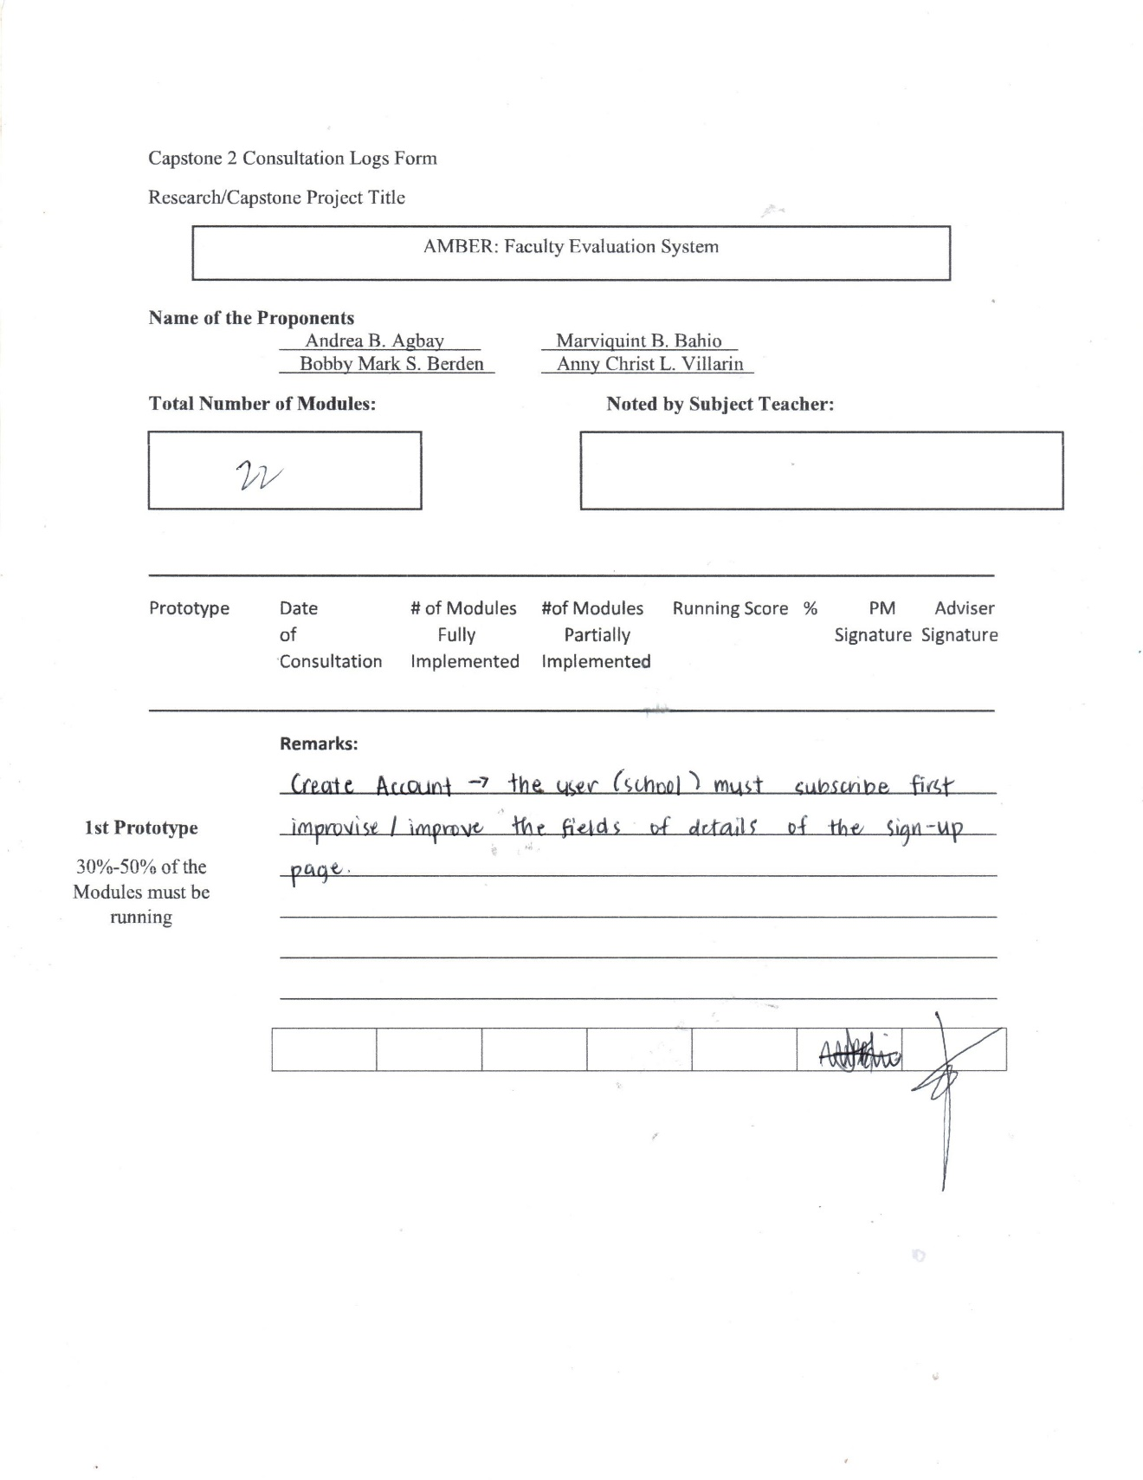

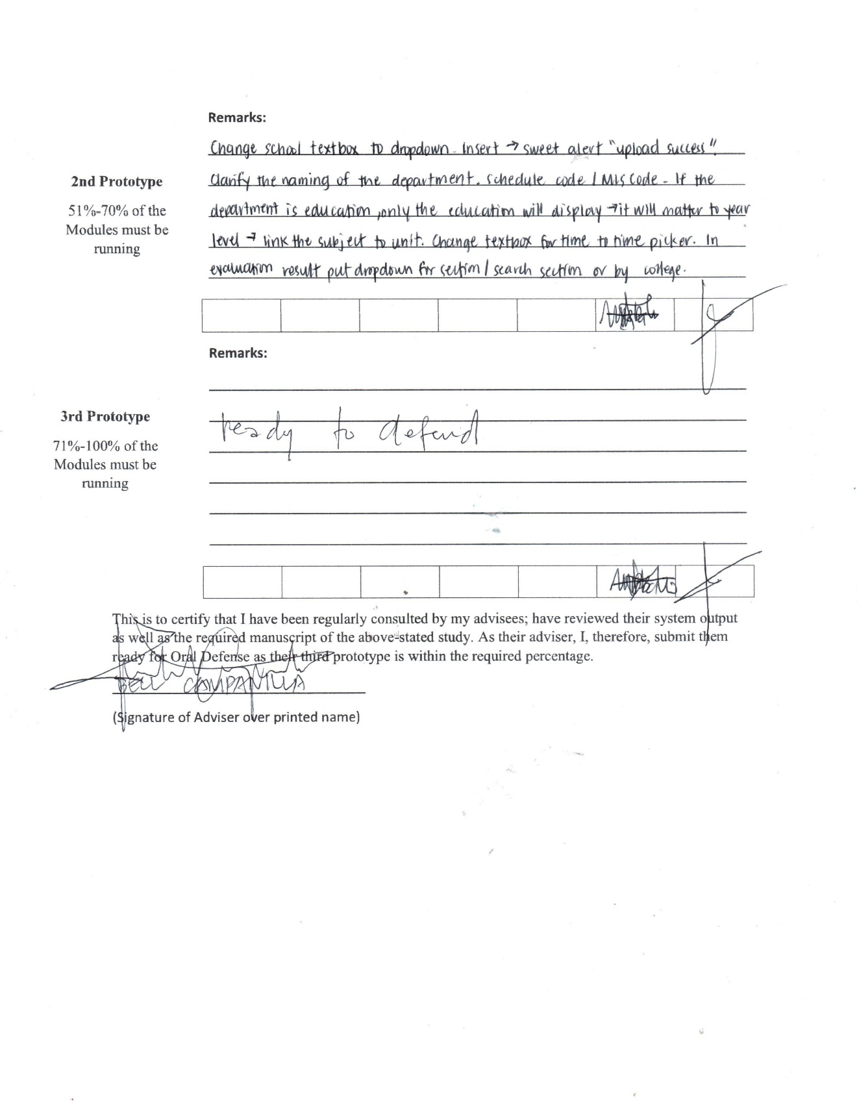

**Appendix E: Source Code**

EvaluateForm.aspx.cs

protected void btnSubmit_Click(object sender, EventArgs e)

{

int count = CategoryCount();

if (IsRadioButtonListFilled())

{

if (chkConfirm.Checked == true)

{

if (ddlInstructor.SelectedValue == " ")

{

Page.ClientScript.RegisterClientScriptBlock(this.GetType(), "sweetalert", "swal.fire('Something went wrong!','Please select an instructor to evaluate', 'warning')", true);

}

else

{

for (int i = 0; i < count; i++)

{

GridViewRow MainGvRow = GridView1.Rows[i];

GridView ChildGV = MainGvRow.FindControl("GridviewIndicator") as GridView;

int index = 0;

foreach (GridViewRow row in ChildGV.Rows)

{

int indicator_id = Convert.ToInt32(ChildGV.DataKeys[index++].Value);

int instructor_id = getScheduleInstructor(ddlInstructor.SelectedValue);

RadioButtonList RBLrate = (row.Cells[0].FindControl("rblScore") as RadioButtonList);

var rate = RBLrate.SelectedValue;

try

{

using (var db = new SqlConnection(connDB))

{

db.Open();

using (var cmd = db.CreateCommand())

{

cmd.CommandType = CommandType.Text;

if (txtComment.InnerText == String.Empty)

{

cmd.CommandText = "INSERT INTO EVALUATION_TABLE(evaluator_id, evaluatee_id, indicator_id, rate, datetime_eval, school_id)"

+ " VALUES("

+ "@evaluator,"

+ "@evaluatee,"

+ "@indicator,"

+ "@rate,"

+ "@datetime,"

+ "@school)";

cmd.Parameters.AddWithValue("@evaluator", Session["studID"]);

cmd.Parameters.AddWithValue("@evaluatee", instructor_id);

cmd.Parameters.AddWithValue("@indicator", indicator_id);

cmd.Parameters.AddWithValue("@rate", rate);

cmd.Parameters.AddWithValue("@datetime", DateTime.Now);

cmd.Parameters.AddWithValue("@school", Session["school"].ToString());

}

else

{

cmd.CommandText = "INSERT INTO EVALUATION_TABLE(evaluator_id, evaluatee_id, indicator_id, rate, comment, datetime_eval, school_id)"

+ " VALUES("

+ "@evaluator,"

+ "@evaluatee,"

+ "@indicator,"

+ "@rate,"

+ "@comment,"

+ "@datetime,"

+ "@school)";

cmd.Parameters.AddWithValue("@evaluator", Session["studID"]);

cmd.Parameters.AddWithValue("@evaluatee", instructor_id);

cmd.Parameters.AddWithValue("@indicator", indicator_id);

cmd.Parameters.AddWithValue("@rate", rate);

cmd.Parameters.AddWithValue("@comment", txtComment.InnerText);

cmd.Parameters.AddWithValue("@datetime", DateTime.Now);

cmd.Parameters.AddWithValue("@school", Session["school"].ToString());

}

var ctr = cmd.ExecuteNonQuery();

if (ctr >= 1)

{

txtComment.InnerText = String.Empty;

chkConfirm.Checked = false;

}

}

}

}

catch (Exception ex)

{

Page.ClientScript.RegisterClientScriptBlock(this.GetType(), "sweetalert", "error()", true);

Response.Write("<pre>" + ex.ToString() + "</pre>");

}

}

btnSubmit.Enabled = false;

chkConfirm.Enabled = false;

Page.ClientScript.RegisterClientScriptBlock(this.GetType(), "sweetalert", "swal.fire('Success!','Thank you for participating', 'success')", true);

}

GridView1.Visible = false;

GridView2.Visible = true;

GVbind2();

txtComment.InnerText = getComments();

GVbind();

}

}

else

{

Page.ClientScript.RegisterClientScriptBlock(this.GetType(), "sweetalert", "swal.fire('Something went wrong!','Please confirm before submitting your evaluation', 'warning')", true);

}

}

else

{

Page.ClientScript.RegisterClientScriptBlock(this.GetType(), "sweetalert", "swal.fire('Something went wrong!','Please Fill all rate', 'warning')", true);

}

}

PeerEvaluation.aspx.cs

protected void btnSubmit_Click(object sender, EventArgs e)

{

int count = CategoryCount();

if (IsRadioButtonListFilled())

{

if (chkConfirm.Checked == true)

{

if (ddlPeer.SelectedValue == "Select Peer")

{

Page.ClientScript.RegisterClientScriptBlock(this.GetType(), "sweetalert", "swal.fire('Something went wrong!','Please select an instructor to evaluate', 'warning')", true);

}

else

{

for (int i = 0; i < count; i++)

{

GridViewRow MainGvRow = GridView1.Rows[i];

GridView ChildGV = MainGvRow.FindControl("GridviewIndicator") as GridView;

int index = 0;

foreach (GridViewRow row in ChildGV.Rows)

{

int indicator_id = Convert.ToInt32(ChildGV.DataKeys[index++].Value);

int instructor_id = Convert.ToInt32(ddlPeer.SelectedValue);

RadioButtonList RBLrate = (row.Cells[0].FindControl("rblScore") as RadioButtonList);

var rate = RBLrate.SelectedValue;

try

{

using (var db = new SqlConnection(connDB))

{

db.Open();

using (var cmd = db.CreateCommand())

{

cmd.CommandType = CommandType.Text;

if (txtComment.InnerText == String.Empty)

{

cmd.CommandText = "INSERT INTO EVALUATION_TABLE(evaluator_id, evaluatee_id, indicator_id, rate, datetime_eval, dept_id, school_id)"

+ " VALUES("

+ "@evaluator,"

+ "@evaluatee,"

+ "@indicator,"

+ "@rate,"

+ "@datetime,"

+ "@dept,"

+ "@school)";

cmd.Parameters.AddWithValue("@evaluator", Session["insID"]);

cmd.Parameters.AddWithValue("@evaluatee", instructor_id);

cmd.Parameters.AddWithValue("@indicator", indicator_id);

cmd.Parameters.AddWithValue("@rate", rate);

cmd.Parameters.AddWithValue("@datetime", DateTime.Now);

cmd.Parameters.AddWithValue("@dept", Session["dept"].ToString());

cmd.Parameters.AddWithValue("@school", Session["school"].ToString());

}

else

{

cmd.CommandText = "INSERT INTO EVALUATION_TABLE(evaluator_id, evaluatee_id, indicator_id, rate, comment, datetime_eval, dept_id, school_id)"

+ " VALUES("

+ "@evaluator,"

+ "@evaluatee,"

+ "@indicator,"

+ "@rate,"

+ "@comment,"

+ "@datetime,"

+ "@dept,"

+ "@school)";

cmd.Parameters.AddWithValue("@evaluator", Session["insID"]);

cmd.Parameters.AddWithValue("@evaluatee", instructor_id);

cmd.Parameters.AddWithValue("@indicator", indicator_id);

cmd.Parameters.AddWithValue("@rate", rate);

cmd.Parameters.AddWithValue("@comment", txtComment.InnerText);

cmd.Parameters.AddWithValue("@datetime", DateTime.Now);

cmd.Parameters.AddWithValue("@dept", Session["dept"].ToString());

cmd.Parameters.AddWithValue("@school", Session["school"].ToString());

}

var ctr = cmd.ExecuteNonQuery();

if (ctr >= 1)

{

txtComment.InnerText = String.Empty;

chkConfirm.Checked = false;

}

}

}

}

catch (Exception ex)

{

Page.ClientScript.RegisterClientScriptBlock(this.GetType(), "sweetalert", "error()", true);

Response.Write("<pre>" + ex.ToString() + "</pre>");

}

}

btnSubmit.Enabled = false;

chkConfirm.Enabled = false;

Page.ClientScript.RegisterClientScriptBlock(this.GetType(), "sweetalert", "swal.fire('Success!','Thank you for participating', 'success')", true);

}

GridView1.Visible = false;

GridView2.Visible = true;

GVbind2();

txtComment.InnerText = getComments();

GVbind();

}

}

else

{

Page.ClientScript.RegisterClientScriptBlock(this.GetType(), "sweetalert", "swal.fire('Something went wrong!','Please confirm before submitting your evaluation', 'warning')", true);

}

}

else

{

Page.ClientScript.RegisterClientScriptBlock(this.GetType(), "sweetalert", "swal.fire('Something went wrong!','Please Fill all rate', 'warning')", true);

}

}

SelfEvaluation.aspx.cs

protected void btnSubmit_Click(object sender, EventArgs e)

{

int count = CategoryCount();

if (IsRadioButtonListFilled())

{

if (chkConfirm.Checked == true)

{

for (int i = 0; i < count; i++)

{

GridViewRow MainGvRow = GridView1.Rows[i];

GridView ChildGV = MainGvRow.FindControl("GridviewIndicator") as GridView;

int index = 0;

foreach (GridViewRow row in ChildGV.Rows)

{

int indicator_id = Convert.ToInt32(ChildGV.DataKeys[index++].Value);

RadioButtonList RBLrate = (row.Cells[0].FindControl("rblScore") as RadioButtonList);

var rate = RBLrate.SelectedValue;

try

{

using (var db = new SqlConnection(connDB))

{

db.Open();

using (var cmd = db.CreateCommand())

{

cmd.CommandType = CommandType.Text;

if (txtComment.InnerText == String.Empty)

{

cmd.CommandText = "INSERT INTO EVALUATION_TABLE(evaluator_id, evaluatee_id, indicator_id, rate, datetime_eval, dept_id, school_id)"

+ " VALUES("

+ "@evaluator,"

+ "@evaluatee,"

+ "@indicator,"

+ "@rate,"

+ "@datetime,"

+ "@dept,"

+ "@school)";

cmd.Parameters.AddWithValue("@evaluator", Session["insID"]);

cmd.Parameters.AddWithValue("@evaluatee", Session["insID"]);

cmd.Parameters.AddWithValue("@indicator", indicator_id);

cmd.Parameters.AddWithValue("@rate", rate);

cmd.Parameters.AddWithValue("@datetime", DateTime.Now);

cmd.Parameters.AddWithValue("@dept", Session["dept"].ToString());

cmd.Parameters.AddWithValue("@school", Session["school"].ToString());

}

else

{

cmd.CommandText = "INSERT INTO EVALUATION_TABLE(evaluator_id, evaluatee_id, indicator_id, rate, comment, datetime_eval, dept_id, school_id)"

+ " VALUES("

+ "@evaluator,"

+ "@evaluatee,"

+ "@indicator,"

+ "@rate,"

+ "@comment,"

+ "@datetime,"

+ "@dept,"

+ "@school)";

cmd.Parameters.AddWithValue("@evaluator", Session["insID"]);

cmd.Parameters.AddWithValue("@evaluatee", Session["insID"]);

cmd.Parameters.AddWithValue("@indicator", indicator_id);

cmd.Parameters.AddWithValue("@rate", rate);

cmd.Parameters.AddWithValue("@comment", txtComment.InnerText);

cmd.Parameters.AddWithValue("@datetime", DateTime.Now);

cmd.Parameters.AddWithValue("@dept", Session["dept"].ToString());

cmd.Parameters.AddWithValue("@school", Session["school"].ToString());

}

var ctr = cmd.ExecuteNonQuery();

if (ctr >= 1)

{

txtComment.InnerText = String.Empty;

chkConfirm.Checked = false;

}

}

}

}

catch (Exception ex)

{

Page.ClientScript.RegisterClientScriptBlock(this.GetType(), "sweetalert", "error()", true);

Response.Write("<pre>" + ex.ToString() + "</pre>");

}

}

btnSubmit.Enabled = false;

chkConfirm.Enabled = false;

Page.ClientScript.RegisterClientScriptBlock(this.GetType(), "sweetalert", "swal.fire('Success!','Thank you for participating', 'success')", true);

}

GridView1.Visible = false;

GridView2.Visible = true;

GVbind2();

txtComment.InnerText = getComments();

GVbind();

}

else

{

Page.ClientScript.RegisterClientScriptBlock(this.GetType(), "sweetalert", "swal.fire('Something went wrong!','Please confirm before submitting your evaluation', 'warning')", true);

}

}

else

{

Page.ClientScript.RegisterClientScriptBlock(this.GetType(), "sweetalert", "swal.fire('Something went wrong!','Please Fill all rate', 'warning')", true);

}

}

EvaluationResult.aspx.cs

protected void GVbind()

{

using (SqlConnection db = new SqlConnection(connDB))

{

db.Open();

SqlCommand cmd = new SqlCommand("SELECT CONSTRUCTOR_TABLE.constructor_id,CONSTRUCTOR_TABLE.constructor_name, INDICATOR_TABLE.indicator_name,CONVERT(DECIMAL(10,2),AVG(CAST(EVALUATION_TABLE.rate as FLOAT))) AS AVERAGE FROM EVALUATION_TABLE JOIN INDICATOR_TABLE ON EVALUATION_TABLE.indicator_id=INDICATOR_TABLE.indicator_Id JOIN CONSTRUCTOR_TABLE ON INDICATOR_TABLE.constructor_id=CONSTRUCTOR_TABLE.constructor_id WHERE EVALUATION_TABLE.evaluatee_id = @instructor AND EVALUATION_TABLE.school_id=@school_id GROUP BY CONSTRUCTOR_TABLE.constructor_id, CONSTRUCTOR_TABLE.constructor_name, INDICATOR_TABLE.indicator_name ORDER BY CONSTRUCTOR_TABLE.constructor_id", db);

cmd.Parameters.AddWithValue("@school_id", Session["school"].ToString());

cmd.Parameters.AddWithValue("@instructor", Session["insID"].ToString());

SqlDataReader dr = cmd.ExecuteReader();

if (dr.HasRows == true)

{

GridView1.DataSource = dr;

GridView1.DataBind();

}

}

}

AdminRankingPage.aspx.cs

protected void dropdownDepartment_SelectedIndexChanged(object sender, EventArgs e)

{

if (dropdownDepartment.SelectedItem.Text == "ALL")

{

gvranks.EditIndex = -1;

GVbind();

}

else if (dropdownDepartment.SelectedItem.Text == "Select School")

{

gvranks.EditIndex = -1;

GVbind();

}

else

{

try

{

DataTable dt = new DataTable();

using (var db = new SqlConnection(connDB))

{

db.Open();

using (var cmd = db.CreateCommand())

{

cmd.CommandType = CommandType.Text;

cmd.CommandText = "SELECT evaluatee_id,profile_picture,(''+INSTRUCTOR_TABLE.fname+' '+INSTRUCTOR_TABLE.mname+' '+INSTRUCTOR_TABLE.lname+'') AS NAME,CONVERT(DECIMAL(10,2),AVG(CAST(EVALUATION_TABLE.rate as FLOAT)))AS AVERAGE FROM EVALUATION_TABLE JOIN INSTRUCTOR_TABLE ON INSTRUCTOR_TABLE.Id = EVALUATION_TABLE.evaluatee_id WHERE EVALUATION_TABLE.school_id='" + Session["school"].ToString() + "' AND EVALUATION_TABLE.dept_id='" + dropdownDepartment.SelectedValue + "' AND isDeleted IS NULL GROUP BY profile_picture,(''+INSTRUCTOR_TABLE.fname+' '+INSTRUCTOR_TABLE.mname+' '+INSTRUCTOR_TABLE.lname+''),evaluatee_id ORDER BY AVERAGE DESC";

SqlDataAdapter da = new SqlDataAdapter(cmd);

da.Fill(dt);

}

db.Close();

gvranks.DataSource = dt;

gvranks.DataBind();

}

}

catch (Exception ex)

{

Page.ClientScript.RegisterClientScriptBlock(this.GetType(), "test", "error()", true);

Response.Write("<pre>" + ex.ToString() + "</pre>");

}

}

}

OverallReports.aspx.cs

public string getQuestionResults(string ColumnName)

{

string result = "";

try

{

using (var db = new SqlConnection(connDB))

{

db.Open();

using (var cmd = db.CreateCommand())

{

cmd.CommandType = CommandType.Text;

cmd.CommandText = "SELECT INDICATOR_TABLE.indicator_id,INDICATOR_TABLE.indicator_name,CONVERT(DECIMAL(10,2),AVG(CAST(EVALUATION_TABLE.rate as FLOAT)))AS AVERAGE FROM EVALUATION_TABLE RIGHT JOIN INDICATOR_TABLE ON INDICATOR_TABLE.indicator_Id = EVALUATION_TABLE.indicator_id WHERE EVALUATION_TABLE.school_id= '" + Session["school"].ToString() + "' AND INDICATOR_TABLE.isDeleted IS NULL GROUP BY INDICATOR_TABLE.indicator_id,INDICATOR_TABLE.indicator_name";

SqlDataReader reader = cmd.ExecuteReader();

if (reader.HasRows == true)

{

while (reader.Read())

{

if (ColumnName == "AVERAGE")

{

result += reader[ColumnName].ToString() + ",";

}

else

{

result += "'" + reader[ColumnName].ToString() + "',";

}

}

}

db.Close();

}

}

}

catch (Exception ex)

{

Response.Write(ex);

Page.ClientScript.RegisterClientScriptBlock(this.GetType(), "sweetalert", "error()", true);

}

return result = result.Substring(0, result.Length - 1);

}

public string getCategoryResults(string ColumnName)

{

string result = "";

try

{

using (var db = new SqlConnection(connDB))

{

db.Open();

using (var cmd = db.CreateCommand())

{

cmd.CommandType = CommandType.Text;

cmd.CommandText = "SElECT CONSTRUCTOR_TABLE.constructor_id,CONSTRUCTOR_TABLE.constructor_name,CONVERT(DECIMAL(10,2),AVG(CAST(EVALUATION_TABLE.rate as FLOAT)))AS AVERAGE FROM EVALUATION_TABLE JOIN INDICATOR_TABLE ON EVALUATION_TABLE.indicator_id=INDICATOR_TABLE.indicator_Id JOIN CONSTRUCTOR_TABLE ON INDICATOR_TABLE.constructor_id=CONSTRUCTOR_TABLE.constructor_id WHERE EVALUATION_TABLE.school_id= '" + Session["school"].ToString() + "' AND CONSTRUCTOR_TABLE.isDeleted IS NULL GROUP BY CONSTRUCTOR_TABLE.constructor_id,CONSTRUCTOR_TABLE.constructor_name";

SqlDataReader reader = cmd.ExecuteReader();

if (reader.HasRows == true)

{

while (reader.Read())

{

if(ColumnName == "AVERAGE")

{

result += reader[ColumnName].ToString() + ",";

}

else

{

result += "'" + reader[ColumnName].ToString() + "',";

}

}

}

db.Close();

}

}

}

catch (Exception ex)

{

Response.Write(ex);

Page.ClientScript.RegisterClientScriptBlock(this.GetType(), "sweetalert", "error()", true);

}

return result = result.Substring(0,result.Length -1);

}

**Curriculum Vitae**

|  |  |
| --- | --- |
| **MARVIQUINT B. BAHIO**  Mactan, Lapu-Lapu City  Mobile Number: 0945 691 1060  Email: marviquintb@gmail.com | May be an image of 1 person |
|  | |
| **PERSONAL DATA** | |
| Date of Birth | : October 26, 2000 |
| Place of Birth | : Mactan, Lapu-Lapu City |
| Sex | : Male |
| Citizenship | : Filipino |
| Civil Status | : Single |
| Religion | : Roman Catholic |
|  |  |
| **EDUCATIONAL BACKGROUND** | |
| College | : Cebu Technological University |
|  | : M.J Cuenco Avenue, Corner R. Palma Street, Cebu City |
|  | : 2019 - Present |
|  | |
| Senior High School | : University of Cebu Lapu-Lapu and Mandaue Campus |
|  | : Looc, Mandaue City |
|  | : 2017-2019 |
|  | |
| Junior High School | : Mactan National High School |
|  | : Mactan, Lapu-Lapu City |
|  | : 2013 - 2017 |
|  | |
| Elementary | : Mactan Elementary School |
|  | : Mactan, Lapu-Lapu City |
|  | : 2007 – 2013 |
| **BOBBY MARK S. BERDEN**  Saac 1 Buaya, Lapu-Lapu City  Mobile Number: 0932 336 0063  Email: bobbymark.berden@ctu.edu.ph |  |
|  | |
| **PERSONAL DATA** |  |
| Date of Birth | : December 8, 2000 |
| Place of Birth | : Cebu City |
| Sex | : Male |
| Citizenship | : Filipino |
| Civil Status | : Single |
| Religion | : Roman Catholic |
|  | |
| **EDUCATIONAL BACKGROUND** | |
| College | : Cebu Technological University |
|  | : M.J Cuenco Avenue, Corner R. Palma Street, Cebu City |
|  | : 2019 - Present |
|  | |
| Senior High School | : AMA Computer Learning Center Northpoint Business Center |
|  | : M.C. Briones Street Highway, Mandaue City, Cebu 6014 |
|  | : 2017-2019 |
|  | |
| Junior High School | : Bankal National High School |
|  | : Bankal Lapu-lapu City, Cebu 6014 |
|  | : 2013 - 2017 |
|  | |
| Elementary | : Bankal Elementart School |
|  | : Bankal Lapu-lapu City, Cebu 6014 |
|  | : 2007 – 2013 |

|  |  |
| --- | --- |
| **ANDREA B. AGBAY**  Basak Kainsong, Lapu-Lapu City  Mobile Number: 0928 211 7005  Email: andrea.agbay@ctu.edu.ph |  |
|  | |
| **PERSONAL DATA** |  |
| Date of Birth | : May 16, 2000 |
| Place of Birth | : Cebu City |
| Sex | : Female |
| Citizenship | : Filipino |
| Civil Status | : Single |
| Religion | : Iglesia |
|  | |
| **EDUCATIONAL BACKGROUND** | |
| College | : Cebu Technological University |
|  | : M.J Cuenco Avenue, Corner R. Palma Street, Cebu City |
|  | : 2019 - Present |
|  | |
| Senior High School | : University of Cebu Lapu-Lapu and Mandaue Campus |
|  | : Looc, Mandaue City |
|  | : 2017-2019 |
|  | |
| Junior High School | : Marigondon National High School |
|  | : Marigondon Lapu-lapu City, Cebu 6015 |
|  | : 2013 – 2017 |
|  | |
| Elementary | : Marigondon Elementary School |
|  | : Marigondon Lapu-lapu City, Cebu 6015 |
|  | : 2007-2013 |

|  |  |  |
| --- | --- | --- |
| **ANNY CHRIST L. VILLARIN**  493 P. Burgo Street, Alang Alang, Mandaue City  Mobile Number: 0923 452 8807  Email: annychrist.villarin@ctu.edu.ph | |  |
|  | | |
| **PERSONAL DATA** |  | |
| Date of Birth | : December 11, 1999 | |
| Place of Birth | : Visayas Community Medical Center, Cebu City | |
| Sex | : Female | |
| Citizenship | : Filipino | |
| Civil Status | : Single | |
| Religion | : Roman Catholic | |
|  | | |
| **EDUCATIONAL BACKGROUND** | | |
| College | : Cebu Technological University | |
|  | : M.J Cuenco Avenue, Corner R. Palma Street, Cebu City | |
|  | : 2019 - Present | |
|  | | |
| Senior High School | : Mandaue City Comprehensive National High School | |
|  | : Plaridel Street, Reclamation Area, Mandaue City | |
|  | : 2016-2019 | |
|  | | |
| Junior High School | : Mandaue City Comprehensive National High School | |
|  | : Plaridel Street, Reclamation Area, Mandaue City | |
|  | : 2012 - 2016 | |
|  | | |
| Elementary | : Manadaue City Central School | |
|  | : Catalino LL. Ouano Street, Centro, Mandaue City | |
|  | : 2006 – 2012 | |